January 2022 | www.collegept.org | info@collegept.org

Welcome to the first edition of Perspectives in 2022.

This year may not have started the way we were all hoping for, but I would like to reiterate my appreciation for the flexibility and perseverance of the physiotherapy community as we continue to navigate COVID-19.

Circumstances with this wave continue to evolve rapidly. I encourage everyone to regularly visit the Ministry of Health website and check with your local Public Health Unit for the most up to date information. We have also highlighted some key pieces of information in this newsletter.

Stay safe,

Rod Hamilton Registrar
College of Physiotherapists of Ontario

Annual Renewal and PISA Launch on February 1

Annual Renewal 2022

Each year all PTs registered in Independent Practice are required to complete the annual renewal process which involves reviewing and verifying your personal and employment information, and paying your annual registration fee.

The 2022 annual renewal process will run from February 1 to March 31. All PTs in Independent Practice must complete annual renewal and pay the registration fee of $575 by 11:59 p.m. on March 31 to avoid additional late fees.

Just like last year, you will complete annual renewal online using the PT Portal . Watch for an email on February 1.

If you have questions, please contact the Renewal Team at renewal@collegept.org or 1-800- 583-5885 ext. 235.
PISA 2022
About Annual Renewal

The Professional Issues Self Assessment (PISA) runs concurrently with annual renewal between February 1 and March 31. PISA is a mandatory self-reflection exercise that all PTs must complete each year. This includes people with both Provisional Practice and Independent Practice certificates.

While PISA is mandatory, it is not scored so there is no pass or fail. There are 10 multiple choice questions designed to get you thinking about the standards and resources and how to apply them in your practice.

Watch for an email on February 1 with the link to complete PISA.

If you have questions about PISA, please contact PISA@collegept.org or 1-800-583-5885 ext. 235.
About PISA

New Blog Post: The Benefits of a Call Bell

Recently the College heard from a patient who wanted to share their positive experience with physiotherapy and their PT. While the patient was nervous to attend treatment, the physiotherapist was able to ease their concerns with good communication and one simple tool - a call bell.

In a new blog post, we explore the importance of using a call bell or similar device and chat about how simple gestures can help strengthen the therapeutic relationship. Be sure to check it out.
Read the Blog

Practice Advice Question

Where can I find updated information about how to manage exposures to COVID-19 or what to do if I test positive myself?
Get the Answer
Myth vs Fact

Practice Supervisors for PT Residents must be approved by the College and complete a Practice Supervision agreement before a PT Resident can practice.

Is this a myth or a fact?
Find Out

COVID Updates

The latest from the Ministry of Health, Public Health Ontario and the College.

Updated Directives

The Ministry of Health has updated a number of directives and documents in the last few weeks including: Directive #1 and the supporting Questions and Answers document, Directive #2 and the supporting Questions and Answers document, and Directive #5 and the supporting Questions and Answers document.

Fit-Tested and PPE

Directive #1 provides guidance for health care providers about interim precautions and the use of PPE with the new Omicron variant. The guidance details requirements for health care providers who are fit-tested for an N95 respirator (or equivalent) and providing care to someone with a suspected, probable or confirmed case of COVID-19. The directive also includes requirements for health care providers who are not yet fit-tested for an N95 respirator or equivalent.

See the Directive #1 Questions and Answers document, question #2 for more information. Virtual Care is an Option
Remember, virtual care remains an option to help reduce physical contact. For example, if a patient screens positive for exposure to the virus or is at risk of complications should they contract COVID-19. Review the guidance for virtual care.

Infection Prevention and Control

Physiotherapists who continue to see patients in person must follow all infection prevention and control guidance from the Ministry of Health and Public Health Ontario. Review the IPAC resources on our website.
COVID Information & Resources

Practice Hours for Annual Renewal

A friendly reminder: physiotherapists who have not completed the PCE within the last five years will be required to report their practice hours for 2021 as part of the 2022 - 2023 annual renewal process, which will run from February 1 to March 31, 2022.

For the next registration year - 2022-2023 - the College will review your reported practice hours from January 1, 2017 through December 31, 2021 to ensure you have 1,200 practice hours.

Practice hours may include:

Hours worked that you have been paid for (clinical settings, consultation, research, administration, academia or sales)

Professional activity/development hours (maximum 30 per year). Professional activity hours include volunteer activity which requires the use of physiotherapy theory and knowledge, continuing education hours and/or participation

If you have questions about the practice hour requirement, please contact the Registration Team at registration@collegept.org or 1-800-583-5885 ext. 222.
About Practice Hours

Check/Renew Your Liability Insurance

Now is also the time to make sure that you check or renew your professional liability insurance. You will be asked to confirm that you have a liability insurance policy that meets the College's requirements when you renew your registration.

Your liability insurance must include:

A minimum coverage of $5 million dollars for the annual policy period A liability limit of at least $5 million dollars per incident
No additional terms, conditions or exclusions, other than standard No deductible
Tail insurance for a minimum of 10 years

Check with your employer to see if they have a policy that protects you. If it doesn't, it's your responsibility to arrange your own.
About Liability Insurance

2022 Council Elections - Nominations are Open

Nominations are now open for the 2022 Council Elections! Nominate a PT you think would be a great addition to College Council. As a professional member of Council, you have the opportunity to participate in self-regulation and contribute to the safety and protection of physiotherapy patients across Ontario.

There are two Council seats up for election this year. In 2022, eligible nominators and nominees must live in:

District 1 South Western

District 2 Central Western

If you live in a district up for election you will have received a separate email alerting you of the chance to nominate a PT or run in the election yourself. You can verify your district by checking your postal code on the College website.

Nominations close on February 23, 2022 at 2:00 p.m.
2022 Election Information

Mental Health Resources for PTs and Patients

In January there is often a spotlight on mental health and wellbeing thanks to Blue Monday (said to be the most depressing day of the year) and Bell Let's Talk Day, a social movement that aims to get people talking about mental health.

As the uncertainty with the pandemic continues, physiotherapists, students, patients, caregivers, employers and others may be in need of mental health support and resources.

Here are three free resources that are available to all:

Wellness Together Canada BounceBack Ontario

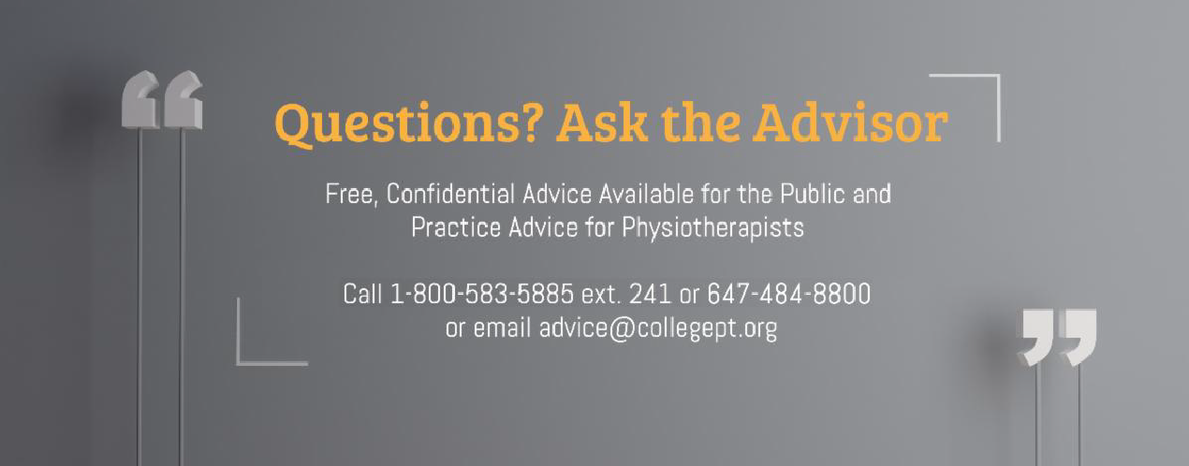Ontario Caregiver Organization

You can also find a comprehensive list of resources on the College website.
More Resources

The College would like to welcome our newly registered physiotherapists.
View the List

Comments or questions related to Perspectives?
Get in touch at communications@collegept.org or 1-800-583-5885 ext. 234. www.collegept.org

