April 2020 | www.collegept.org | info@collegept.org

I would like to thank everyone for their patience and cooperation during these unprecedented times. I know these past weeks have been challenging for everyone on both a professional and personal level.

At times the information related to COVID-19 may seem overwhelming. The College is doing its best to break down the information, provide direction in line with the provincial and federal requirements, and share reliable resources with you. We do appreciate your questions and suggestions for further information. We will continue our efforts to provide the information that you need to make this difficult time a little easier to understand.

Our staff is ready and available to answer your questions and assist you as required. Please email info@collegept.org or call 1-800-583-5885 and we will direct your inquiry to the appropriate person.

Please stay safe,

Rod Hamilton Registrar
College of Physiotherapists of Ontario

COVID-19: Updates and Information

We have a dedicated COVID-19 page with the most up to date information from the Ministry of Health, Public Health, direction from the College and helpful resources. This page is updated almost daily, so please check back frequently.
COVID-19 Page

Check out the FAQs on our Website

We are continually adding to a list of frequently asked questions related to COVID-19 and other pertinent topics including infection prevention, the use of PPE, and virtual care.

Find answers to the following questions and many more:

What constitutes urgent care?
Can physiotherapists be redeployed from one position to another during the pandemic? What infection control measures and products should I use to clean my clinic?
What if PPE is not available?

If you can't find the answer to your question, please call the Practice Advisor at 1-800-583- 5885 (extension 241) or email advice@collegept.org.
All FAQs

Practice Advice Question

Can I re-use personal protective equipment (PPE)?
Get the Answer
Myth vs Fact

Physiotherapists can provide tele- practice for non-urgent care.

Is this a myth or a fact?
Find Out

Free Training Courses and Resources

If you have been asked to do tasks that are outside of your typical scope of practice and feel that you would benefit from some additional training, there are a number of free courses and resources available to you.

Canadian Physiotherapy Association:

A Review of Obstructive Respiratory Disease & Implications for Secretion Clearance A Review of Arterial Blood Gas Interpretation for Physiotherapists with Tania Larsen Frontal Chest Radiography Interpretation with Simone Gruenig
Review of Mechanical Ventilation for Critical Care with Anastasia Newman

Quick ICU Training for COVID-19: Quick ICU Training

Physiotherapy Alberta:

The Continuum of Care for Patients with COVID-19

Roster Reminder!
Keep in mind that PTs need to roster - add their names to a list indicating they have the required training, education and experience to safely perform the higher risk activity. This applies to a PT both performing or delegating a controlled act (and remember that not all can be delegated).

Roster for tracheal suctioning, spinal manipulation, acupuncture (dry needling), treating a wound below the dermis, pelvic internal exams and administering a substance by inhalation.
COVID-19 Page

Where to Find Mental Health Support During COVID-19

During these unprecedented times, many people may experience an increase in stress and
anxiety. Front line health care workers and their families may experience additional mental health challenges related to burnout and seeing the results of COVID-19 firsthand.

There are a number of free resources available to health care workers, patients, caregivers and others. We have compiled a list of resources to help point you in the right direction.
Where to Find Help

Don't Forget to Update the Public Register

Changing jobs or no longer working at a clinic? You're required to update the Public Register within 30 days.

PTs have a year-round legal requirement to ensure their information on the Public Register is accurate. This includes any changes to your employment information.

So if you've changed jobs or are no longer working at a particular clinic, you MUST update the Public Register within 30 days of the change.

Your information appears on the Public Register so patients can find you, insurers can confirm your employment, and we can reach you, so it's imperative that the information is current.

Update your information on the PT Portal. If you have questions, please email registration@collegept.org.
Go to the PT Portal

COVID-19 Health Care Worker and Volunteer Recruitment

The Ontario government is taking further action to stop the spread of COVID-19 by actively recruiting health care workers, such as physiotherapists, to increase the front line capacity of hospitals, clinics, and assessment centres.

To help recruit health care workers as efficiently as possible, the province has launched an online tool that will help match skilled frontline workers with employers.
Learn More

The federal government is also seeking volunteers during COVID-19 to help in the following areas:

- Case tracking and contact tracing
- Health system surge capacity
- Case data collection and reporting

Check out the recruitment page for more information.
Government Recruitment Page

Annual Renewal Deadline Extended Until June 30

We understand that this is an incredibly difficult time for physiotherapists with the health care system in flux and with so many of you not able to see your patients. We are well aware of the financial impact this is having on you and your family.

As the result of these extraordinary circumstances, the College has extended the annual renewal deadline to June 30, 2020.

If you have already renewed - thank you. PTs who have not renewed can do so any time on or before June 30, but it is essential that all physiotherapists complete and pay for their registration by the deadline to maintain their certificate of registration.

If you have questions about the annual renewal extension, please reach out to our Renewal Team at renewal@collegept.org or call 1-800-583-5885 ext. 235.
Renew Now
Renewal FAQs

PISA Update

Note that if you have not yet completed PISA, it is not necessary that you complete it until further notice.

However, PISA remains open, should you wish to complete it.

A reminder that PISA is a quick multiple choice exercise that provides you with an opportunity to assess your awareness of practice issues, reflect on practice-related questions and have a look at resources and Standards on the College’s website.

If you choose to complete PISA, you will be redirected to a secure Survey Monkey site.
PISA FAQs

New YouTube Videos - Answers to Top Practice Advice Questions

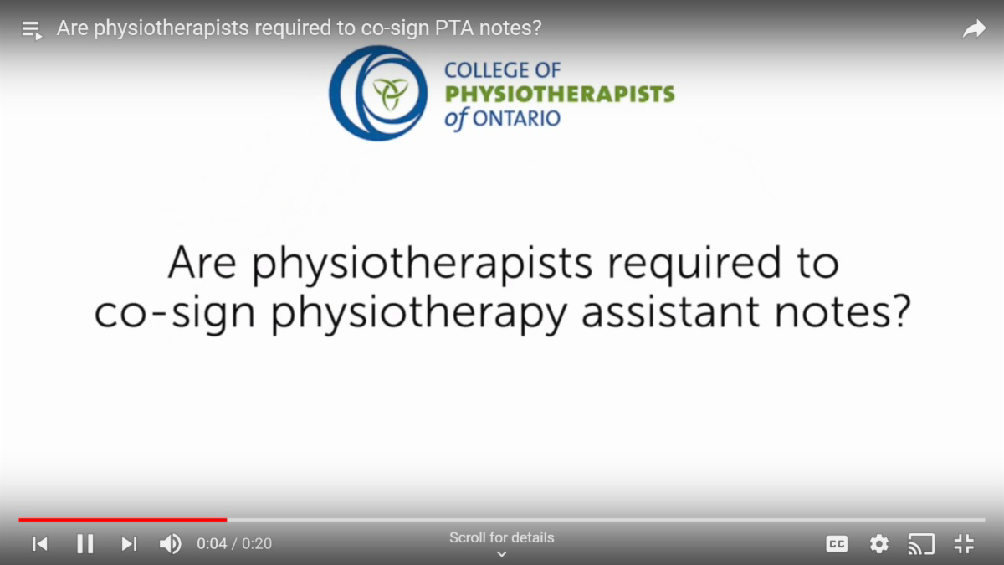

You have questions, we have answers! We recently filmed a series of popular practice advice questions for our YouTube channel including:

Can a physiotherapist start a practice in their own home? What needs to be included in the financial record?
Can a physiotherapist treat a family member? And more!

Be sure to check out the Practice Advice Questions and Answers playlist on our YouTube channel, like the videos and subscribe to updates.

If you have questions about anything in the video, feel free to leave a comment on YouTube, or give the Practice Advisor a call at 1-800-583-5885 (extension 241).
YouTube Channel

New Case of the Month: The Impostor

When a patient goes to see a PT, they should have confidence that they are... well, actually seeing a trained physiotherapist. Some people think they can pretend to be a PT in order to see patients, bill insurance companies and make money, but this is illegal and they will get caught.

Find out what happens when a former massage therapist decides to enter the world of physiotherapy, without a degree or a license, and starts delivering patient care. Read a new case of the month - The Impostor - now.
Read the Case

The College would like to welcome our newly registered physiotherapists.

View the List

Comments or questions related to Perspectives?
Get in touch at communications@collegept.org or 1-800-583-5885 ext. 234. www.collegept.org

