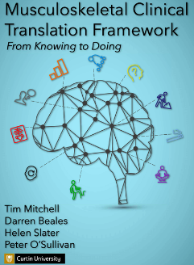
A Clinical Reasoning Framework Activity

The clinical reasoning framework acknowledges the multidimensional nature of pain, disability and associated behaviors in individuals with musculoskeletal pain and disability. The Framework has been designed to better enable health care practitioners to examine, interpret and implement targeted management for patients.

Each category should be cues to be considered in the context of each unique patient. The categories can be addressed in any order. This is an exercise in overt clinical reasoning and will help your mentor know how best to assist you in your professional development. As you work through the questions, provide as much information about your patient - do not provide names or dates as this is confidential information. All these factors are important to provide optimal physiotherapy to your patients.

Consider each category (in any order you think is appropriate for the specific patient) and enter either not applicable/NA", or give an appropriate description.

Permission to utilize the MCTF from Dr. T. Mitchell, (previously at Curtin University).

Full Name
Click or tap here to enter text.

Email
Click or tap here to enter text.

It is essential to understand the patient's problem(s) from their perspective. Good listening skills and asking further questions will help clarify the problem and create a therapeutic, helping relationship.

Fill in the answers under the three areas 1. Individual Perspective, 2. Functional Capacity and 3. Goals). Examples of probing questions you might ask a patient are shown in quotation marks).

Click or tap here to enter text.

Prioritise the Individual’s Problem(s)
Probing Questions:
“What are your main problems or concerns?"
- Provides overall context for the clinical interaction.
- Acknowledgement of the individual’s perspective is required.

Click or tap here to enter text.

Functional Capacity
Probing Questions:
“How do these problems affect your daily activities/quality of life?”
"Can you give specific examples of how the pain affects you in the day"
- Could be difficult to delineate in a ‘pain focused’ individual?
- Look for what can be done and build from there.

Click or tap here to enter text.

Goals/Expectations
Probing Questions:
“What do you expect from this session/interaction?”
“What are your goals or what are you hoping to achieve?”
"What would you like to do, that you cannot do right now?"

- Addressing an individual's goals and expectations are important for compliance and ‘buy-in’ and to align with individual-centred care.

Click or tap here to enter text.

RED FLAGS
Red flags refer to clinical features (signs and /or symptoms) potentially associated with a serious condition and which require urgent medical evaluation or intervention. These conditions include, but are not limited to malignancy, inflammatory disorders, fracture, infection, cauda equina syndrome, hx of dizziness, falls, multi-system involvement.

Is there a suspected serious disorder present?
-If yes, refer to other health care providers for appropriate further investigation /management.
-If no, are there signs and symptoms of a specific disorder/dysfunction?
Provide your answer below.

Click or tap here to enter text.

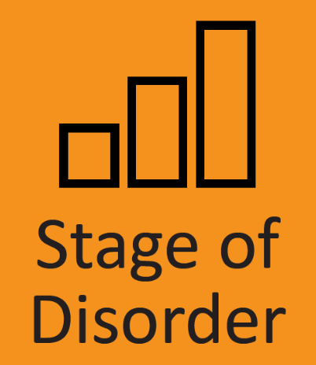
Identify which stage your client is at. The four stages are below.
Describe the assessment findings supporting your decision.
If there is more than one pain site, at different stages, describe all in the appropriate textbox.

Click or tap here to enter text.

Acute
Acute pain may develop immediately following a local tissue injury and is the natural physiological tissue response to injury. At this stage, physiotherapy management is directed towards prevention of further tissue damage and promoting recovery. In e.g., of an acute flare of symptoms of osteoarthritis, rheumatoid arthritis the focus might be on symptom relief, regaining function and a focus on addressing contributing factors.
Management Implications:
- Immediate pain control.
- Prevention of further tissue damage/sensitization (acute injury).
- Reassurance and other ‘active’ management advice.

Click or tap here to enter text.

Sub-Acute
A phase of transition from traumatic injury to normal expected tissue healing (1-2 mo). In absence of trauma, it is the phase where symptoms subside as part of natural history of disorder.
Management Implications
- gradual restoration of functional capacity
- continued pain control as needed to create a therapeutic window to get active

Click or tap here to enter text.

Recurrent
experiencing a new episode of previously experienced musculoskeletal symptoms following a period of being symptom free. Some patients may present with ongoing, mild persistent symptoms but have recent episodes of increased symptoms that are impacting on the usual activities.
Management Implications
- Manage immediate symptoms as per acute/sub=acute disorders.
- Investigation of potential factors contributing to the recurrent/episodic nature of the disorder for long term solutions.
- Reinforce active management

Click or tap here to enter text.

Chronic/Persistent
Most commonly defined by a time frame of greater than three to six months duration, or pain that extends beyond the expected period of disorder resolution. Some disorders are chronic, though episodes of pain are recurrent/episodic.
Management Implications
- Ensure there is not missed or associated serious pathology that continues to contribute to the chronicity of the disorder.
- Investigation of potential factors contributing to the chronic nature of the disorder for long term management.

Click or tap here to enter text.

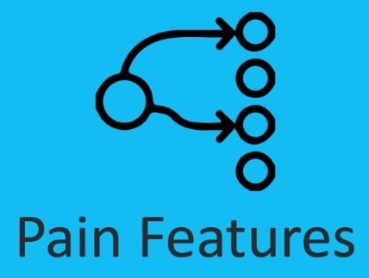
PAIN FEATURES - TYPE
"Pain is a distressing experience associated with actual or potential tissue damage with sensory, emotional, cognitive and social components". (Williams AC, Craig KD, 2016).

Use the descriptors below to determine which type of pain your patient presents with at this time. The type of pain experienced matters, as this can influence what specific management strategies may best target the pain. Three descriptors are recommended; Nociceptive (two types: tissue damage or inflammation), neuroplastic (caused by a lesion or disease of the somatosensory system) or nociplastic pain (no clear evidence of damage or disease). (https:/www.iasp-pain.org/resources/terminology/?navItemNumber=576)

Click or tap here to enter text.

Nociceptive (type 1 - tissue damage)
: pain that arises from actual or threatened damage to non-neural tissue and is due to the activation of nociceptors. This includes pain associated with acute actual tissue damage (ie. post-operative) and inflammatory conditions.
Clinical Tip: Typically short lasting, stimulus-response coupled;
Management Implications
- Moving early/staying active important; active management vs passive.
- May respond to simple analgesia, ice or other modalities.

Click or tap here to enter text.

Nociceptive (type 2 - inflammatory)
Considered under the term nociceptive pain, inflammatory pain can be associated with actual tissue damage, infection, or active inflammatory conditions such as rheumatoid arthritis.
Clinical Tip: When acute, typically stimulus-response coupled; familiar verbal descriptors.
Management Implications
- Manage pain to enable increased activity without pain flares; stay active.
- Typically responds to simple analgesia.
- May require collaboration with a physician or nurse Practitioner for specific inflammatory process management.

Click or tap here to enter text.

Neuropathic
Pain caused by a lesion or disease of the peripheral somatosensory nervous system. This term is designed to contrast the nociceptive pain.
Clinical Tip: Typical verbal descriptors (e.g., tingling, burning, stabbing, electric shocks); common in conditions such as shingles, cervical or lumbar radiculopathy, neuritis, neuroma, phantom limb pain, trigeminal neuralgia, or diabetic neuropathy; sensory abnormalities (loss or gain of sensitivity).

Management Implications
- Manual treatments may readily provoke symptoms until pain is controlled.

Click or tap here to enter text.

Nociplastic
Pain arising from altered nociception despite no clear evidence of actual or threatened tissue damage causing the activation of peripheral nociceptors, or evidence for disease or lesion of the somatosensory system causing the pain.
Clinical Tip: States include fibromyalgia, irritable bowel syndrome, interstitial cystitis and tension type headache.
Management Implications
- Interdisciplinary management including education directed at co-morbidities and lifestyle factors may moderate pain sensitivity, pace activity carefully.
- Low evidence for simple analgesia; anti-neuropathics.

Click or tap here to enter text.

Mixed
Pain caused by a lesion or disease of the peripheral somatosensory nervous system. This term is a combination of various pain types, eg nociceptive and neuropathic pain components in an individual with low back pain and painful lumbar radiculopathy; or neuropathic pain combined with functional pain (sciatic and irritable bowel or dysmenorrhea or fibromyalgia).
Clinical Tip: May have widespread sensitivity, fatigue; sleep disruption; altered immune dysfunction; poor response to conservative treatment.
Management Implications
- Target contributing factors relevant for the individual (eg. education, sensori-motor training, functional restoration and addressing lifestyle factors). Encourage paced activity and consider co-morbid pain conditions.
- Consider whether there is appropriate pharmacologic management for all pain types.

Click or tap here to enter text.

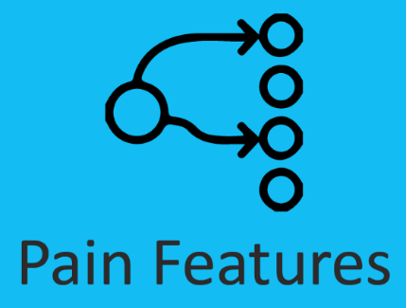
PAIN FEATURES - CHARACTERISTICS
The concepts of mechanical and non-mechanical characteristics are not mutually exclusive. In clinical practice, the complexity of individual presentations means PTs need to consider the concept of mechanical versus non-mechanical characteristics as a continuum.
Use the descriptors below to determine whether your patient presents with mechanical, non-mechanical pain or a mix at this time.

Click or tap here to enter text.

Mechanical
The pain is activity-dependent. Response is proportionate to the stimulus. Pain fluctuations clearly linked to aggravating and easing activities
Example: Acute sprained ankle will hurt to move/bear weight but eases with rest.
Management
- focus on the type of pain.

Click or tap here to enter text.

Non-Mechanical
: Pain is NOT activity-independent. Response disproportionate to the stimulus. Constant pain with significant difficulty to find easing postures or activities.
Example: Individual describes “I am not sure why it is sore. It’s even when I’m resting.”
Management
- Focus on addressing mechanical factors is unlikely to be helpful. Broad management focus required to consider other contributing factors.

Click or tap here to enter text.

Mixed
Constant pain overlaid by clear and consistent patterns of activity related aggravation.
Some easing positions, but limited time of easing.
Management
- Establish a functional baseline from which to graduate exposure to physical loading while minimizing increased pain or increased sensitization.

Click or tap here to enter text.

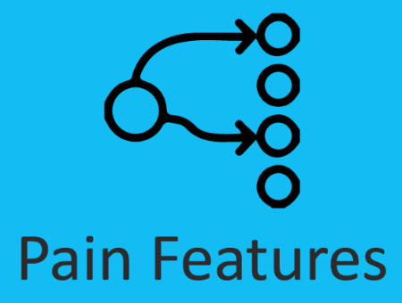
PAIN FEATURES – SENSITIZATION

Sensitization to stimuli such as: movement, posture, load, palpation, light, stress/distress, touch/pressure/thermal.

Based on the degree of sensitization: Is it localized? Multisite? Widespread? Is it typical for the clinical history and stage of the disorder? What are contributing factors? What are the management implications?

Use the descriptors below to determine which type of pain your patient presents with at this time.

Click or tap here to enter text.

Low Sensitization
Sub-acute neck pain (no red flags), with clear aggravating and easing factors. Low responsiveness to stimuli such as posture, movement, and palpation of local neck structures.
Example: Persistent knee pain with clear aggravating and easing factors. Locally sensitized to palpation of affected knee structures. Pain with postures and movement consistent with the clinical picture.
Management Implications
- As per clinical guidelines for the condition.

Click or tap here to enter text.

High Sensitization – Helpful/Protective
Example: Acute supination ankle sprain, clear sensitization (allodynia and hyperalgesia localized to affected ankle structures) and consistent with the clinical history. This degree of sensitization aligns with the acute injury/trauma.
Example: Sub-acute low back pain + painful radiculopathy (allodynia, mixed sensory signs with hyperalgesia; hypoalgesia; dysesthesias). In the acute to sub-acute stages this increased sensitization can be considered protective.
Management Implications
- As per clinical guidelines for the condition and monitor sensitization. Sensitization should settle as disorder settles.

Click or tap here to enter text.

High Sensitization – Unhelpful/Provocative.
Example: Acute low back pain (no red flags), with allodynia (nerve pain) and either localized or mode widespread hyperalgesia beyond what might be expected for the clinical history and stage.
Example: Chronic OA knee with heightened responsiveness to touch, movement, load and pressure and extending beyond the knee and possibly affecting the other knee or other un-related areas.
Management Implications
- Need to address factors contributing to the increased sensitization. For example, neuropathic pain, psychological factors and lifestyle factors. Need to avoid frightening and disempowering language.

Click or tap here to enter text.

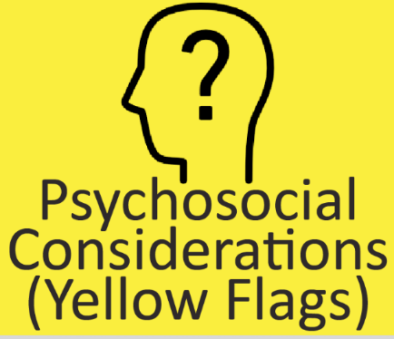
PSYCHOSOCIAL CONSIDERATIONS (YELLOW FLAGS)

Pain is not only a sensory event but also an emotional experience (Williams AC, Craig KD, 2016).

Psychosocial is an umbrella term for cognitive, affective and social factors. We have to consider these factors on an individual patient level in order to inform the relative ‘weighting’ and contribution of these factors to the patient's presentation.

Respond to the questions below, providing appropriate details.

Click or tap here to enter text.

Cognitive Factors (thoughts and beliefs)
Attention, Attitudes, Beliefs, Expectations, Self-Efficacy, Catastrophizing, Coping
Possible Effects: Influence behaviors related to pain such as avoidance, catastrophizing and over-activity. Influence behaviors related to care seeking such as passive coping and doctor shopping. Directly influence pain intensity and disability levels. Influence compliance, acceptance and expectations. Reliance on biomedical model.
Clinical Questions: "What do you understand is the cause of your problem? What does your pain mean to you? How do you cope with your pain? What do you think you need to help you get better? What do you think will be the outcome of your problem?
Screening Tools
- Pain Catastrophizing Scale
- Back Beliefs Questionnaire
- Pain Self-Efficacy Scale

Click or tap here to enter text.

Affective Factors
Depression, Anxiety, Stress, Fear, Worry, Frustration/Anger
Possible Effects: Elevated pain experience (via altered neurophysiological processes anywhere along the nociceptive systems through to changing the emotional experience of pain). Increased pain attention/focus, tissue sensitivity, muscle tension/guarding/autonomic arousal. Altered pain behaviours (eg. Fear avoidance). Impact on lifestyle element and social factors.
Clinical Questions: How much is your pain distressing you? Your screening questionnaire suggests you are under increased distress at the moment – Do you think this has an impact on your problem? What do you think is the cause of your distress? Is stress/anxiety/depression an underlying problem for you? How is it managed? Do you have strategies for coping with stress/anxiety/depression?
Screening Tools
- Depression, Anxiety and Stress Scales
- Orebro Musculoskeletal Pain Questionnaire (long or short form)
- Tampa Scale of Kinesiophobia

Click or tap here to enter text.

Social Factors
Socioeconomics, Education, Relationships, Health Literacy, Culture, Health Care
Possible Effects: Influence care-seeking options; Influences barriers to recovery; Prescription and non-prescription drug and alcohol use/misuse. Smoking
Clinical Questions: Social/living situation. Level of support/significant life stress. Presence of social factors that could impact on pain. Career beliefs, behaviours. Do you understand your pain problem?
Screening Tools
- Demographics
- Lifestyle factors

Click or tap here to enter text.

WORK CONSIDERATIONS
(BLUE & BLACK FLAGS)
Personal and societal costs of work-related injuries are enormous. Early, effective interventions and early return to work are essential for successful recovery.
In the textboxes below provide the appropriate information outlined.

Click or tap here to enter text.

Blue Flags (Perceptions of Work)
Job satisfaction, Job culture, Co-worker support, Management support, Suitable duties.
Possible Effects: Experience of stress at work, potentially impacting symptoms experience. Job dissatisfaction influencing motivation to return to work. Perceptions of lack of support from co-workers or employers creates barriers to return to work. Perceptions that work is unsafe or that there is a high risk of re-injury.
Clinical Questions: Tell me about your work. Do you enjoy your work? Do you feel supported at work? When do you think you can go back to work? Do you think it is safe for you to do your job?
Screening Tools
- Clinical interview
- Orebro Musculoskeletal Pain Questionnaire.
- Pain Self-Efficacy Questionnaire.

Click or tap here to enter text.

Black Flags (Workplace Factors)
Nature of work, Job demands, Workplace processes, Compensation claim, Claim Acceptance, Legal Issues.
Possible Effects: Work tasks or nature of work (eg. Night shift) may impair return to usual or modified duties. Negative experience of workplace management of injury or symptoms. Lack of acceptance by employer or co-workers of legitimacy of symptoms. Lack of acceptance of relevance of psychological issues.
Clinical Questions: Tell me about your work. Is your work heavy or repetitive? Is your work keeping in contact with you? Has your claim been accepted? Do you have a plan for return to work?
Screening Tools
- Clinical interview
- Work task analysis (e.g. Job requirements & Physical Demands Scale)
- Communication with employer and other stakeholders
- Worksite visit

Click or tap here to enter text.

LIFESTYLE CONSIDERSATIONS

Physical Activity, Sedentary lifestyle, Sleep, Smoking, Alcohol use, Obesity/low BMI, Nutrition/Diet
Possible Effects: Increased risk around under and over activity. Multifactorial benefits of cardiovascular exercise. Influence neurophysiological modulation of pain and mood. Effects of diet/nutrition on bone and joint health and risk of osteoarthritis/osteoporosis.
Clinical Questions: Are you currently doing any physical activity? Is your problem impacting on your sleep? What are your usual sleep habits? Is your sleep impacting your pain? Do you think your weight has an impact on your pain? Do you smoke/drink?
Resources/Management Tips
- SNAP (smoking, nutrition, alcohol, physical activity) is a population health guide to behavioural risk factors in general practice. (www.racgp.org.au) replace with Canadian*
- Pain Management Network consumer information resource *
- Education and lifestyle-behavioural change strategies
- Sleep diary and sleep hygiene assessment

Provide these details as they pertain to your patient.

Click or tap here to enter text.

WHOLE PERSON CONSIDERATIONS

Co-morbidities, Family history, Personal history, Medication, Genetics.
Possible Effects: Increased inherent risk around of developing musculoskeletal pain disorder. Influence bodies healing and recovery processes. Susceptibility to pain disorders or heightened pain sensitivity, or musculoskeletal pain disorders (rheumatoid arthritis, osteoarthritis).
Clinical Questions: How is your general health? Do you suffer from any other medical problems? Do any of your immediate relatives have similar problems to you? What medications are you presently taking?
Management Tips
- Poorer general health and co-morbidity negatively influence the prognosis or the outcomes. In the example of an individual with a non-specific pain disorder with metabolic syndrome and depression, development of a cardiovascular exercise program that could positively influence all these issues is indicated.

Click or tap here to enter text.

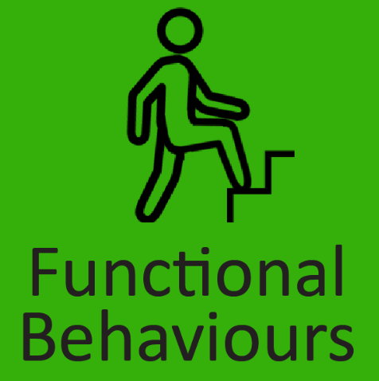
FUNCTIONAL BEHAVIOURS

: functional control (of posture and movement), pain behaviours deconditoning.

These can be:
Helpful/protective behaviours that serve to prevent further tissue damage/allow tissue healing to occur. Helpful behaviour is when normalising the behaviour results in decreased symptoms. Example limping after an acute lower limb injury.
Unhelpful/provocative behaviours provoke a disorder, resulting in persistence of symptoms past the time of normal tissue healing. Examples limping or guarding with no patho-anatomical basis.
Below are descriptors of movement - how is your patient presenting? Provide your assessment findings to support the presentation.

Click or tap here to enter text.

Impairment of Movement
Restricted active and passive movement in the direction of pain provocation. If in the acute phase it may be helpful guarding and protective. however in the sub acute and chronic it may be unhelpful functional behaviour.

Clinical Example:
Helpful behaviours: Loss of cervical spine movement associated with underlying inflammatory disorder or acute trauma. Repeated movement increases pain.
Unhelpful behaviours: Loss of cervical spine movement associated with a neck sprain 6-months earlier (no pathology detected). Associated with perception that pain is harmful and protective muscle guarding. Relaxation of muscles results in less pain with movement.

Click or tap here to enter text.

Impairment of Control
These are common in may articular pain disorders of the spine and peripheral joints. No impairment of movement but where pain is associated with abnormal movement control.
Clinical Example:
Helpful behaviours: Arc of pain with aberrant movement pattern in glenohumeral joint associated with sub-acromial pain due to acute inflammatory process (full active and passive range). Attempts to normalize movement pattern exacerbates pain.
Unhelpful behaviours: Arc of pain with aberrant movement pattern in glenohumeral joint associated with a chronic impingement pain disorder. Normalization of movement pattern reduces pain and enhances function.
Management Tips:
Helpful behaviours: Management of the underlying inflammatory disorder.
Unhelpful behaviours: Graduated restoration of normal movement incorporating reassurance that pain does not equal harm. Graduated normal movement in the direction of impairment +/- manual therapies.

Click or tap here to enter text.

Deconditioning
: A consequence of lifestyle changes. Avoidance of exercise, poor posture results in deficit in muscle strength, endurance and/or physical capacity.

Clinical Example:
Helpful behaviour: Grade 3 medial ligament strain to the knee, treated with hinged knee bracing during the acute tissue healing period. Associated with a loss of quadriceps and lower limb muscle strength and endurance.
Unhelpful behaviour : Chronic patella-femoral joint pain associated with pain avoidance behaviours and rest leading to a loss of quadriceps and lower limb strength and endurance..

Management Tips:
Helpful behaviour: Ensure adequate tissue healing before progressive rehabilitation program.
Targeted behaviour : Graduated quadriceps and lower limb strength training to restore function and reduce forces over the patello-femoral joint.

Click or tap here to enter text.

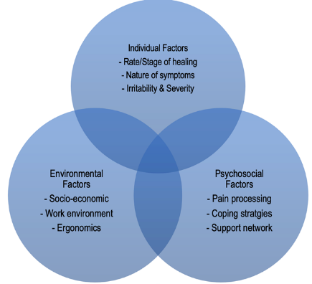
PROGNOSTIC FACTORS

Each patient is unique and their presentation is the result of the interaction of individual, psychosocial and environmental factors. These factors can be favorable and unfavorable, helpful in recovery or hindering recovery.
What factors apply to your patient?
What is influencing their recovery?

Click or tap here to enter text.

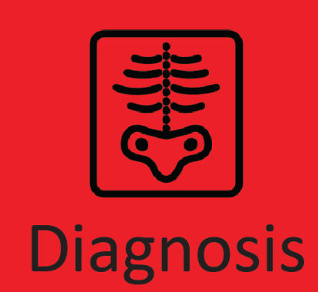
The patient's clinical symptoms can be directly attributed (at least in part) to the presence of biological processes associated with the musculoskeletal system that are causing the disorder (e.g. rheumatoid arthritis, stress fractures, disc protrusion or from the CNS etc.) .

State your diagnosis and explain your rationale. What is the supporting evidence for your diagnosis?

Click or tap here to enter text.

Provide your Analysis Statement.

Click or tap here to enter text.

CLINICAL DECISION MAKING & MANAGEMENT
Summary
Diagnosis
Stage
Prioritized List of Contributing Factors
Prioritized List of your Physiotherapy Management for this patient. Include if any need for referral to other health care providers e.g., if any need to target pharm logical management to create a therapeutic window? need for education, functional rehab. plan (Frequency, Intensity, Time, Type (F.I.T.T.) , patient goals to return to physical activity, .... etc.).
Describe in detail.

Click or tap here to enter text.

Provide one progression in the treatment you would expect after 3 weeks. Explain your rationale.

Click or tap here to enter text.

