Technical Support: Frequently Asked Questions

How do I create a new account and access COVID Care Learning resources?
- 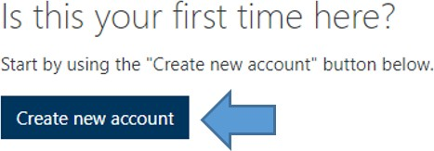On the main login screen, click Create new account.
- Complete the new account registration form.
  - It is recommended that you use your work/institutional email, if available.
- Enter the access code provided by your hospital organization, long-term care facility, professional association, or other source.
  - Type the access code in. Do not copy and paste the access code as this could result in additional spaces and an invalid access code.
- Wait for your email confirmation from donotreply@criticalcarelearning.ca with subject line “Critical Care Learning: account confirmation”.
- Confirm your account by clicking the link in the confirmation email. Proceed to login using the email address and password you registered with.

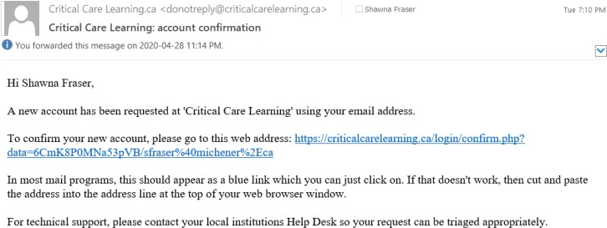
Account Confirmation Email

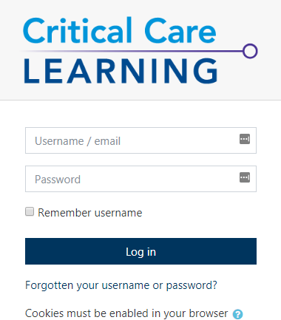Login Screen

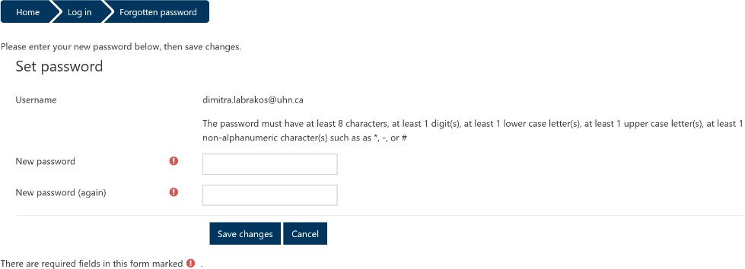

What should I do if I do not receive a confirmation email?
- Double check your junk/spam filters for an email from donotreply@criticalcarelearning.ca with the subject line “Critical Care Learning: account confirmation”.
- If you have registered with your organizational email address and did not receive a confirmation email, please reach out to your organization’s helpdesk. They may need to add donotreply@criticalcarelearning.ca to their approved sender list.

I forgot my username and/or password. How do I reset it?
- 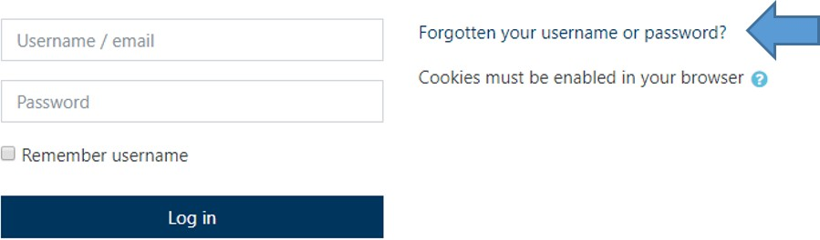On the main login screen click Forgotten your username or password?

Enter the email address you used to register.
- An email will be sent to your account with a link. Click the link and create your new username or password.

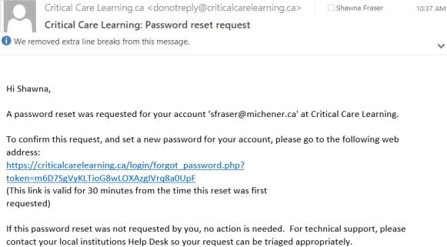
Forgot Password Email Set Password Screen

Where can I obtain an access code if I do not have one?
The access code may have been circulated to you by email from your local hospital organization, long- term care facility, professional association, or other source. Please follow-up with any of these organizations to obtain the access code.

What browser should I use to access the website and its resources?
We recommend you use the latest versions of Chrome (Desktop and Mobile), Firefox, Safari (Desktop and Mobile), and Edge. We do not recommend using Internet Explorer.
Please note:
- There are known compatibility issues with Internet Explorer 10 and below, Safari 7 and below.
- A mobile app is not available, however it is mobile responsive and can be accessed via web browser.
- Some of the learning materials contain audio. Please have a headset or your computer speakers turned on.

Why have I been automatically logged out of my account?
The system will automatically logout after some inactivity time for security purposes. Please login again.

