College of Physiotherapists of Ontario
Annual Report (April 1, 2019 to March 31, 2020)

College of Physiotherapists of Ontario Annual Report (April 1, 2019 to March 31, 2020)

About the College President’s Letter Registrar’s Letter Strategic Plan
College Council and Committees
The Year in Review Financial Statements Program Review
Discipline Summaries 2019-2020 Contact the College

- of 10

About the College
College of Physiotherapists of Ontario

The College of Physiotherapists of Ontario

Protecting Every Patient’s Right to Safe, Competent and Ethical Physiotherapy Care

The College of Physiotherapists of Ontario is the regulator for physiotherapists in Ontario. We set rules and develop programs to ensure that members of the physiotherapy profession practice in the best interest of the public.

We work to protect and serve the public interest, and to continually improve the practice of more than 10,000 physiotherapists, also known as physical therapists or PTs.

By law, we are required to:

Make sure that only qualiﬁed people can practice as physiotherapists Ensure that physiotherapists continue learning throughout their career
Make sure that all physiotherapists meet our standards for entry into the profession and for ongoing conduct and practice
Consider all complaints and concerns brought to the College’s attention by the public

Our work is guided by the College Council, which is made up of:

Members of the public—appointed by the Lieutenant Governor of Ontario Physiotherapists—elected by their peers
Academic representatives who are physiotherapists—appointed by their educational institutions

Vision
Innovative Regulatory Leadership Promoting a Healthier Ontario

Mission Statement
To protect and serve the public interest by promoting collaboration and accountability for self-regulation and enabling a culture of continuous improvement to ensure that physiotherapists provide competent and ethical services.

 Watch our Video: What is the College of Physiotherapists of Ontario?

- of 10

President’s Letter
College of Physiotherapists of Ontario

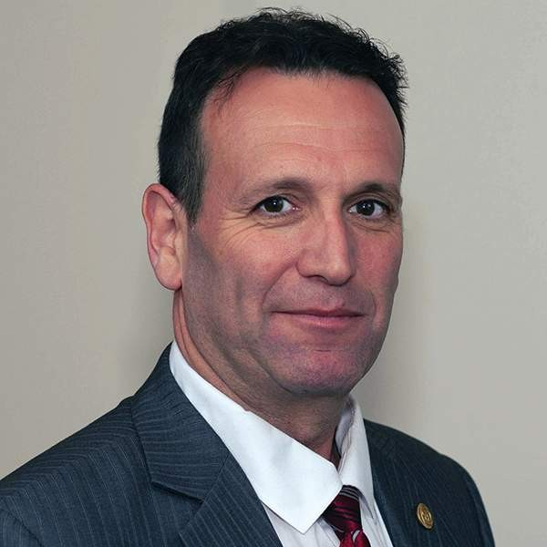

President’s Letter

Darryn Mandel, PT Council President
College of Physiotherapists of Ontario

My ﬁrst year as President at the College of Physiotherapists of Ontario has concluded, and it was certainly one of the most challenging times our College has ever had. The diﬃculties in navigating a regulated health profession through a global pandemic were extremely demanding, and quite unique.

Many physiotherapists were forced to stop practicing, or signiﬁcantly transform and reduce their practices. Others continued to work on the front lines, and some were redeployed to assist where help was most needed. Regardless of your situation, I applaud your ability to adapt to an ever-evolving environment.

Considering the ﬁnancial implications of COVID-19 for many physiotherapists, the College extended the 2020 annual renewal deadline to September 30. Hopefully, this will assist registrants as many start to return to practice.

Aside from, and independent of the pandemic, Council lowered the registration fee for independent practice in 2020. That’s the second fee reduction in the past four years. When I ran for election to Council, one of my main concerns was that the College can fulﬁll its mandate of protecting the public interest while reducing costs to the registrants. I have now carried out that goal.

This year, Council identiﬁed the need to review and update the College’s By-laws and governance policies. I look forward to seeing this project through, and improve the framework that guides the College’s daily operations.

I would like to recognize and express my appreciation and gratitude to all my fellow Council members. Respectful debate and dissent has always led us to better decisions. I would also like to extend my appreciation to our Registrar, Rod Hamilton, and all of the College staff for their hard work and dedication — not just in this past year, but also in creating it as part of the culture inherent in the organization. I am honoured and humbled to serve as President with all these ﬁne people.

Sincerely,

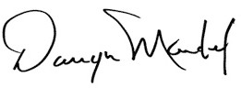

Darryn Mandel, PT President
College of Physiotherapists of Ontario
CONTI NUE

- of 10

Registrar's Letter
College of Physiotherapists of Ontario

Registrar's Letter

Rod Hamilton Registrar
College of Physiotherapists of Ontario

“There is no education like adversity.”
Benjamin Disraeli

As I sit down to craft my second annual report letter as Registrar at the College of Physiotherapists of Ontario, I cannot help but reﬂect on the adversity we have all faced.

I truly believe we will learn so much from what we have endured in the ﬁrst few months of 2020 and be stronger for it, so this letter will focus on the positives — what we accomplished before our lives were put on hold and what we look forward to accomplishing as we cautiously push restart.

As you ﬂip through the annual report you will ﬁnd a snapshot of the work the College has completed in the past year. College Council, Committees and staff have been busy as we work to guide the practice of more than 10,000 physiotherapists in the province to ensure every patient has access to safe, competent and ethical care.

This year, the College focused heavily on outreach and education to try and connect with physiotherapists and others at a grassroots level and create a library of resources that would help bring the rules and standards to life.

Thankfully, we were able to connect with many PTs, employers, students and other stakeholders via in person outreach events across the province before physical distancing measures were implemented. We will continue to seek innovative ways to connect with our audiences directly, even if we are unable to gather in groups.

We also created a number of new resources including a virtual welcome kit for new physiotherapists which led to the development of a provisional practice welcome kit for PT residents. Further, we developed a highly interactive learning module covering the Working with Physiotherapist Assistants Standard.

Finally, we partnered with experts in their ﬁelds for webinars on mental health and business practices. These webinars are always available on the College YouTube channel.

All of these initiatives support the College’s commitment to serve the public interest by promoting

collaboration and enabling a culture of continuous improvement.

I would like to extend my gratitude to Council, Committees and staff at the College for their hard work and dedication. I look forward to many new and exciting initiatives in the year to come.

Stay safe,

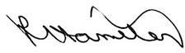

Rod Hamilton Registrar
College of Physiotherapists of Ontario

CONTI NUE

- of 10

Strategic Plan
College of Physiotherapists of Ontario

The College of Physiotherapists of Ontario's strategic plan allows us to set priorities and direction, to be most efﬁcient and effective with our resources, and to successfully communicate with our stakeholders.

1

Ensure physiotherapists’
business practices meet professional standards and do not damage the reputation of the profession.

2

Promote quality
physiotherapy services by ensuring registered physiotherapists are aware of and adhere to professional standards and expectations.

3

Increase the value and awareness of the services the College provides for Ontarians.

CONTI NUE

- of 10

College Council and Committees
College of Physiotherapists of Ontario

Annual Report (April 1, 2019 to March 31, 2020)

The Council is the governing body for more than 10,000 PTs practicing in Ontario. Council is made up of eight elected physiotherapists, two academic representatives and seven government-appointed public members. Councillors are responsible for ensuring the protection of the public interest.

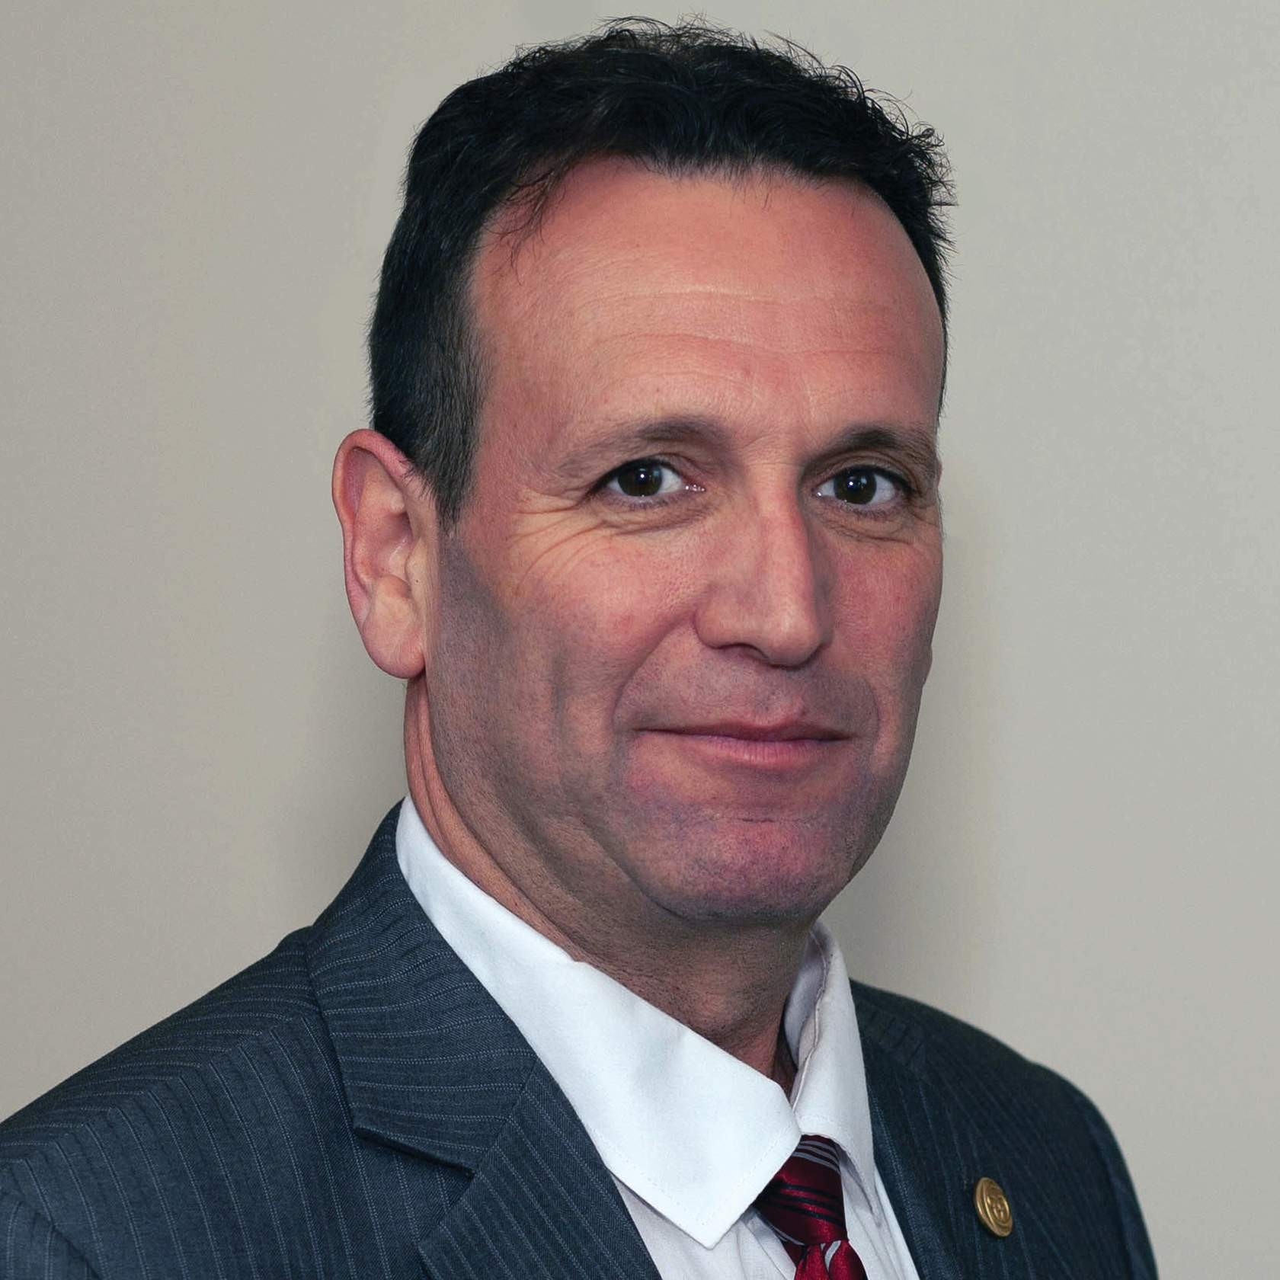
Darryn Mandel, Council President (Elected Representative)

Theresa Stevens, Council Vice- President (Elected Representative)

Elected Representatives
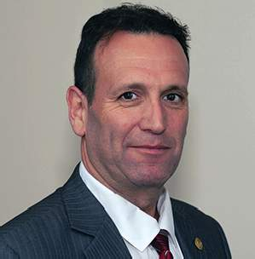

Nicole Graham Janet Law Darryn Mandel Sharee Mandel-
Benyacar

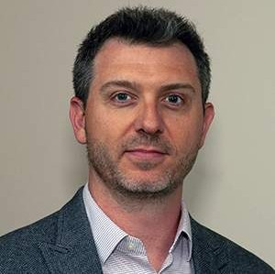

Gary Rehan Mark Ruggiero Theresa Stevens Lisa Tichband
(until June 2019)

Katie Schulz (from June 2019)

Academic Representatives

Kathleen Norman— Queen’s University
Martin Bilodeau
—University of Ottawa

Public Appointees

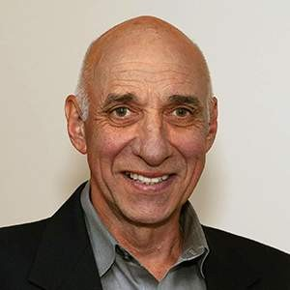
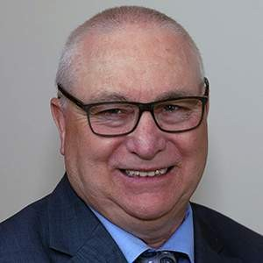

Kenneth Moreau (until December 2019)
Ronald Bourret Jane Darville Tyrone Skanes

Jennifer Dolling (until December 2019)
Nitin Madhvani (from December 2019)
Jesse Finn (from February 2020)

Professional Committee Members
Heather Anders (until February 2020) Jatinder Bains (until June 2019) Beth Bergmann (from June 2019) Sheila Cameron (until June 2019)
Monica Clarke
Marcia Dunn (until June 2019)

Sue Grebe
Angelo Karalekas (from June 2019) Vinh Lu (until June 2019)
Antoinette Megens (from June 2019) Daniel Negro
Lori Neill (until June 2019) Anastasia Newman (from June 2019) Richa Rehan (from June 2019)
Jim Wernham

College of Physiotherapists of Ontario Committees

In addition to Council, the College has statutory and non-statutory Committees described in the legislation. These Committees are made of a combination of Council and Non-Council members.

Executive Committee –
Gary Rehan (Chair until June 2019) Darryn Mandel (Chair from June 2019) Sharee Mandel-Benyacar
Tyrone Skanes Theresa Stevens

Patient Relations Committee –
Jennifer Dolling (Chair until June 2019) Nicole Graham (Chair from June 2019) Jatinder Bains (until June 2019)
Martin Bilodeau (from June 2019) Jane Darville (from June 2019) Antoinette Megens (from June 2019) Kathleen Norman (until June 2019) Mark Ruggiero (until June 2019)
Discipline and Fitness to Practise Committee –
Ronald Bourret (Chair until June 2019)
Sharee Mandel-Benyacar (Chair from June 2019) Heather Anders (until February 2020)
Martin Bilodeau (from June 2019) Sheila Cameron (until June 2019)

Jennifer Dolling (until June 2019) Nicole Graham (from June 2019) Sue Grebe
Angelo Karalekas (from June 2019) Janet Law
Darryn Mandel (until June 2019) Ken Moreau (until Jan 2020) Daniel Negro
Lori Neill (until June 2019) Kathleen Norman (from June 2019) Richa Rehan (from June 2019) Katie Schulz (from June 2019)
Lisa Tichband (until June 2019) Jim Wernham
Inquiries, Complaints and Reports Committee –
Tyrone Skanes (Chair until June 2019) Gary Rehan (Chair from June 2019) Monica Clarke
Jane Darville (from March to June 2019, and from September 2019 to March 2020) Jennifer Dolling (from June 2019 to September 2019)
Mark Ruggiero (from June 2019) Theresa Stevens (until June 2019)
Registration Committee –
Jennifer Dolling (until December 2019, Chair until June 2019) Tyrone Skanes (Chair from June 2019)
Martin Bilodeau
Marcia Dunn (until June 2019)
Sharee Mandel-Benyacar (until June 2019) Ken Moreau (until June 2019)
Anastasia Newman (from June 2019) Katie Schulz (from June 2019)

 | Quality Assurance Committee | –
Theresa Stevens (Chair) Jatinder Bains (until June 2019)
Beth Bergmann (from June 2019) Ronald Bourret (until June 2019) Jane Darville (from June 2019) Nicole Graham (until June 2019) Janet Law
Vinh Lu (until June 2019)
Antoinette Megens (from June 2019) Ken Moreau (until January 2020) Kathleen Norman (from June 2019)
 | Finance Committee | –
Gary Rehan (Chair) Nicole Graham Darryn Mandel
Ken Moreau (until Dec 2020) Mark Ruggiero (until June 2019) Theresa Stevens (from June 2019)
 | The Canadian Alliance of Physiotherapy Regulators Representative | –
 | Gary Rehan

CONTI NUE

- of 10
The Year in Review
College of Physiotherapists of Ontario

Annual Report (April 1, 2019 to March 31, 2020)

Outreach Events
This year the College Practice Advisors visited locations across Ontario to connect with physiotherapists and other stakeholders at a grassroots level. The sessions, aptly titled Everything You Need to Know About the Rules, highlighted key elements of College standards, answered top questions from PTs and others, and provided people with a chance to network with their peers.

Thank you to everyone who joined us in the following cities:

Toronto North York Barrie London Windsor Richmond Hill Thunder Bay

Student Outreach

We were committed to ensuring that physiotherapy students preparing to enter the profession are aware of the role of the College and the rules and standards that govern their practice. This year, we visited ﬁrst and second year students at all the universities that offer physiotherapy programs in Ontario.

University of Toronto

Ontario Internationally Educated Physical Therapy Bridging Program (University of Toronto) Queen’s University
University of Ottawa McMaster University Western University

The conversation with students is always fresh, insightful and full of great questions.

“I wanted to thank the Practice Advisor for coming to our school earlier this year and speaking to our class. I learned a lot that day, especially about the standards physiotherapists are required to follow. I will be sure to watch your webinars as I want to stay updated and current.”

Webinars

The College was pleased to host a variety of webinars featuring guest experts in their ﬁeld designed to help physiotherapists, students, employers and physiotherapist assistants gain a better understanding of pertinent subjects like mental health and appropriate business practices.

We also hosted an online version of our outreach event with the College Practice Advisors, Everything You Need to Know About the Rules where we discussed a handful of College standards in great detail and answered your top practice advice questions.

Collectively, these webinars helped us connect with more than 2,000 people and counting. All of our webinars are archived on our YouTube channel and can be accessed at any time.

Be sure to subscribe to our YouTube channel for updates on College content.

1

In Harm’s Way—Strategies to Support Patients Dealing with Mental Health Issues

What should you do when a patient discloses that they have been abused or is experiencing suicidal thoughts or is struggling with their mental health? It is a situation more and more physiotherapists ﬁnd themselves in.

We know patients trust their physiotherapists and often share personal details about their lives. We also know that this kind of health care does not fall within a PT’s scope of practice, but you need to support your patients to get the help they need.

On Thursday, April 25, 2019 from noon until 1 pm we heard from a panel of experts— psychiatrist Dr. Mary Preisman, suicide interventionist Yvonne Bergmans and College Senior Physiotherapist Advisor, Fiona Campbell—who provided practical strategies, shared helpful support and answered your questions.

2

Business Practices: The Good, the Bad and the Ugly

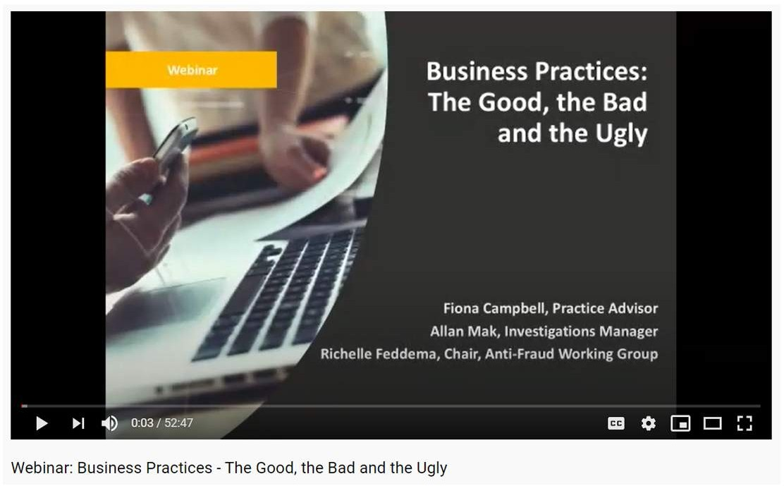

The College has a zero-tolerance policy when it comes to inappropriate business practices and insurance providers are keeping a watchful eye on practitioners and clinics. Whether you’re a physiotherapist, clinic owner, gym owner or another health professional, the best way to protect yourself is to ensure that you’re following good business practices — one hundred percent of the time.
On February 20, 2020, Fiona Campbell, Practice Advisor, Allan Mak, Investigations Manager and Richelle Feddema, an insurance industry representative and chair of a health care anti-fraud working group — shared real-life examples to highlight where people have gone wrong, chat about the investigations process and shared tips and tools to help you avoid common mistakes.

What does it mean to be delisted?

What is the impossible day?

What are some red ﬂags for insurance providers?

How can you recognize and correct billing errors?

3

Everything You Need to Know About the Rules

On March 10, 2020, Senior Physiotherapist Advisor, Fiona Campbell, PT and Registrar, Rod Hamilton shared trends the College is seeing, discussed the rules and standards and answered questions.

The webinar provided practical advice, answers to your questions on best practices, and shared examples where other people have gone wrong to help you avoid those same pitfalls.

College YouTube Channel

Be sure to subscribe to our YouTube Channel for updates on College content or learn more about College Webinars.

Strategies to Help Patients Dealing with Mental Health
WATCH THE WEBINAR

Business Practices: The Good, the Bad and the Ugly
WATCH THE WEBINAR

Everything You Need to Know About the Rules
WATCH THE WEBINAR

Frequently Asked Questions Videos
In an effort to improve the accessibility and availability of resources, we created a series of digestible, easy to understand videos answering some top questions that PTs ask our practice advice team. Find answers to frequently asked questions (FAQs) below.

How much can a PT charge to provide a patient with a copy of their record? What is a PT responsible for when assigning care to an assistant?
Can a physiotherapist treat a family member?

Can a physiotherapist give gift cards for patient referrals? Can a physiotherapist start a practice in their own home?

YOUTUBE

We believe that tangible examples help to bring
the standards to life and will ultimately improve
the knowledge of physiotherapists and the quality of patient care.
Check out a full series of Frequently Asked Questions videos, along with many other resources, on our YouTube channel.

“I appreciate the College website and all the videos and resources
that are available, facilitating adherence to standards. As a manager of other clinicians, I regularly recommend that they review the College website and attend webinars because I ﬁnd both the website
and the webinars to be a value!”

CONTI NUE

Welcome Kits

We want to ensure that new physiotherapists are entering the profession with the knowledge and skills they need to deliver safe, competent and ethical care. To accomplish this, we need to make sure that new graduates and registrants of the College are aware of the rules and standards that guide their practice, as well as the wealth of resources available to support them.

We created two comprehensive digital welcome kits, one for physiotherapists registering for an Independent Practice Certiﬁcate of Registration, and one or Physiotherapy Residents registering for a Provisional Practice Certiﬁcate of Registration.

These welcome kits are interactive and help raise awareness of the College, highlight key standards and responsibilities, and helpful resources that can be used throughout a PT’s career.

Welcome New PTs Guide: welcome.collegept.org

Welcome New Physiotherapy Residents Guide: welcomeprovisional.collegept.org

WELCOME PACKAGE

'Welcome Package' by College of Physiotherapists of Ontario
Built with Readymag-a tool to design anything on the web.
READ MORE WELCOME PACKAGE 

PROVISIONAL PRACTICE - WELCOME PACKAGE

'Provisional Practice - Welcome Package' by College of Physiotherapists of Ontario
Built with Readymag-a tool to design anything on the web.
READ MORE PROVISIONAL PRACTICE - WELCOME PACKAGE 
CONTI NUE

E-Learning Modules: Bringing the Standards to Life

We have been hard at work creating interactive e-learning modules to help highlight some of our key standards. E-learning modules are a great tool for new PTs, students and even experienced physiotherapists who want to brush up on their skills, test their knowledge and see elements of the standards featured in relatable scenarios. Our goal is to create supportive resources for as many standards as possible to help all PTs better understand their obligations.

This past year we created a brand-new Working with Physiotherapist Assistants E-Learning Module, as well as a refreshed Ethics E-Learning Module.

We are pleased to offer these e-learning modules in English, French and audio formats to make them accessible to the widest possible audience.

Be sure to check them out! Next, we plan to create an e-learning module for the Boundaries and Sexual Abuse Standard so keep an eye on the website for more information.

Ethics E-Learning Module
REVIEW MODULE

Working with Physiotherapist Assistants E-Learning Module
REVIEW MODULE

Annual Renewal

In light of the extraordinary circumstances and the ﬁnancial hardships that many physiotherapists experienced as a result of the COVID-19 pandemic, Council made the decision to extend the 2020 Annual Renewal deadline. Council is sympathetic to the challenges many PTs have faced after being forced to close, severely limit or adjust their practice, and is hopeful that the extension will help to ease the ﬁnancial burden.

Up until the extension, the online renewal process was running smoothly, and we are appreciative of all physiotherapists who renewed before the deadline was changed.

“I just completed the renewal and the PISA. I just wanted to say thank you for making it a smooth process. I really appreciate having access to the rules, standards, checklists, and other important information in a user friendly and accessible format. Good job!”
CONTI NUE

Quality Assurance Program Update

In accordance with the Regulated Health Professions Act (RHPA), the College is required to have a Quality Assurance program.

1

The program is designed to:

Promote continuing competence and continuing quality improvement among physiotherapists

Address changes in practice environments

Incorporate standards of practice, advances in technology, changes made to entry to practice competencies and other relevant issues at the discretion of Council

2

The program must include:

Self, peer and practice assessments

A mechanism for the College to monitor registrants’ participation in, and compliance with, the quality assurance program

3

We continue to work on the redevelopment of our Quality Assurance program. Highlights of the new program include:

The selection of physiotherapists is no longer random. PTs will be selected to participate in the process based on when they last completed a practice assessment. This means that physiotherapists who have not completed a practice assessment in a while will be selected ﬁrst. Once a PT completes the process, they are moved to the bottom of the selection list.

Physiotherapists will be selected for a practice assessment once every 10 to 12 years, which means every PT should complete at least one assessment during their career.

The streamlined process is much less time-consuming for physiotherapists. Those who are selected will complete a screening questionnaire following by a one-hour assessment conducted virtually/remotely.

4

Depending on Results and Outcome

Depending on the results of the remote assessment, a physiotherapist may be asked to participate in a more comprehensive on-site assessment to further explore areas of improvement in their practice. During the on-site assessment, an assessor will visit the PT’s workplace to ask questions, run through practice scenarios and review patient charts. The assessor then completes a report which is shared with the Quality Assurance Committee for review.

Depending on the outcome of the report, the Committee may determine that the physiotherapist has additional learning requirements that should be addressed with a tailored practice enhancement program. This program may include coaching sessions or a review of College materials such as learning modules.

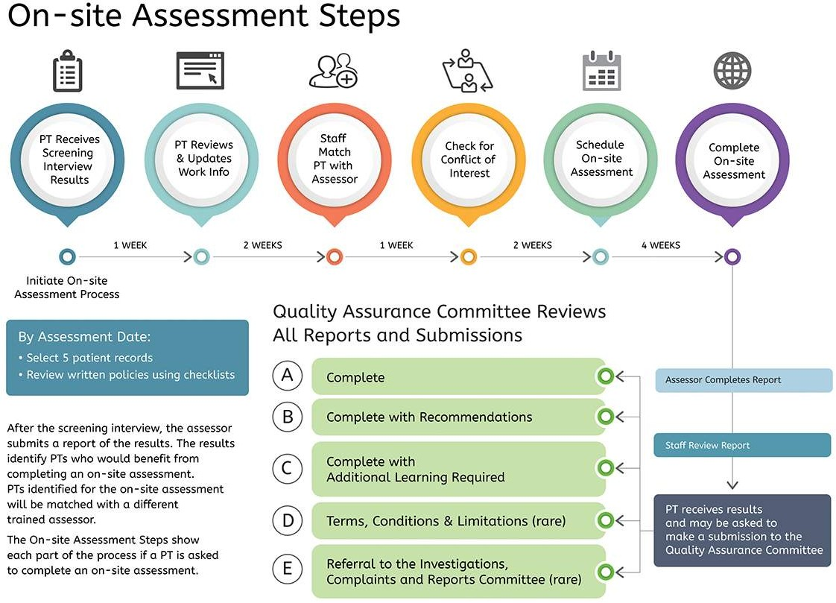

Step 1
Screening Interview Results

The College will email the PT your screening interview report and inform the PT if they are required to complete an on-site assessment.

Step 2
Your Matched Assessor and Observer

Within two weeks you will be matched with two assessors. One assessor will conduct the on-site assessment and the second assessor will act as an observer. Assessors are registrants of the College who have been appointed and trained to conduct practice assessments.

The College asks the PT to complete a conﬂict of interest check with both the assessor and the observer.

If a conﬂict of interest exists, the PT will be re-matched, and will complete the conﬂict of interest process again.

Step 3
Schedule a Date

If no conﬂict of interest exists, the on-site assessment is scheduled. The on-site assessment will take approximately four hours and takes place at the employment site.

Step 4
Prepare the Necessary Documents

Before the on-site assessment, the PT prepares by gathering certain documents for the assessor to review. The PT selects ﬁve patient charts and provides access to the completed checklists and the written policies.

Step 5
Complete the On-site Assessment

The on-site assessment will include the following components:

Introduction

Review of written policies and checklists

Review of three to ﬁve patient charts

Behaviour-based interview: case-based questions

Behaviour-based interview: situation-based questions

Feedback and discussion

Closing

Step 6
Staff Review

The on-site assessment is in the pilot test phase. College staff would normally review reports within two weeks. Due to additional checks and reviews that need to occur during the pilot, the staff review may take longer than two weeks.

Step 7
The Results

The PT will receive an email with the results of the on-site assessment and be able to view the report.

On-Site Assessment Pilot

A group of physiotherapists were selected to participate in a pilot project to test the framework for the new Quality Assurance program. In January 2020, physiotherapists began completing on-site assessments as part of the pilot project. The majority of on-site assessments were completed prior to COVID restrictions being implemented in March 2020 and the remainder of the assessments will be conducted when it is safe to do so.

We are now in the ﬁnal stages of reviewing the feedback from the pilot project to make adjustments and improvements to the practice assessment before rolling it out to all physiotherapists.

Here is a snapshot of the feedback we have received so far:

“The assessor was kind and respectful, made me feel at ease.”
-

“Both assessors were very professional, thorough and to the point.”
-

“The assessment was an eye opener in many ways, both professionally and personally. After the assessment I was thankful I was chosen as it gave me opportunities to learn both from it and after it.”
-

“The assessment process allowed me to reﬂect on my practices, it has helped me to understand and develop a process of obtaining consent.”
-

CONTI NUE

- of 10
Financial Statements
College of Physiotherapists of Ontario

Annual Report (April 1, 2019 to March 31, 2020)

Contact the College

The ﬁnancial statements are available for viewing or downloading.

For a complete set of audited ﬁnancial statements or an accessible format of the ﬁnancial statements, contact Zoe Robinson, Director, Corporate Services at zrobinson@collegept.org
or 1-800-583-5885 ext. 244.

College of Physiotherapists of Ontario Financial Statements 2020.pdf
440.3 KB

COLLEGE OF PHYSIOTHERAPISTS OF ONTARIO

FINANCIAL STATEMENTS
MARCH 31, 2020

Independent Auditor's Report
To the Council of the College of Physiotherapists of Ontario
Opinion
We have audited the financial statements of the College of Physiotherapists of Ontario (the "College"), which comprise the statement of financial position as at March 31, 2020, and the statements of operations, changes in net assets and cash flows for the year then ended, and notes to the financial statements, including a summary of significant accounting policies.
In our opinion, the accompanying financial statements present fairly, in all material respects, the financial position of the College as at March 31, 2020, and the results of its operations and its cash flows for the year then ended in accordance with Canadian accounting standards for not-for-profit organizations.
Basis for Opinion
We conducted our audit in accordance with Canadian generally accepted auditing standards. Our responsibilities under those standards are further described in the Auditor's Responsibilities for the Audit of the Financial Statements section of our report. We are independent of the College in accordance with the ethical requirements that are relevant to our audit of the financial statements in Canada, and we have fulfilled our other ethical responsibilities in accordance with these requirements. We believe that the audit evidence we have obtained is sufficient and appropriate to provide a basis for our opinion.
Responsibilities of Management and Those Charged with Governance for the Financial Statements
Management is responsible for the preparation and fair presentation of the financial statements in accordance with Canadian accounting standards for not-for-profit organizations, and for such internal control as management determines is necessary to enable the preparation of financial statements that are free from material misstatement, whether due to fraud or error.
In preparing the financial statements, management is responsible for assessing the ability of the College to continue as a going concern, disclosing, as applicable, matters related to going concern and using the going concern basis of accounting unless management either intends to liquidate the College or to cease operations, or has no realistic alternative but to do so.
Those charged with governance are responsible for overseeing the financial reporting process of the College.
Auditor's Responsibilities for the Audit of the Financial Statements
Our objectives are to obtain reasonable assurance about whether the financial statements as a whole are free from material misstatement, whether due to fraud or error, and to issue an auditor's report that includes our opinion. Reasonable assurance is a high level of assurance, but is not a guarantee that an audit conducted in accordance with Canadian generally accepted auditing standards will always detect a material misstatement when it exists. Misstatements can arise from fraud or error and are considered material if, individually or in the aggregate, they could reasonably be expected to influence the economic decisions of users taken on the basis of the financial statements.
As part of an audit in accordance with Canadian generally accepted auditing standards, we exercise professional judgment and maintain professional skepticism throughout the audit. We also:
- Identify and assess the risks of material misstatement of the financial statements, whether due to fraud or error, design and perform audit procedures responsive to those risks, and obtain audit evidence that is sufficient and appropriate to provide a basis for our opinion. The risk of not detecting a material misstatement resulting from fraud is higher than for one resulting from error, as fraud may involve collusion, forgery, intentional omissions, misrepresentations, or the override of internal control.

Independent Auditor's Report (continued)

Auditor's Responsibilities for the Audit of the Financial Statements (continued)
- Obtain an understanding of internal control relevant to the audit in order to design audit procedures that are appropriate in the circumstances, but not for the purpose of expressing an opinion on the effectiveness of the internal control of the College.
- Evaluate the appropriateness of accounting policies used and the reasonableness of accounting estimates and related disclosures made by management.
- Conclude on the appropriateness of management's use of the going concern basis of accounting and, based on the audit evidence obtained, whether a material uncertainty exists related to events or conditions that may cast significant doubt on the ability of the College to continue as a going concern. If we conclude that a material uncertainty exists, we are required to draw attention in our auditor's report to the related disclosures in the financial statements or, if such disclosures are inadequate, to modify our opinion. Our conclusions are based on the audit evidence obtained up to the date of our auditor's report. However, future events or conditions may cause the College to cease to continue as a going concern.
- Evaluate the overall presentation, structure and content of the financial statements, including the disclosures, and whether the financial statements represent the underlying transactions and events in a manner that achieves fair presentation.
We communicate with those charged with governance regarding, among other matters, the planned scope and timing of the audit and significant audit findings, including any significant deficiencies in internal control that we identify during our audit.
We also provide those charged with governance with a statement that we have complied with relevant ethical requirements regarding independence, and to communicate with them all relationships and other matters that may reasonably be thought to bear on our independence, and where applicable, related safeguards.
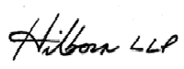

Toronto, Ontario Chartered Professional Accountants
September 23, 2020 Licensed Public Accountants

COLLEGE OF PHYSIOTHERAPISTS OF ONTARIO
Statement of Financial Position
March 31 | 2020  $ | 2019  $
ASSETS
Current assets Cash | 4,497,763 | 7,035,323
Investments (note 3) | 951,365 | 722,934
Prepaid expenses | 347,043 | 277,988
 | 5,796,171 | 8,036,245
Investments (note 3) | 4,082,425 | 4,204,278
Capital assets (note 4) | 698,619 | 838,479
 | 4,781,044 | 5,042,757
 | 10,577,215 | 13,079,002
LIABILITIES
Current liabilities  Accounts payable and accrued liabilities (note 5) | 922,789 | 1,338,418
Deferred registration fees | 3,331,608 | 5,638,274
 | 4,254,397 | 6,976,692
Deferred lease incentives (note 6) | 192,010 | 219,118
 | 4,446,407 | 7,195,810
NET ASSETS
Invested in capital assets | 506,609 | 619,361
Internally restricted for complaints and discipline (note 8) | 1,000,000 | 1,000,000
Internally restricted for sexual abuse therapy (note 9) | 100,000 | 100,000
Internally restricted for strategic initiatives (note 10) | - | 500,000
Internally restricted for IT improvements (note 11) | - | 250,000
Unrestricted | 4,524,199 | 3,413,831
 | 6,130,808 | 5,883,192
 | 10,577,215 | 13,079,002
The accompanying notes are an integral part of these financial statements
Approved on behalf of the Council:
President Darryn Mandel

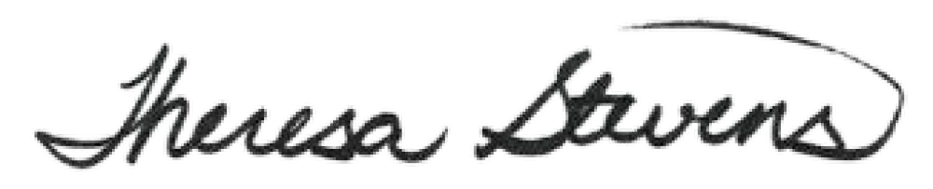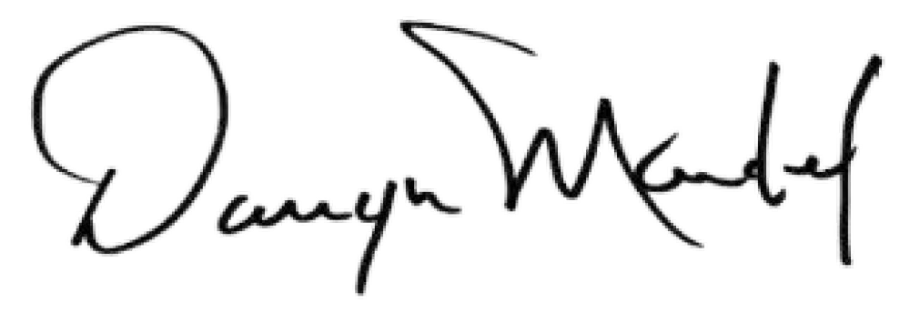Vice-President Theresa Stevens

COLLEGE OF PHYSIOTHERAPISTS OF ONTARIO
Statement of Operations
Year ended March 31 | 2020 | 2019
 | $ | $
Revenues
Registration fees | 6,029,601 | 5,839,607
Investment income | 188,264 | 169,878
 | 6,217,865 | 6,009,485
Expenses
Salaries and benefits | 3,443,196 | 3,635,617
Administration and office (note 6) | 936,685 | 965,201
Programs | 229,590 | 264,215
Communications | 119,596 | 153,867
Professional fees (note 7) | 366,662 | 555,352
Organizational effectiveness | 111,402 | 69,218
Committee fees and expenses | 273,969 | 270,712
Information technology | 290,782 | 467,149
Networking, representation and travel | 47,546 | 22,611
Amortization | 150,821 | 154,513
 | 5,970,249 | 6,558,455
Excess of revenues over expenses (expenses over revenues) for year | 247,616 | (548,970)
The accompanying notes are an integral part of these financial statements

COLLEGE OF PHYSIOTHERAPISTS OF ONTARIO
Statement of Changes in Net Assets

Year ended March 31 |  | Internally  restricted for | Internally | Internally
 | Invested in  capital | complaints  and | restricted for sexual abuse | restricted for  strategic | Internally restricted for IT |  | 2020
 | assets | discipline | therapy | initiatives | improvements | Unrestricted | Total
 | $ | $ | $ | $ | $ | $ | $
Balance, beginning of year | 619,361 | 1,000,000 | 100,000 | 500,000 | 250,000 | 3,413,831 | 5,883,192
Excess of revenues over expenses for year | - - - - |  |  |  | - | 247,616 | 247,616
Amortization of capital assets | (150,821) - - - |  |  |  | - | 150,821 | -
Amortization of deferred lease incentives | 27,108 - - - |  |  |  | - | (27,108) | -
Purchase of capital assets | 10,961 - - - |  |  |  | - | (10,961) | -
Internally imposed restrictions | - - - (500,000) |  |  |  | (250,000) | 750,000 | -
(notes 10 and 11)
Balance, end of year | 506,609 | 1,000,000 | 100,000 | - | - | 4,524,199 | 6,130,808
Year ended March 31 |  | Internally restricted for | Internally | Internally
 | Invested in  capital | complaints  and | restricted for  sexual abuse | restricted for  strategic | Internally  restricted for IT |  | 2019
 | assets | discipline | therapy | initiatives | improvements | Unrestricted | Total
 | $ | $ | $ | $ | $ | $ | $
Balance, beginning of year | 719,349 | 1,000,000 | 100,000 | 500,000 | 250,000 | 3,862,813 | 6,432,162
Excess of expenses over revenues for year | - | - - - - |  |  |  | (548,970) | (548,970)
Amortization of capital assets | (154,513) | - - - - |  |  |  | 154,513 | -
Amortization of defered lease incentives | 27,107 | - - - - |  |  |  | (27,107) | -
Purchase of capital assets | 27,418 | - - - - |  |  |  | (27,418) | -
Balance, end of year 619,361 1,000,000 100,000 500,000 250,000 3,413,831 5,883,192

The accompanying notes are an integral part of these financial statements

5

COLLEGE OF PHYSIOTHERAPISTS OF ONTARIO
Statement of Cash Flows

Year ended March 31 2020 2019
$ $

Cash flows from operating activities
Excess of revenues over expenses (expenses over revenues) for
year 247,616 (548,970)
Adjustments to determine net cash provided by (used in) operating
activities  Amortization of capital assets | 150,821 | 154,513
Interest capitalized on investments | (92,152) | (73,881)
Interest received on investments capitalized in prior years | 58,013 | 148,583
Amortization of deferred lease incentives | (27,108) | (27,107)
Change in non-cash working capital items | 337,190 | (346,862)
Increase in prepaid expenses | (69,055) | (17,209)
Increase (decrease) in accounts payable and accrued liabilities | (415,629) | 711,491
Increase (decrease) in deferred registration fees | (2,306,666) | 775,523
 | (2,454,160) | 1,122,943
Cash flows from investing activities Purchase of investments | (745,621) | (1,228,622)
Proceeds from disposal of investments | 673,182 | 1,049,360
Purchase of capital assets | (10,961) | (27,418)
 | (83,400) | (206,680)
Net change in cash | (2,537,560) | 916,263
Cash, beginning of year | 7,035,323 | 6,119,060
Cash, end of year | 4,497,763 | 7,035,323
The accompanying notes are an integral part of these financial statements

COLLEGE OF PHYSIOTHERAPISTS OF ONTARIO
Notes to Financial Statements

March 31, 2020

Nature and description of the organization

The College of Physiotherapists of Ontario (the "College") was incorporated as a non-share capital corporation under the Regulated Health Professions Act, 1991 ("RHPA"). As the regulator and governing body of the physiotherapy profession in Ontario, the major function of the College is to administer the Physiotherapy Act, 1991 in the public interest.

The College is a not-for-profit organization, as described in Section 149(1)(l) of the Income Tax Act, and therefore is not subject to income taxes.

  - Significant accounting policies

These financial statements have been prepared in accordance with Canadian accounting standards for not-for-profit organizations and include the following significant accounting policies:

    - Revenue recognition Registration fees
Registration fees are recognized as revenue in the fiscal year to which they relate. The registration year of the College coincides with that of the fiscal year of the College, being April 1 to March 31. Registration fees received in advance of the fiscal year to which they relate are recorded as deferred registration fees.

Investment income

Investment income comprises interest from cash and investments and realized gains and losses from the disposal of investments.

Revenue is recognized on an accrual basis. Interest on investments is recognized over the terms of the investments using the effective interest method.

    - Investments

Investments consist of guaranteed investment certificates and fixed income investments whose term to maturity is greater than three months from date of acquisition. Investments that mature within twelve months from the year-end date are classified as current.

COLLEGE OF PHYSIOTHERAPISTS OF ONTARIO
Notes to Financial Statements (continued)

March 31, 2020

1. Significant accounting policies (continued)

    - Capital assets

The costs of capital assets are capitalized upon meeting the criteria for recognition as a capital asset, with the exception of expenditures on internally generated intangible assets during the development phase, which are expensed as incurred. The cost of a capital asset comprises its purchase price and any directly attributable cost of preparing the asset for its intended use.

Capital assets are measured at cost less accumulated amortization and accumulated impairment losses.

Amortization is provided for, upon commencement of the utilization of the assets, on a straight-line basis at rates designed to amortize the cost of the capital assets over their estimated useful lives. The annual amortization rates are as follows:

Furniture and fixtures 5 years
Computer equipment 3 years
Computer software 2 years

Amortization of leasehold improvements is provided for on a straight-line basis over the remaining term of the lease.

A capital asset is tested for impairment whenever events or changes in circumstances indicate that its carrying amount may not be recoverable. If any potential impairment is identified, the amount of the impairment is quantified by comparing the carrying value of the capital asset to its fair value. Any impairment of the capital asset is recognized in income in the year in which the impairment occurs.

An impairment loss is not reversed if the fair value of the capital asset subsequently increases.

    - Deferred lease incentives

Lease incentives consist of tenant inducements received in cash used to purchase capital assets.

Lease incentives received in connection with original leases are amortized to income on a straight-line basis over the terms of the original leases. Lease incentives received in connection with re-negotiated leases are amortized to income on a straight-line basis over the period from the expiration date of the original lease to the expiration date of the re- negotiated lease.

    - Net assets invested in capital assets

Net assets invested in capital assets comprises the net book value of capital assets less the unamortized balance of deferred tenant inducements used to purchase capital assets.

COLLEGE OF PHYSIOTHERAPISTS OF ONTARIO
Notes to Financial Statements (continued)

March 31, 2020

1. Significant accounting policies (continued)

    - Financial instruments

Measurement of financial assets and liabilities

The College initially measures its financial assets and financial liabilities at fair value adjusted by the amount of transaction costs directly attributable to the instrument.

The College subsequently measures all of its financial assets and financial liabilities at amortized cost.

Amortized cost is the amount at which a financial asset or financial liability is measured at initial recognition minus principal repayments, plus or minus the cumulative amortization of any difference between that initial amount and the maturity amount, and minus any reduction for impairment.

Financial assets measured at amortized cost include cash and investments.

Financial liabilities measured at amortized cost include accounts payable and accrued liabilities.

Impairment

At the end of each year, the College assesses whether there are any indications that a financial asset measured at amortized cost may be impaired. Objective evidence of impairment includes observable data that comes to the attention of the College, including but not limited to the following events: significant financial difficulty of the issuer; a breach of contract, such as a default or delinquency in interest or principal payments; and bankruptcy or other financial reorganization proceedings.

When there is an indication of impairment, the College determines whether a significant adverse change has occurred during the year in the expected timing or amount of future cash flows from the financial asset.

When the College identifies a significant adverse change in the expected timing or amount of future cash flows from a financial asset, it reduces the carrying amount of the financial asset to the greater of the following:

- the present value of the cash flows expected to be generated by holding the financial asset discounted using a current market rate of interest appropriate to the financial asset; and

- the amount that could be realized by selling the financial asset at the statement of financial position date.

COLLEGE OF PHYSIOTHERAPISTS OF ONTARIO
Notes to Financial Statements (continued)

March 31, 2020

- Significant accounting policies (continued)

- Financial instruments (continued) Impairment (continued)
Any impairment of the financial asset is recognized in income in the year in which the impairment occurs.

When the extent of impairment of a previously written-down financial asset decreases and the decrease can be related to an event occurring after the impairment was recognized, the previously recognized impairment loss is reversed to the extent of the improvement, but not in excess of the impairment loss. The amount of the reversal is recognized in income in the year the reversal occurs.

- Management estimates

The preparation of financial statements in conformity with Canadian accounting standards for not-for-profit organizations requires management to make judgments, estimates and assumptions that affect the application of accounting policies and the reported amounts of assets and liabilities and the disclosure of contingent assets and liabilities at the date of the financial statements and the reported amounts of revenues and expenses during the current year. Actual results may differ from these estimates, the impact of which would be recorded in future years.

Estimates and underlying assumptions are reviewed on an ongoing basis. Revisions to accounting estimates are recognized in the year in which the estimates are revised and in any future years affected.

- Financial instrument risk management

The College is exposed to various risks through its financial instruments. The following analysis provides a measure of the College's risk exposure and concentrations.

The financial instruments of the College and the nature of the risks to which those instruments may be subject, are as follows:
Risks
Financial instrument | Credit | Liquidity | Market risk  Currency Interest rate Other price
Cash | X |  | X
Investments  Accounts payable and accrued liabilities | X | X | X

COLLEGE OF PHYSIOTHERAPISTS OF ONTARIO
Notes to Financial Statements (continued)

March 31, 2020

2. Financial instrument risk management (continued) Credit risk
The College is exposed to credit risk resulting from the possibility that parties may default on their financial obligations, or if there is a concentration of transactions carried out with the same party, or if there is a concentration of financial obligations which have similar economic characteristics that could be similarly affected by changes in economic conditions, such that the College could incur a financial loss. The College does not hold directly any collateral as security for financial obligations of counterparties.

The maximum exposure of the College to credit risk is as follows:
2020 2019
$ $

Cash 4,497,763 7,035,323
Investments 5,033,790 4,927,212

9,531,553 11,962,535

The College reduces its exposure to the credit risk of cash by maintaining balances with a Canadian financial institution.

The College manages its exposure to the credit risk of investments through its investment policy which restricts the types of eligible investments.

Liquidity risk

Liquidity risk is the risk that the College will not be able to meet a demand for cash or fund its obligations as they come due.

The liquidity of the College is monitored by management to ensure sufficient cash is available to meet liabilities as they come due.

Market risk

Market risk is the risk that the fair value or future cash flows of a financial instrument will fluctuate because of changes in market prices. Market risk is comprised of currency risk, interest rate risk and other price risk.

Currency risk

Currency risk refers to the risk that the fair value of financial instruments or future cash flows associated with the instruments will fluctuate due to changes in foreign exchange rates.

The College is not exposed to currency risk.

Interest rate risk

Interest rate risk refers to the risk that the fair value of financial instruments or future cash flows associated with the instruments will fluctuate due to changes in market interest rates.

COLLEGE OF PHYSIOTHERAPISTS OF ONTARIO
Notes to Financial Statements (continued)

March 31, 2020

- Financial instrument risk management (continued) Other price risk
Other price risk refers to the risk that the fair value of financial instruments or future cash flows associated with the instruments will fluctuate because of changes in market prices (other than those arising from currency risk or interest rate risk), whether those changes are caused by factors specific to the individual instrument or its issuer or factors affecting all similar instruments traded in the market.

The College is not exposed to other price risk.

Changes in risk

There have been no significant changes in the risk profile of the financial instruments of the College from that of the prior year.

- Investments

2020 2019
$ $

Current | 951,365 | 722,934
Long-term | 4,082,425 4,204,278
5,033,790 |  | 4,927,212

Investments have effective interest rates ranging from 1.50% to 3.55% (2019 - 1.50% to 3.55%), and maturity dates ranging from May 2020 to January 2025 (2019 - May 2019 to September 2024).

- Capital assets

Cost
Accumulated Amortization
2020
Net

$ $ $

Furniture and fixtures 345,134 214,417 130,717
Computer equipment 36,047 35,813 234
Leasehold improvements 793,263 225,595 567,668

1,174,444 475,825 698,619

COLLEGE OF PHYSIOTHERAPISTS OF ONTARIO
Notes to Financial Statements (continued)

March 31, 2020

4. | Capital assets (continued) | Cost | Accumulated Amortization | 2019  Net
 |  | $ | $ | $
 | Furniture and fixtures | 346,854 | 151,381 | 195,473
 | Computer equipment | 75,325 | 68,823 | 6,502
 | Computer software | 7,941 | 7,941 | -
 | Leasehold improvements | 782,302 | 145,798 | 636,504
 |  | 1,212,422 | 373,943 | 838,479

During the year, capital assets with a net book value of nil (cost and accumulated amortization both of $48,939) were disposed of for no gain or loss.

During the prior year, capital assets with a net book value of nil (cost and accumulated amortization both of $8,077) were disposed of for no gain or loss.

- Accounts payable and accrued liabilities

2020 2019
$ $

Trade payables and accrued liabilities | 410,755 |  | 765,317
Accrued liabilities - complaints and discipline |  | 512,034 573,101
 |  | 922,789 1,338,418
6. Deferred lease incentives |  | Accumulated 2020
 | Cost  $ | Amortization Net  $ $
Tenant inducements | 271,073 | 79,063 192,010
 | Cost | Accumulated 2019  Amortization Net
 | $ | $ $
Tenant inducements | 271,073 | 51,955 219,118

Pursuant to the lease agreement for the College's office premises (note 12), lease incentives comprised of tenant inducements in the amount of $271,073 were received in the year the lease commenced.

Amortization of lease incentives in the amount of $27,108 (2019 - $27,017) was credited to administration and office expense in the current year.

COLLEGE OF PHYSIOTHERAPISTS OF ONTARIO
Notes to Financial Statements (continued)

March 31, 2020

- Professional fees

2020 2019
$ $

Complaints and discipline 353,489 512,646
Cost recoveries (58,083) (34,556)

295,406 478,090
Other professional 71,256 77,262

366,662 555,352

- Net assets internally restricted for complaints and discipline

The College makes best efforts to anticipate the costs associated with complaints and discipline matters based on past experience and current caseload. However, in the event that the College incurs costs beyond the normal scope of such matters, the Council of the College has internally restricted net assets to fund expenditures related to these matters.

The internal restriction is subject to the direction of the Council upon the recommendation of the Finance Committee.

- Net assets internally restricted for sexual abuse therapy

The Council of the College has internally restricted net assets to meet the anticipated future requirements of the College for sexual abuse therapy.

The internal restriction is subject to the direction of the Council upon the recommendation of the Finance Committee.

- Net assets internally restricted for strategic initiatives

The Council of the College previously internally restricted net assets to meet the anticipated future requirements of the College for strategic initiatives.

In the current year, the Council of the College ceased the internal restriction of net assets for strategic initiatives and approved the transfer of $500,000 from net assets internally restricted for strategic initiatives to unrestricted net assets.

- Net assets internally restricted for IT improvements

The Council of the College previously internally restricted net assets to meet the anticipated future requirements of the College for IT improvements.

In the current year, the Council of the College ceased the internal restriction of net assets for IT improvements and approved the transfer of $250,000 from net assets internally restricted for IT improvements to unrestricted net assets.

- Commitment

The College is committed to lease its office premises until February 28, 2027. The future annual lease payments, including an estimate of premises common area expenses, are as follows:

COLLEGE OF PHYSIOTHERAPISTS OF ONTARIO
Notes to Financial Statements (continued)

March 31, 2020

12. | Commitment (continued)
 |  | $
 | 2021 | 500,664
 | 2022 | 511,959
 | 2023 | 512,986
 | 2024 | 524,281
 | 2025 | 525,307
 | Subsequent years | 1,028,488
 |  | 3,603,685

- Subsequent events

Subsequent to the year end, the global pandemic of the virus known as COVID-19 led the Canadian Federal government, as well as provincial and local governments, to impose measures, such as restricting foreign travel, mandating self-isolations and physical distancing, and closing non-essential businesses. Because of the high level of uncertainty related to the outcome of this pandemic, it is difficult to estimate the financial effect, if any, on the College. No adjustments have been made in the financial statements as a result of these events.

H I L B O R N
LI S T E N E R S. THINKERS. DOE R S.

40 1 Say Street· Su1'ce 3100 · P.O. Box 49 · To ron to · Oi ·CA· iviSH 2Y4 · ? 416 -3 64 -1 359 · F416-3 64 - 9503 · hiibornca.com

- of 10

Program Review
College of Physiotherapists of Ontario

Practice Advice

Information Service
Patients, caregivers, physiotherapists, students, assistants, employers, insurers, and others can contact the College for conﬁdential advice about the practice of physiotherapy. This service is offered to support quality of practice and to help the public better understand their rights as physiotherapy patients.

Watch our Video: What is a Physiotherapy Information Advisor?

Practice Advice Team

In 2019-2020 the number of inquiries to the Information Service was 6,120, in comparison to 5,410 in 2018-2019.
This was a 13% increase.

Percentage Number of Calls

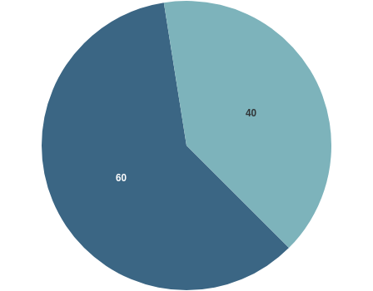

PTs

Patients, Insurers & Public

The percentage number of calls from PTs was 60% while 40% was from patients, insurers, public and others. There was a ~

10% increase in inquiries received from public sources.

Breakdown of Practice Advice Calls and Emails

 | 2018–2019 | 2019–2020
Q1 | 1,000 | 1,300
Q2 | 1,100 | 1,370
Q3 | 1,460 | 1,250
Q4 | 1,850 | 2,200
TOTAL | 5,410 | 6,120

Top Five Practice Advice Questions in 2019-2020

Practice Management (25%):
1
Billings requirements, Infection Prevention & Control, Starting & Leaving a Practice

Patient Care (17%):
2
Consent discussions, Performing Controlled Acts, Safety Concerns

Professional Obligations (13%):
3
Mandatory Reporting Obligations, Public Register Information, Practice Hours

Record Keeping (12%):
4
Privacy, Security and Access to patient Information, Documenting consent and an analysis

Supervision (10%):
5
Supervision of PTAs, students

Registration

The College is responsible for ensuring individuals applying to become registered physiotherapists in Ontario are qualiﬁed. Those who use the title physiotherapist, physical therapist or PT in Ontario must be registered with the College. To maintain a registration or licence, physiotherapists must renew annually. This ensures public safety.

In 2019-2020, there were 10,061 registrants,
of those, 588 were new.

New Registrants
There were 588 new registrants in 2019- 2020,
compared to 604 new registrants in 2018-
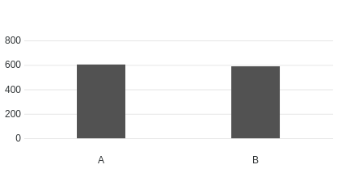
2019.
Number of Registrants
Year

A. 2018-2019 | 604

B. 2019-2020 | 588

Total Registrants
There were 10,061 total registrants in 2019- 2020,
compared to 9,537 total registrants in
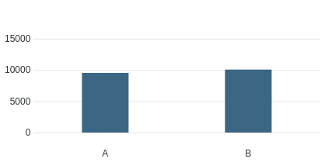
2018-2019.
Number of Registrants
Year

A. 2018-2019 | 9537

B. 2019-2020 | 10061

Top Five Source Countries for International Graduates

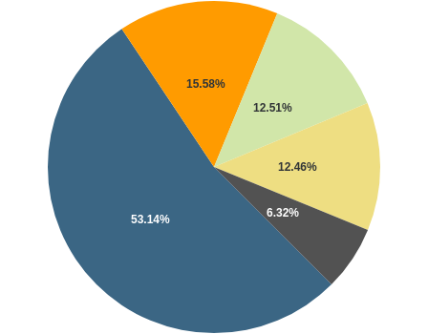
India: 1228

United Kingdom: 360

United States of America: 289 Philippines: 288
Australia: 146

Gender Breakdown of Registrants

Gender | Registrants
Female | 7168
Male | 2889

Gender | Registrants
X | 4

Registrant Education
There were 7165 registrants educated in Canada and 2896 educated outside of Canada.

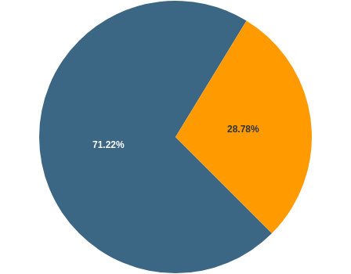

Educated in Canada Educated Outside of Canada

Canadian Labour Mobility (AIT)
48 individuals registered in Ontario using the
Canadian Free Trade Agreement (CFTA) provisions
between April 1, 2019 to March 31, 2020.

Registration Committee Decisions

 | 2018–2019 | 2019–2020
Total Number of Decisions | 7 | 14
Certiﬁcates Granted | 0 | 3
Certiﬁcate of Registration Granted with Additional Terms, Conditions and Limitations | 3 | 5

 | 2018–2019 | 2019–2020
Certiﬁcates Denied | 5 | 6

There was one appeal of a Registration Committee Decision to the Health Professions Appeal and Review
Board (HPARB), which is ongoing.

CONTI NUE

Quality Assurance

The Quality Assurance Committee did not have any new cases while the on-site assessment pilot completed. The new program was being launched and the pilot will be completed by the end of 2020.

246 PTs who had a screening interview (April – June 2019) received their results in the fall of 2019. The on-site assessment pilot started in January 2020 and 23/30 on-site assessments were completed as of March 13, 2020. Seven on-site assessments were deferred to the next ﬁscal year due to COVID-19.

Number of screening interviews completed: 246
1

Number of quality assurance ﬁles closed following the screening interview: 216
2

Number of physiotherapists referred to participate in an on-site assessment based on results of the screening interviews: 32
3

Number of physiotherapists deferred from the on-site assessment: 2
4

Number of on-site assessments completed between January 7, 2020 and March 13, 2020:
5
23

Number of matters considered by the QA Committee (includes where cases were discussed more than once): 0
6

Number of decisions issued by QA Committee: 0
7

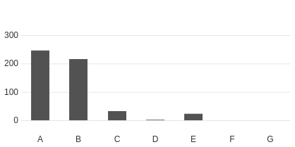
Quality Assurance

- Screening Interviews | 246

- Quality Assurance Files Closed | 216

- On-site Assessment Referrals | 32

- Number of PTs Deferred | 2

- On-site Assessments Completed | 23

- Considered by QA Committee | 0

- QA Committee Decisions | 0

CONTI NUE

Professional Conduct

The College of Physiotherapists of Ontario receives complaints and reports about the practice or conduct of physiotherapists. All complaints made by the public are investigated. The College Registrar may also initiate investigations where reported information suggests reasonable and probable grounds to believe a physiotherapist may have engaged in professional misconduct or is incompetent.

The results of investigations are considered by the Inquiries, Complaints and Reports Committee, which may take no action, order a range of educational or remedial activities, or refer a physiotherapist to the Discipline Committee or Fitness to Practise Committee for a hearing.

The College also receives information about individuals who are not registered to practice but refer to themselves as physiotherapists or physical therapists (holding out).

In 2019–2020, the College received 254 concerns about physiotherapists and individuals holding out. 132 of these matters were complaints ﬁled by members of the public. Of this number 81 individuals proceeded through the formal complaints process. The 51 matters that did not go through the complaints process in addition to the other 122 concerns brought to the College’s attention were considered by the Registrar to determine if the appointment of an investigator was warranted.

1

In 2019–2020, the College received 254 concerns about physiotherapists and individuals holding out.

2

132 of these matters were complaints ﬁled by members of the public. Of this number, 81 individuals proceeded through the formal complaints process.

3

The 51 matters that did not go through the complaints process, in addition to the other 122 concerns brought to the College’s attention, were considered by the Registrar to determine if the appointment of an investigator was warranted.

The College received the following concerns from physiotherapists and members of the public about physiotherapists:

Complaints

Mandatory reports—sexual abuse, termination, incapacity Self reports—offences, charges/conviction and bail conditions
Physiotherapists reporting that their names and registration numbers have been used inappropriately
Physiotherapists who failed to complete the Professional Issues Self Assessment (PISA) Other practice/conduct concerns

The Registrar appointed an investigator on 23 occasions in 2019-2020. Where an investigator was not appointed, the Registrar may have closed the ﬁle, issued an education letter, invited the physiotherapist to participate in an educational session or meeting with the Practice Advisor.

Dispositions of the Inquiries, Complaints and Reports Committee
* Some decisions may include more than one outcome.

 | 2018–2019 | 2019–2020
Total Decisions | 68 | 79
No Action | 26 | 29
Advice and Recommendations | 21 | 23
Caution | 6 | 2
Speciﬁed Continuing Education and Remediation Program (SCERP) | 1 | 1
Referral to Discipline Committee | 8 | 6
Referral to Fitness to Practise Committee | 0 | 0
SCERP and Caution | 2 | 2
Frivolous and Vexatious |  | 7
Caution and Undertaking |  | 1

 | 2018–2019 | 2019–2020
Undertakings | 2 | 5
SCERP and Undertaking | 1 | 1
Withdrawal | 1 | 2

Health Professions Appeal and Review Board (HPARB) Review Process (Complaints)

 | 2019–2020
Number of Cases Appealed to the Board | 10
Number of Decisions Received from HPARB | 7
Number of Decisions Conﬁrmed by HPARB | 6
Number of Decisions Returned for Reconsideration | 1
Number Withdrawn | 0

Hearings

2019–2020

 | 2019–2020
Number of Hearings | 10
Uncontested Hearings | 7
Contested Hearings | 3
Hearings Adjourned Sine Die | 0
Discipline Hearings Completed | 9
Findings of Professional Misconduct | 9
Fitness of Practise Hearings | 0
Findings of Incapacity | 0
Reinstatement of Hearings | 0

Divisional Court Reviews

 | 2019-2020
Divisional Court Reviews | 2

CONTI NUE

Patient Relations

The role of the Patient Relations Committee is to advise Council with respect to the patient relations program and to administer the program to provide funding for therapy and counselling to patients. The Committee is made up of two professional Council members, one public Council member and one member who is a physiotherapist registered with the College.

Funding for Therapy and Counselling
The College maintains a program to provide funding for therapy and/or counselling for individuals who have been sexually abused by a physiotherapist. Individuals can submit an application for funding to the College, and the applications are reviewed by the Patient Relations Committee.

The Patient Relations Committee met once
to consider one application for funding for therapy and counselling.

CONTI NUE

- of 10
Discipline Summaries 2019-2020
College of Physiotherapists of Ontario

Discipline Hearings
(April 1, 2019 to March 31, 2020)

In 2019–2020 there were nine Discipline Hearings that took place at the College of Physiotherapists of Ontario.

See a complete list of past Discipline Hearings and decisions by visiting CanLII.org or
www.collegept.org.

Be sure to visit the College’s Public Register, also known as Find a Physiotherapist to access important information before visiting a physiotherapist. All regulated healthcare providers have a similar Public Register on their College’s website. See a complete list of Public Registers at ontariohealthregulators.ca

 Please click on the name below to view the Discipline hearing details.

Cheung, Kang-Ming (Johnny) Registration #07298 Case: 2015 0311
–

On October 23, 2018, the Inquiries, Complaints and Reports Committee (ICRC) referred a matter involving Kang-Ming ( Johnny) Cheung to the Discipline Committee for a hearing. The hearing was held on September 24, 2019. Decisions of the Discipline Committee are posted on CanLII (www.canlii.org).

Overview of the Allegations

The allegations refer to the following headings of professional misconduct:

  - At all materials times, Kang-Ming ( Johnny) Cheung (Mr. Cheung) was a registered member of the College.

  - During the period January 1, 2012 and August 31, 2017, Mr. Cheung engaged in professional misconduct within the meaning of the following paragraphs of section 1 of the Professional Misconduct Regulation, O. Reg. 388/08:
paragraph 1 (failing to maintain the standards of the profession);

paragraph 18 (engaging in conduct or performing an act relevant to the practice of the profession that, having regard to all the circumstances, would reasonably be regarded by members as disgraceful, dishonourable or unprofessional);
paragraph 26 (failing to keep records in accordance with the standards of practice of the profession)
paragraph 27 (falsifying a record);

paragraph 28 (signing or issuing a document containing a statement that the member knows or ought to know contains a false or misleading statement);
paragraph 32 (submitting an account or charge for services that the member knows or ought to know is false or misleading); and
paragraph 33 (failing to take reasonable steps to ensure that any accounts submitted in the member’s name or billing number are fair and accurate).

Finding

At the conclusion of the hearing the panel found that Mr. Cheung had committed several acts of professional misconduct and they ordered the following penalty:
Requiring the Mr. Cheung to be reprimanded by the panel of the Discipline Committee at the conclusion of the hearing
Directing the Registrar to suspend the Mr. Cheung’s certiﬁcate of registration for a period of ten months, with ﬁve months of the suspension to be remitted provided the Member completes outlined remediation activities.
Mr. Cheung cannot practice as a physiotherapist assistant (PTA) during the period of the served suspension

Mr. Cheung is required to complete the ProBe ethics program and a standards review

Mr. Cheung is subject to a practice assessment, practice enhancement coaching and random re- assessments
Mr. Cheung is required to pay costs to the College in the amount of $8,000.00

You can read the full decision of the Discipline Committee of the College of Physiotherapists of Ontario at: www.canlii.ca
Fearman, H. Douglas Registration #04261 Case: 2017 0153 –
On January 31, 2018 the Inquiries, Complaints and Reports Committee referred a matter involving H Douglas Fearman to the Discipline Committee for a hearing. The hearing was held on May 13, 2019. The panel’s decision will be made available on CanLII (www.canlii.org).

Overview of the Allegations

The allegations refer to the following headings of professional misconduct:

- paragraph 1 (failing to maintain the standards of the profession);

- paragraph 10 (sexually abusing a patient);

- paragraph 18 (engaging in conduct or performing an act relevant to the practice of the profession that, having regard to all the circumstances, would reasonably be regarded by members as disgraceful, dishonourable or unprofessional);
- paragraph 19 (conduct unbecoming a physiotherapist);

- paragraph 32 (submitting an account or charge for services that the member knows or ought to know is false or misleading);
- paragraph 33 (failing to take reasonable steps to ensure that any accounts submitted in the member’s name or billing number are fair and accurate).

Finding:

At the conclusion of the hearing the panel found that Mr. Fearman had committed several act(s) of professional misconduct and they ordered the following penalty.
The College withdrew allegations related to paragraphs 10, 32 and 33

Requiring the Member to appear before the panel of the Discipline Committee to be reprimanded at the conclusion of the hearing on May 13, 2019.
Pursuant to the Member’s consent, directing the Member to pay $5,000 to the College’s fund for therapy/counselling for patients, to be paid by June 30, 2020.
Directing the Member to pay $5,000 in costs to the College by June 30, 2020.
In addition, Mr. Fearman signed an undertaking with the College in which he agreed never to apply or re-apply for membership, registration, licensure or similar status with the College as a physiotherapist or for a license to practice physiotherapy in Ontario or in another jurisdiction.

Additional information:

Mr. Fearman resigned his membership and certiﬁcate of registration with the College effective April 1, 2019.
Fong, Michael Registration #16156 Case: 2017 0119 and 2018 0237 –
Case 2017 0119
On October 23, 2018, the Inquiries, Complaints and Reports Committee (ICRC) referred a matter involving Michael Fong to the Discipline Committee for a hearing. This matter was heard on October 3, 2019.

Overview of the Allegations

- At all materials times, Michael Fong was a registered member of the College.
- During the period April 1, 2017 and September 30, 2018, Mr. Fong engaged in professional misconduct within the meaning of the following paragraphs of section 1 of the Professional Misconduct Regulation, O. Reg. 388/08:
paragraph 1 (failing to maintain the standards of the profession);

paragraph 4 (practicing the profession while the member’s certiﬁcate of registration has been suspended);
paragraph 13 (failing to reply appropriately or within a reasonable time to a written inquiry from the College);
paragraph 14 (contravening, by act or omission, the Physiotherapy Act, the Regulated Professional Act, 1991 or the regulations under either act); and

paragraph 18 (engaging in conduct or performing an act relevant to the practice of the profession that, having regard to all the circumstances, would reasonably be regarded by members as disgraceful, dishonourable or unprofessional);

Finding

At the conclusion of the hearing on October 3, 2019 the panel found that Mr. Fong had committed professional misconduct as deﬁned in paragraphs 1, 4, 13 and 18 of section 1 of Ontario Regulation 861/93 as amended, under the Physiotherapy Act, 1991.

Penalty

The Panel of the Discipline Committee ordered the following penalty and cost order:

Requiring the Mr. Fong to be reprimanded by the panel of the Discipline Committee at the conclusion of the hearing.
Directing the Registrar to suspend the Mr. Fong’s certiﬁcate of registration, effective October 3, 2019, until which time that he has successfully completed the ProBe ethics program.
Mr. Fong is required to participate in practice enhancement coaching upon his return to practice.

Mr. Fong cannot practice as a physiotherapist assistant (PTA) during the period of the served suspension.
Mr. Fong is required to pay costs to the College in the amount of $6,000.00.

This order is to be served concurrently with the penalty and cost order made in matter 2018-0237.

You can read the full decision of the Discipline Committee of the College of Physiotherapists of Ontario at: www.canlii.ca

Case 2018 0237
On May 24, 2019, the Inquiries, Complaints and Reports Committee (ICRC) referred a matter involving Michael Fong to the Discipline Committee for a hearing. This matter was heard on October 3, 2019.

Overview of the Allegations

- At all material times, Michael Fong was a registered member of the College.

- During the period October 1, 2016 and May 30, 2019, Mr. Fong engaged in professional misconduct within the meaning of the following paragraphs of section 1 of the Professional Misconduct Regulation, O. Reg. 388/08:
paragraph 1 (failing to maintain the standards of the profession);

paragraph 13 (failing to reply appropriately or within a reasonable time to a written inquiry from the College);
paragraph 14 (contravening, by act or omission, the Physiotherapy Act, the Regulated Professional Act, 1991 or the regulations under either act); and
paragraph 18 (engaging in conduct or performing an act relevant to the practice of the profession that, having regard to all the circumstances, would reasonably be regarded by members as disgraceful, dishonourable or unprofessional).

Finding

At the conclusion of the hearing on October 3, 2019 the panel found that Mr. Fong had committed professional misconduct as deﬁned in paragraphs 1, 13, 14 and 18 of section 1 of Ontario Regulation 861/93 as amended, under the Physiotherapy Act, 1991.

Penalty

The Panel of the Discipline Committee ordered the following penalty and cost order:

Requiring the Mr. Fong to be reprimanded by the panel of the Discipline Committee at the conclusion of the hearing.
Directing the Registrar to suspend the Mr. Fong’s certiﬁcate of registration, effective October 3, 2019, until which time that he has successfully completed the PROBE ethics program.
Mr. Fong is required to participate in practice enhancement coaching upon his return to practice.

Mr. Fong cannot practice as a physiotherapist assistant (PTA) during the period of the served suspension
Mr. Fong is required to pay costs to the College in the amount of $6,000.00.

This order is to be served concurrently with the penalty and cost order made in matter 2017-0119.

You can read the full decision of the Discipline Committee of the College of Physiotherapists of Ontario at: www.canlii.ca
Poling, Michael Registration #12205 Case: 2017 0151 –
Case 2017 0151

On December 10, 2018 the Inquiries, Complaints and Reports Committee (ICRC) referred a matter involving Michael Poling to the Discipline Committee for a hearing.

The hearing took place on March 2, 2020. This matter was resolved by way of an Agreed Statement of Facts and a Joint Submission on Penalty.

Finding

The Discipline Committee issued a decision on the ﬁnding on March 2, 2020, on penalty on March 2, 2020 and on costs on March 2, 2020.

After having considered all of the evidence, a panel of the Discipline Committee found Michael Poling to have committed the following acts of professional misconduct:
Paragraph 2 (Reg 861/93) and Paragraph 1 (Reg 388/08)(failing to maintain the standards of the profession);
Paragraph 8 (Reg 861/93) and Paragraph 5 (Reg 388/08)(practicing the profession while the Registrant is in a conﬂict of interest);
Paragraph 13 (Reg 861/93) and Paragraph 26 (Reg 388/08)(failing to keep records in accordance with the standards of practice of the profession);
Paragraph 16 (Reg 861/93) and Paragraph 28 (Reg 388/08)(signing or issuing a document that the Registrant knows or ought to know contains a false or misleading statement);
Paragraph 18 (Reg 861/93) and Paragraph 32 (Reg 388/08)(submitting an account or charge for services that the Registrant knows or ought to know is false or misleading);
Paragraph 24 (Reg 861/93) and Paragraph 15 (Reg 388/08) (contravening a provincial law relevant to the member’s suitability to practice the profession);
Paragraph 25 (Reg 861/93) and Paragraph 18 (Reg 388/08)(engaging in conduct or performing an act relevant to the practice of the profession that, having regard to all the circumstances, would reasonably be regarded by Registrants as disgraceful, dishonourable or unprofessional);
Paragraph 33 (Reg 388/08) (failing to take reasonable steps to ensure that any accounts submitted in the member’s name or billing number are fair and accurate).

Penalty

The panel of the Discipline Committee ordered the following penalty. That Mr. Poling: Receive a reprimand at the conclusion of the hearing (delivered on March 2, 2020)
Serve a suspension for the period of March 18, 2020 through to an including September 18, 2020. The suspension could be extended if Mr. Poling is unable to complete the remaining requirements
Complete a review of various College standards, tools and resources

Meet with a practice coach on two occasions Successfully complete the PROBE program Not work as a PTA while serving his suspension

The Committee also ordered Michael Poling to pay costs to the College in the amount of $8,000 to offset some of the costs associated with investigating and prosecuting this case.

As a part of the penalty the Committee also issued a reprimand which read as follows:

The panel has found that you engaged in professional misconduct. This sort of misconduct cannot be tolerated by the profession. Your actions have negatively affected the reputation of the physiotherapy profession, and actions such as these undermine public conﬁdence.

The public interest depends on the integrity of the profession and protecting the integrity of the profession demands a zero tolerance of inappropriate business practices. We would expect the strictest adherence to College standards, particularly by a PT who is also a clinic owner. We expect that, going forward, your practice will uphold the standards of the profession, and that we will not ﬁnd you before a panel of the Discipline Committee in the future.

Status

The physiotherapist is working on completing the following requirements of the order as outlined by the panel of the Discipline Committee:
The suspension

The review of the College standards, tools and resources The meetings with the practice coach
The PROBE program

You can read the full decision of the Discipline Committee of the College of Physiotherapists of Ontario at: www.canlii.ca
Roxon, Boanerges Jehoshaphat ("BJ") Registration #13140 Case: 2017 0050 –
On December 7, 2017, the Inquiries, Complaints and Reports Committee (ICRC) referred a matter involving Boanerges Jehoshaphat ("BJ") Roxon to the Discipline Committee for a hearing. This matter was heard on December 6 2018, March 25 2019 and September 9 & 10, 2019.

Overview of the Allegations

- At all material times Boanerges Jehoshaphat (“BJ”) Roxon was a registered member of the College.

- During the period of August 1, 2007 to July 31, 2008, Mr. Roxon engaged in professional misconduct within the meaning of the following paragraphs of section 1 of the Professional Misconduct Regulation, 0. Reg. 861/93:
paragraph 2 (failing to maintain the standards of the profession);

paragraph 23 (performing an act or making an omission inconsistent with the Physiotherapy Act 1991, the Regulated Health Professions Act, 1991, or the regulations under either of these acts); and
paragraph 25 (engaging in conduct or performing an act relevant to the practice of the profession that, having regard to all the circumstances, would reasonably be regarded by members as disgraceful, dishonourable or unprofessional)

- During the period of August 1, 2007 to July 31, 2008, the Member committed an act of professional misconduct under ss. 1(3), 1(4) and s.51(1)(b.1) of the Health Professions Procedural Code, being Schedule 2 to the Regulated Health Professions Act, 1991, S.O. 1991, c.18 (the “Code”).

Penalty

At the conclusion of the hearing the panel found that Mr. Roxon had committed several acts of professional misconduct. The College withdrew allegations related to paragraphs 23 and ss. 1(3), 1(4) and s.51(1) (b.1) of the Health Professions Procedural Code. The panel ordered the following penalty:
  - A reprimand

  - A suspension of two months. If remedial activities are not successfully completed within the required timelines, the suspension will continue until such time as they are successfully completed.
  - Successful completion of the PROBE Ethics program

  - Successful completion of research, ethics and boundaries training.

  - During his suspension, Mr. Roxon may only practice as a physiotherapy assistant under the supervision of an approved College registrant.
  - Mr. Roxon shall not supervise physiotherapy students or physiotherapists who hold a Provisional Practice Certiﬁcate until successful completion of the ProBe Ethics program and his training in research, ethics and boundaries. Mr. Roxon is required to pay costs to the College in the amount of $18, 000.

You can read the full decision of the Discipline Committee of the College of Physiotherapists of Ontario at: www.canlii.org

Shah, Samir Registration #12039 Case: 2011 0179 –
The following is a summary of a matter placed before a four member panel of the Discipline Committee of the College of Physiotherapists of Ontario on September 21, 2012.

In July 2011 the College received a mandatory report (termination) which prompted an investigation into Mr. Shah’s conduct. At the conclusion of the investigation the Inquiries, Complaints and Reports Committee of the College referred the matter to the Discipline Committee for a hearing.

At the hearing, Mr. Shah admitted to the facts contained in the agreed statement of facts and conﬁrmed that his actions constituted professional misconduct.

The Facts as Agreed to by the Parties

- At the material times, Mr. Shah was employed at ABC Company in Brampton, Ontario, doing in- home physiotherapy visits.
- On or about June 23, 2011, Mr. Shah acted inappropriately in relation to an elderly client who had fallen and become unconscious while Mr. Shah was at the client’s home.
- Mr. Shah failed to assess the client appropriately after the client fell.

- Mr. Shah quickly left the client’s home after the client fell, leaving the client’s wife to attend to her husband alone.
- Mr. Shah returned to the client’s home with an acquaintance after the ambulance arrived and Mr. Shah allowed the acquaintance to enter the client’s home without the client’s wife’s permission.
- Mr. Shah told the client’s wife that his acquaintance was his supervisor which was untrue.

- On or about June 24, 2011, Mr. Shah made a false verbal and written report to his employer regarding the incident of June 23, 2011, by reporting that he had stayed with the client, checked his vital signs and told the client’s wife to call 911, when in fact Mr. Shah did not do one or more of those things.

Summary of the Penalty as Ordered by the Panel

- Mr. Shah will receive a reprimand, the fact of which shall be recorded on the College register.

- Mr. Shah’s certiﬁcate of registration will be suspended for three months with six weeks suspended if Mr. Shah completes the PROBE ethics program within twelve months.
- There will be a term, condition and limitation on Mr. Shah’s certiﬁcate of registration requiring him to successfully complete the PROBE ethics course, at his own expense, within eighteen (18) months

of the date of the discipline panel’s order.

- There will be a term, condition and limitation on Mr. Shah’s certiﬁcate of registration requiring him to successfully complete, at his own expense, a one-on-one ethics course following the completion of the PROBE program.
- The Registrar will be directed to impose a term, condition and limitation on Mr. Shah’s certiﬁcate of registration requiring him to complete, at his own expense, a ﬁrst responder’s course approved by the Registrar, each year for the next three years.
- Mr. Shah is ordered to pay to the College costs in the amount of $4000.00 over a two year period.

Decision

The panel agreed that the facts set out in the agreed statement of facts would support a ﬁnding of professional misconduct and ordered a speciﬁed penalty consistent with the joint submission on penalty. In its decision and reasons the panel noted that it had considered both the aggravating and mitigating factors.
The panel concluded that the penalty was reasonable and in the public interest. The member cooperated with the College and by agreeing to the facts and proposed penalty, has accepted responsibility for his actions.
Soleman, Beshoy—Registration #15793 Case: 2017 0219 and 2018 0197 –
On December 5, 2018, the Inquiries, Complaints and Reports Committee (ICRC) referred a matter involving Beshoy Soleman to the Discipline Committee for a hearing. This matter was heard on October 18, 2019.

Overview of the Allegations

The allegations refer to the following headings of professional misconduct:

- At all material times Beshoy Soleman (“Mr. Soleman” or the “Member”) was registered as a Physiotherapist in the Province of Ontario.

- Between the period of September 1, 2017 and October 31, 2018, Mr. Soleman engaged in professional misconduct within the meaning of the following paragraphs of section 1 of the Professional Misconduct Regulation, 0. Reg. 388/08:
paragraph 1 (failing to maintain the standards of the profession);

paragraph 2 (discontinuing professional services that are needed unless alternative services are arranged, or the patient is given a reasonable opportunity to arrange alternative services);

paragraph 18 (engaging in conduct or performing an act relevant to the practice of the profession that, having regard to all the circumstances, would reasonably be regarded by members as disgraceful, dishonourable or unprofessional);
paragraph 26 (failing to keep records in accordance with the standards of the profession); paragraph 27 (falsifying records);
paragraph 28 (signing or issuing a document containing a statement that the member knows or ought to know contains a false or misleading statement); and
paragraph 30 (failing, without reasonable cause, to provide a report or certiﬁcate relating to an examination or treatment performed by the member with a reasonable time to the patient).

Finding

At the conclusion of the hearing on October 18, 2019 the panel found that Mr. Soleman had committed professional misconduct as deﬁned in paragraphs 1, 2, 18, 26, 27, 28 and 30 of section 1 of Ontario Regulation 861/93 as amended, under the Physiotherapy Act, 1991.

Penalty

The Panel of the Discipline Committee ordered the following penalty:

Requiring the Member to appear before the panel of the Discipline Committee to be reprimanded at the conclusion of the hearing on October 18, 2019.
Directing the Registrar to suspend the Member’s certiﬁcate of registration for a period of six months, with three months of the suspension to be suspended provided the Member completes the remediation activities set out below:

    - Successfully complete (unconditional pass) the PROBE ethics program offered through the CPEP, by June 30, 2020.

    - Within 60 days of the date of the Discipline Committee’s Order, the Member complete a review of College standards, tools, and resources (Professional Misconduct Regulation, Fees, Billing and Accounts Standard, Record Keeping Standard, Record Keeping E-Learning Module, Essential Competency Proﬁle for Physiotherapists in Canada, Leaving a Practice Checklist, Opening a Practice Checklist, Starting a New Job Checklist, Code of Ethics, Health Breach Statistics Workbook and Completion Guide, Safeguarding Personal Health Information
- IPC)

The Member shall practice as a PTA only under the supervision of a registered member of the College who is a physiotherapist in the Member’s practice location.
The Member will participate in a practice enhancement coaching program for a one year period upon the his return to practice. Mr. Soleman must pay costs to the College in the amount of $4,000, by December 31, 2022.

You can read the full decision of the Discipline Committee of the College of Physiotherapists of Ontario at: www.canlii.ca
Trambulo, Joseph Registration #11391 Case: 2017 0306 –
On August 9, 2018, the Inquiries, Complaints and Reports Committee referred a matter involving Joseph Trambulo to the Discipline Committee for a hearing. The hearing was held on April 29, 2019. The panel’s decision will be made available on CanLII (www.canlii.org).

Overview of the Allegations

The allegations refer to the following headings of professional misconduct:

- At all material times Joseph Trambulo was a registered member of the College of Physiotherapists of Ontario.
- On or about December 5, 2016, Mr. Trambulo engaged in professional misconduct within the meaning of the following paragraphs of section 1 of the Professional Misconduct Regulation, 0. Reg. 388/08:
  - paragraph 1 (failing to maintain the standards of practice of the profession);
  - paragraph 10 (sexual abuse of a patient);
  - paragraph 18 (engaging in conduct or performing an act relevant to the practice of the profession that, having regard to all the circumstances, would reasonably be regarded by members as disgraceful, dishonourable or unprofessional); and
  - paragraph 19 (conduct unbecoming a physiotherapist).

- On or about December 5, 2016, Mr. Trambulo committed an act of professional misconduct under ss. 1(3), 1(4) and s.51(1)(b.1) of the Health Professions Procedural Code, which is Schedule 2 to the Regulated Health Professions Act, 1991, S.O. 1991, c.18 (the "Code") in that he engaged in sexual abuse of a patient.

Finding

At the conclusion of the hearing, the Panel found that Mr. Trambulo had committed several acts of professional misconduct and they ordered the following penalty. The College withdrew allegations related to paragraph 10—sexual abuse of a patient.

Outcome

The registrant received a reprimand at the conclusion of the hearing on April 29, 2019.
The registrant’s certiﬁcate of registration will be suspended for a period of twelve months, commencing July 1, 2019 and ending on June 30, 2020.

The registrant must successfully complete the ProBe Ethics program by June 30, 2020.
The registrant must successfully complete the Understanding Boundaries and Managing Risks Inherent in the Doctor-Patient Relationship course no later than June 30, 2020.

The registrant must attend for therapy and counseling sessions which will focus on the issue of boundaries and the inherent power imbalance in the relationship between a health care provider and a patient.

The registrant must complete a review of the following College Standards, tools, and resources and send written conﬁrmation to the Registrar conﬁrming that he has done so.
Professional Misconduct Regulation

Essential Competency Proﬁle for Physiotherapists in Canada and the Quick Reference Document Boundaries and Sexual Abuse Standard
Code of Ethics

The registrant is required to pay costs to the College in the amount of $5,500 by June 30, 2020.

In addition, the registrant signed an undertaking with the College in which he agreed not to work as a physiotherapist assistant during the period of time that he is serving his suspension.
Zimmermann, Christine Registration #14717 Case: 2016 0107 –
On August 9, 2018, the Inquiries, Complaints and Reports Committee referred a matter involving Christine Zimmermann to the Discipline Committee for a hearing. The hearing was held on April 3, 2019. The panel’s decision will be made available on CanLII (www.canlii.org).

Overview of the Allegations
The allegations refer to the following headings of professional misconduct:

- At all material times Christine Zimmermann was a registered member of the College of Physiotherapists of Ontario.

- During the period from January 1, 2013 to December 31, 2016, Ms. Zimmermann engaged in professional misconduct within the meaning of the following paragraphs of section 1 of the Professional Misconduct Regulation, 0.Reg. 388/08:
a. paragraph 1 (failing to maintain the standards of practice of the profession);

- paragraph 18 (engaging in conduct or performing an act relevant to the practice of the profession that, having regard to all the circumstances, would reasonably be regarded by members as disgraceful, dishonourable or unprofessional);
- paragraph 26 (failing to keep records in accordance with the standards of practice of the profession);
- paragraph 32 (submitting an account or charge for service that the member knows or ought to know is false or misleading);
- paragraph 34 (charging a fee that is excessive in relation to the service performed);

- paragraph 40 (continuing treatment of a patient where it is no longer indicated, has ceased to be effective or is unnecessary); and
- paragraph 41 (failing to supervise in accordance with the standards of practice of the profession).

Penalty

At the conclusion of the hearing the panel found that Ms. Zimmermann had committed several acts of professional misconduct and they ordered the following penalty:
- A reprimand

- A suspension of 15 months, with 9 months remitted remedial activities are completed within the required timelines
- Successful completion of the ProBe Ethics program

- A review of various College standards, tools and resources

- Ms. Zimmermann is required to work with a practice coach for no more than two years during which she will not be able to supervise physiotherapy students or physiotherapy assistant students, or members of the College who hold a Provisional Practice Certiﬁcate.

Ms. Zimmermann is required to pay costs to the College in the amount of $5000.

You can read the full decision of the Discipline Committee of the College of Physiotherapists of Ontario at: www.canlii.ca

CONTI NUE

- of 10

Contact the College
College of Physiotherapists of Ontario

College of Physiotherapists of Ontario 375 University Avenue, Suite 800 Toronto, Ontario M5G 2J5

www.collegept.org

Concerns or Complaints
1-800-583-5885 ext. 227
416-591-3828 ext. 227
investigations@collegept.org

Practice Advisor/Physiotherapy Information Advisors
1-800-583-5885 ext. 241
647-484-8800
advice@collegept.org

Registration & Renewal
1-800-583-5885 ext. 222

registration@collegept.org

Financial Statements
To request a copy of the audited ﬁnancial statements, please contact:

Zoe Robinson
Director of Corporate Services 1-800-583-5885 ext. 244
416-591-3828 ext. 244
zrobinson@collegept.org

www.collegept.org

