March 2022 | www.collegept.org | info@collegept.org

Welcome to the March edition of Perspectives.

As a gentle reminder, the March 31 deadline for Annual Renewal and PISA is quickly approaching. PISA must be completed by everyone in both Provisional and Independent Practice.

Anyone with an Independent Practice certificate must also renew their registration and pay their annual fee of $575. If you do not complete renewal prior to the deadline, there will be an additional $225 late fee. If you are planning to go on leave in the coming year, this video outlines two options for you to consider.

As always, our staff is available to help you complete both of these required activities. Please give us a call if you have questions or concerns.

Stay safe,

Rod Hamilton Registrar
College of Physiotherapists of Ontario

Exam Exemption: Updated Eligibility Now Available

On February 23, 2022, the Registration Committee of the College of Physiotherapists of Ontario made amendments to the Exam Exemption Policy. These amendments will allow more PT Residents who currently hold a Provisional Practice Certificate of Registration to apply for Independent Practice.

We will start accepting the second grouping of applications for Independent Practice under this policy on March 14, 2022.

You may be eligible if:

If you have accumulated 1,200 hours since receiving your Provisional Practice certificate
If you have at least one College-approved Practice Supervisor who has supervised you for at least 600 hours over 6 months (you do not have to work with at the same employer/practice location)
If you have worked at no more than 4 employers/practice locations

The full eligibility requirements and supporting FAQs are now available on the College website.
Exam Exemption 2021

Ontario Clinical Exam (OCE) Development

In December 2021, Council approved the work and resources required to establish the Ontario Clinical Exam (OCE). An external consultant is leading the exam development work for the College. Between now and fall of 2022, we will work on the development policies, procedures, and technology tools that will support the exam process.

The OCE is not an Objective Structured Clinical Examination or OSCE. It will follow a behaviour-based interview (BBI) process where two examiners meet with the candidate by video conference in order to explore the candidate’s knowledge, skills and abilities and how these are applied in practice.

We are anticipating that these exams will start before the end of 2022. There will be a fee for candidates to take the exam. More information will be shared as it becomes available.
Clinical Exam Information

Now Recruiting: OCE Examiners

We are currently recruiting up to six registered physiotherapists to work as examiners to support the administration of the OCE.

Examiners will work as independent contractors and be expected to:

Participate in training and exam development activities
Conduct a 3-hour exam with the candidate by video communication
Complete reports following the exam and submit them within the required timeline

View the complete job posting on the Careers page on the College website. We anticipate that training for examiners will begin in April or May.
Careers Page

Practice Advice Question
I'm setting up a professional social media account for my physiotherapy practice. What should I consider?
Get the Answer
Myth vs Fact

Physiotherapists going on short-term leave may choose to either keep or resign their registration with the College.

Is this a myth or a fact?
Find Out

Standard Highlight: Supervision

The Supervision Standard details the responsibilities of a PT when supervising others involved in patient care.

The supervising physiotherapist is responsible and accountable for ensuring that the Standards are upheld when individuals under their supervision are providing patient care.

The level of supervision required will depend on patient need and the knowledge, skills and professional judgement of the individual being supervised. When supervising Physiotherapy Residents, the Practice Supervisor must maintain records that demonstrate the adequacy of their supervision.

What should be included in supervision records?

A Practice Supervisor may record supervision in a number of different ways. This may include but is not limited to:

A log of the dates that the Practice Supervisor met / spoke with the PT Resident and what was discussed
The Supervisor’s notes created when a Practice Supervisor is observing a PT Resident deliver patient care
The results of chart reviews which may or may not have included the use of the CPO Record Keeping Checklist
Specific feedback provided to the PT Resident

Read the full Supervision Standard and supporting FAQs for more information. If you have a question about supervision, please contact the Practice Advisors at 1-800-583-5885 (extension 241).
Read the Standard

New Case of the Month: Orthotics, Shoes and Fraud

Sometimes investigators from insurance companies may visit a physiotherapy clinic undercover to investigate incentive or benefits fraud.

In a new Case of the Month, we find out what happens when one physiotherapist sets an undercover investigator up with unnecessary orthotics and shoes, all while making sure the patient doesn't pay anything out of pocket.

This is a classic case of fraud that highlights why the College has a zero tolerance approach to inappropriate business practices. Don't miss Orthotics, Shoes and Fraud.
Read the Case

An Update on Mask Mandates

On March 9, 2022, the Chief Medical Officer of Health (CMOH) announced that mask mandates would be lifted in most public spaces in Ontario on March 21, 2022.

According to the Ministry of Health technical brief, this guidance does not apply to high-risk settings including hospitals, long-term care and other health care settings.

Physiotherapists working in community settings such as private practice clinics should continue to follow the guidance from the Ministry of Health as outlined in the document Primary Care Providers in a Community Setting . We will continue to monitor information coming from the Ministry and will share updates on our website and social media channels.

The CMOH has also announced that Directive #6 for COVID Vaccination Policy in Health Settings will be revoked as of March 14, 2022.

Review the COVID information and resources on the College website for more information.
COVID Information & Resources

Next Council Meeting - March 23 and 24

The next College Council meeting is scheduled for Wednesday, March 23 and Thursday, March 24. Council will discuss the development of the Ontario Clinical Exam (OCE).

Council meetings are open to public and are livestreamed on the College's YouTube channel. The livestream links and meeting materials will be posted to the website at least one week prior to the scheduled meeting.
About Council

Annual Renewal and PISA: March 31 Deadline

Annual Renewal 2022

The 2022 annual renewal process will run from February 1 to March 31. All PTs in Independent Practice must complete annual renewal and pay the registration fee of $575 by 11:59 p.m. on March 31 to avoid additional late fees.

Just like last year, you will complete annual renewal online using the PT Portal .

If you have questions, please contact the Renewal Team at renewal@collegept.org or 1-800- 583-5885 ext. 235.
About Annual Renewal

PISA 2022

The Professional Issues Self Assessment (PISA) runs concurrently with annual renewal between February 1 and March 31. PISA is a mandatory self-reflection exercise that all PTs must complete each year. This includes people with both Provisional Practice and Independent Practice certificates.

PISA is not scored so there is no pass or fail. There are 10 multiple choice questions

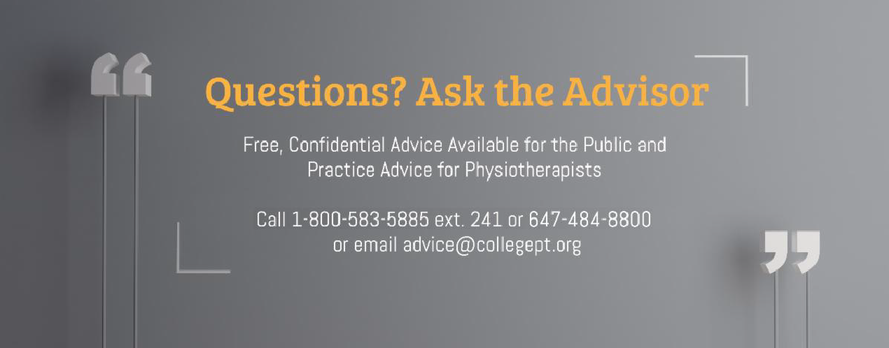designed to get you thinking about the standards and resources and how to apply them in
your practice.

Please log in to the PT Portal to complete PISA.

If you have questions about PISA, please contact PISA@collegept.org or 1-800-583-5885 ext. 235.
About PISA

The College would like to welcome our newly registered physiotherapists.
View the List

Comments or questions related to Perspectives?
Get in touch at communications@collegept.org or 1-800-583-5885 ext. 234. www.collegept.org

