June 2020 | www.collegept.org | info@collegept.org

Welcome to the June edition of Perspectives. I hope you have been well and are enjoying an early taste of summer.

Many of you are in the process of re-opening your practice or resuming non-urgent care. We have included lots of information in this newsletter to help guide you through this next phase and ensure the safety of patients, staff and yourselves.

Stay safe,

Rod Hamilton Registrar
College of Physiotherapists of Ontario

Re-opening Clinics and Returning to Practice

As you know, the Ontario Government updated Directive #2 which allows regulated health providers to gradually return to work with additional precautions in place. Before you consider returning to work it is essential that you implement additional safeguards to protect patients and yourself. Virtual practice continues to be an option.

The College has developed guidance to help physiotherapists re-open their practice based on information coming from the Ministry of Health and Public Health Ontario.

Please be sure to read it and check back regularly for updates.
Read the Return to Work - General Guidance

Top Return to Practice Questions

Q: Do I have to wear goggles during a treatment session if a patient screens negative?

A: No, you do not. PTs might want to consider the use of goggles or a face shield when treating a patient who screens negative for COVID-19, but it is not required.

Keep in mind a physiotherapist should always conduct a point-of-care risk assessment to

determine the level of precaution required. For example, if there are a number of COVID-19
cases in your region, you may choose to wear eye protection.

COVID-19 Operational Requirements: Health Sector Restart (pg 11 - 12) What if a patient screens positive?
According to the government's direction on the use of PPE, eye protection is required for all interactions with, and within two metres of, patients who screen positive for COVID-19.

Visit the Return to Work FAQs section of the website for more answers to popular FAQs.

Do I need to wear a gown if my clothing will be in contact with a patient?

Can I use cloth privacy screens and curtains in my clinic? Do they increase risk of transmission?

My employer is pushing to increase the number of patients at the expense of physical distancing. What should I do?
Read a Complete List of Return to Work FAQs

Upcoming IPAC Webinar: COVID-19 Infection Prevention & Control for Regulated Health Professionals
We wanted to make you aware of an upcoming Infection Prevention and Control Canada (IPAC) webinar.

This webinar will focus on infection prevention and control, IPAC principles and IPAC in the context of COVID-19. Two representatives from Public Health Ontario will lead this presentation and answer any questions you may have.

The webinar will be held on Thursday, June 25, 2020 from 12 p.m. to 1 p.m. There are limited spots available and if you cannot attend, a recording will be made available on the College website.

You are encouraged to submit questions ahead of time by completing this form .
Register Now

COVID Education: Long-Term, Critical and Acute Care

Criticalcarelearning.ca is a free, online learning portal created by the provincial government for health care professionals supporting COVID-19 and critically ill patients in Ontario.

It offers education resources to support upskilling PTs and others when redeployed to care for COVID-19 and critically ill patients in hospitals and long-term care settings.

An access code is required to log in for the first sign up. Email communications@collegept.org and we will be happy to send you the code.

Note: Chrome is the recommended browser to access the learning portal and you should also type the code into the box instead of using copy/paste.

COVID-19 Critical Care Learning

Practice Advice Question

A patient wants to see me in person.

What do I need to discuss with them before the visit?
Get the Answer
Myth vs Fact

A physiotherapist can refuse treatment if a patient will not wear a mask as requested.

Is this a myth or a fact?
Find Out

Check Out the Practice Setting Specific Information

We have been making every effort to organize information and resources on our website as effectively as possible. To help PTs and others locate specific information we have created a general COVID-19 tab in the main navigation, and we have also organized information and resources based on practice setting.

Working in private practice, the community or home care? Visit the webpage. Working in long-term care or a retirement home? Visit the webpage.
Working in a hospital? Visit the webpage.

Each section has frequently asked questions specific to that workplace setting, as well as links for additional resources.

Quick Links and Helpful Resources

We understand there is a ton of COVID-19 information available and it can be challenging to stay on top of the most recent updates.

Here are some helpful websites. Be sure to bookmark them and check back regularly:

Government Workplace PPE Supplier Directory: List of Companies Selling PPE & Other Supplies

Virtual Practice in Physiotherapy

Where to Find Mental Health Supports During COVID-19

Ontario Government's one stop website for all things COVID-19

Public Health Ontario's COVID-19 website

Public Health Ontario: Finding your way on the public health information highway during COVID-19

Updated COVID-19 Self-Assessment Tool

COVID-19 Guidance for the Health Sector

Printable COVID-19 resources in multiple languages - consider posting as a reminder for staff and patients

Canadian Institute for Health Information COVID-19 Resources

If you are having trouble locating a resource or finding specific information, please contact the Practice Advisors and they will do their best to help you find what you need.

Call 1-800-583-5885 (extension 241) or email advice@collegept.org.
COVID Information and Resources

Employment Change? Remember to Update Your Information

If you have changed jobs or recently stopped working , we urge you to take a few minutes and update your information on the Public Register. Updates are required within 30 days. Visit the PT Portal or email registration@collegept.org

Webinar Recording Now Available

Thanks to everyone who attended our webinar Returning to Practice in a Pandemic. We hope you found it useful. We've done our best to answer questions we didn't get to during the webinar in the FAQ section of the website.

If you still have questions after watching the webinar and reading the FAQs, reach out to the Practice Advice team as they are happy to help.

If you were unable to attend, the full recording is available on the College YouTube channel.

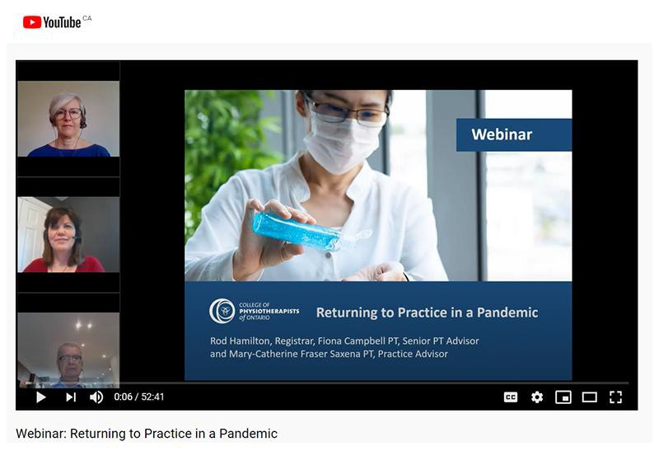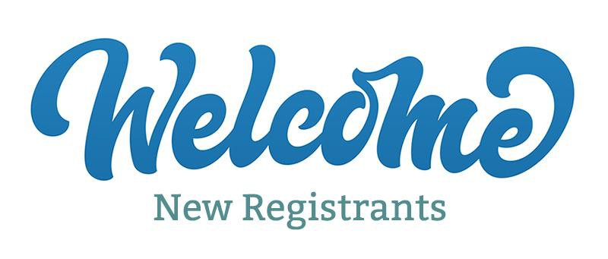

Watch the Webinar Now

Annual Renewal Deadline Extended Until September 30

As the result of the ongoing extraordinary circumstances associated with COVID-19, the College has extended the annual renewal deadline to September 30, 2020.

If you have questions about the extension, please reach out to our Renewal Team at renewal@collegept.org or call 1-800-583-5885 ext. 235.
Renew Now

The College would like to welcome our newly registered physiotherapists.
View the List

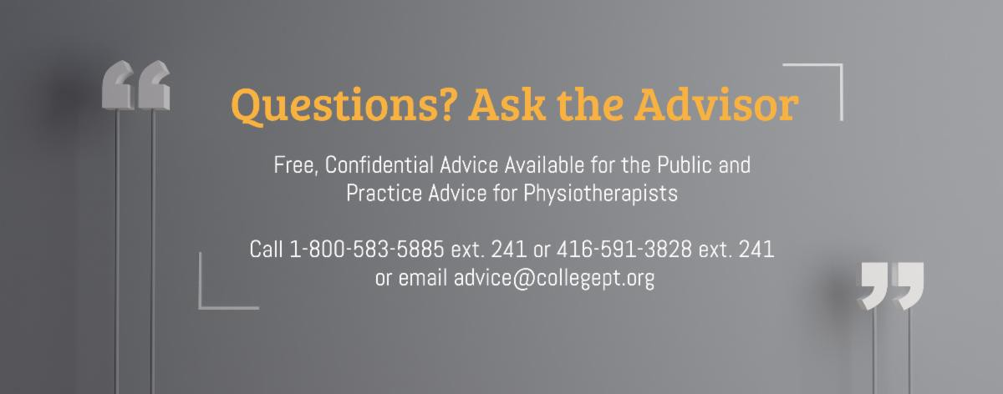

Comments or questions related to Perspectives?
Get in touch at communications@collegept.org or 1-800-583-5885 ext. 234. www.collegept.org

