January 2020 | www.collegept.org | info@collegept.org

Welcome to a new decade and the first issue of Perspectives in 2020.

We are right back in the swing of things at the College with a lot happening over the next couple of months including annual renewal, PISA, webinars and in person events. You will find everything you need to know in the newsletter, but if you have any questions feel free to contact us.

Rod Hamilton Registrar
College of Physiotherapists of Ontario

Get Ready: Annual Renewal and PISA Start February 1

Keep an eye on your inbox for emails about annual renewal and PISA on February 1.

Once again, this year's renewal process will be all online using the PT Portal and registrants must renew between February 1 and March 31, 2020. If you do not renew by the deadline you will be charged an additional fee, so why not do it early and cross it off your to-do list?

Unlike last year, PISA will run concurrently with annual renewal in 2020. This means PISA must also be completed between February 1 and March 31, 2020. A reminder that PISA is a short, multiple choice exercise designed to help you better understand the standards and your professional obligations. There is no pass or fail – you just need to complete it.

The theme for PISA is something everyone can relate to: transition in the workplace. Whether you're leaving a job, changing jobs, going on leave or retiring, there are things you need to do to ensure patient safety. Stay tuned for more information!
More About PISA

How to Resign Your Registration or Retire

If you are no longer planning to practice physiotherapy or use the title of physiotherapist in

Ontario, you may choose not to renew your certificate of registration.

If you want to resign please sign in to the PT Portal, click My Profile and then select Submit Resignation Notice.

Please note that if you are the professional corporation shareholder and resign from the College, your professional corporation will no longer exist. This is something to consider when making the decision to resign.

If you want to return to practice, you need to submit an application to the College. It can take up to 15 business days for your application to be reviewed, processed and approved by the Registrar. Depending on the amount of time you have been away from practice your application may be referred to the Registration Committee and there may be further requirements to ensure you have current knowledge, skills and judgment to practice.

If you have questions, please contact the Registration Team at registration@collegept.org or 1-800-583-5885 ext. 222.
Resigning from the College

Upcoming Webinars and Events

Webinar: Business Practices – the Good, the Bad and the Ugly

On February 20, from noon to 1 p.m., join the College for a lunch-hour webinar all about business practices. Whether you’re a physiotherapist, clinic owner, gym owner or another health professional, the best way to protect yourself is to ensure that you’re following good business practices — one hundred percent of the time.

The panel will share real-life examples to highlight where people have gone wrong, chat about the investigations process and share tips and tools to help you avoid common mistakes.

What does it mean to be delisted? What is the impossible day? What are some red flags for insurance providers? How can you recognize and correct billing errors? Join the webinar to get these answers and much more.
Register Now

In Person Events: Everything You Need to Know About the Rules

The College is travelling across Ontario to meet with PTs and others for coffee, sandwiches and good conversation. Senior Physiotherapist Advisor, Fiona Campbell, PT will cover a range of topics – from working with physiotherapist assistants, to consent, to privacy, to record keeping and more.

Join us in:
North York on January 30 from 6 to 8:30 p.m. Downtown Toronto on February 11 from 1 to 3 p.m.

This is a great opportunity to gain practical advice, have your questions answered and connect with your peers. Come hungry as food and refreshments will be provided.

Please be sure to register if you plan on attending so we can ensure there is enough space and food for all.
Register Now

Webinar: Everything You Need to Know About the Rules

If you haven't been able to join us at one of our events, don't worry, we're hosting a webinar version of this chat on March 10 from noon to 1 p.m .

Send your questions in advance to communications@collegept.org or ask them during the session.
Register Now

New Job Posting: Full-Time Practice Advisor

Are you a registered PT with at least five years experience and looking for a career shift? Read on...

The College is seeking qualified candidates for a new Practice Advisor role. This is a full-time, permanent position and is based in the College office in Toronto.

As a College Practice Advisor, you will provide advice about professional practice to external stakeholders and represent the College at various events to raise awareness and educate.

Registered physiotherapists with a minimum of five years experience are encouraged to apply. This is a great opportunity to get more involved in regulation and help support your peers and patients/caregivers across Ontario.
See the Job Posting

New Case of the Month: Disappearing Act

Imagine a patient showing up to a physiotherapy appointment and the clinic is empty... abandoned without so much as a note on the door and no trace of the physiotherapist.

Find out what happens when one patient, who needs their records for insurance purposes, goes on a wild goose chase looking for their PT, and ultimately files a complaint with the College.
Read the Case

New Blog Post: Being More Inclusive in Your Practice

At a recent discussion with a group of physiotherapy students, the College, the Ontario Physiotherapy Association, the Canadian Physiotherapy Association and the Canadian Alliance of Physiotherapy Regulators, we were asked how physiotherapists can make their practices and organizations more inclusive.

A great question that got us thinking about practical tips we can share.

Be sure to read the blog for 10 tips you can start implementing in your practice, along with helpful resources for providing non-judgmental, non-stigmatized care to diverse communities and ensuring that you meet Ontario's accessibility requirements.
Read the Blog

Practice Advice Question

Can I open a practice out of my home?
Get the Answer
Myth vs Fact

The College will mail you a tax receipt at the end of the year.

Is this a myth or a fact?
Find Out

Do You Complete Disability Determination Packages or Medical Review Packages?
If you're a health care provider who completes Disability Determination Packages, Medical Review Packages or provides Additional Medical Information to the Disability Adjudication Unit, note that there has been a change in the billing process with the Ministry of Health and Long-Term Care. Health care providers who cannot bill OHIP can now bill the Disability Adjudication Unit directly using the new online invoice, searchable under code 3261.

Questions about OHIP billing processes or how to access the online invoice? Contact Ola Kolodij, Social Assistance Central Services Branch (Ministry representative) at 416-212-6752 or at Ola.Kolodij@ontario.ca.
Access the Online Forms

The College would like to welcome our newly registered physiotherapists.

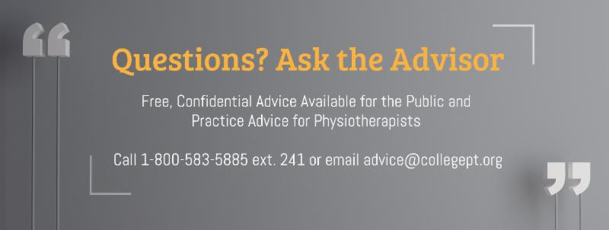
View the List

Comments or questions related to Perspectives?
Get in touch at communications@collegept.org or 1-800-583-5885 ext. 234. www.collegept.org

