November 2019 | www.collegept.org | info@collegept.org

Welcome to the November issue of Perspectives.

Did you know: almost 60% of registered physiotherapists in Ontario work with physiotherapist assistants? Well, our team has been hard at work developing a new e- learning module covering the Working with Physiotherapist Assistants Standard.

I'm happy to say the module is now ready – you will find a link as you scroll down. Be sure to give it a try.

Rod Hamilton Registrar
College of Physiotherapists of Ontario

Surveillance Cameras in Treatment Areas: A Violation of Privacy

The College Practice Advisors are often asked by physiotherapists if surveillance cameras can be used in treatment areas for security or reputational risk concerns.

The answer?

No, not in Ontario.

According to Ontar io' s pr ivacy laws , the patient must expressly consent to the collection, use and disclosure of health information, and the rules only allow the collection of health information for the purposes of providing health care. These rules extend to surveillance cameras in treatment rooms and the argument of having them for reasons related to security or reputational risk does not meet the legal requirements.

A recent decision from the Information and Privacy Commissioner of Ontario highlights this, stating:

"Bottom line: positioning a camera in an exam room and collecting footage where patients are undressed, vulnerable, and without an opportunity to expressly consent violates the trust that patients must have in the medical community. Without this trust, people might avoid seeking health care when

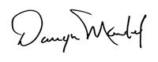they need it … resulting in serious ramifications for the health care system in
Ontario."
More on Privacy

By-Law Consultation – Proposed Fee Reduction

The College is committed to ensuring that the resources it collects from registrants is consistent with its regulatory activities. The College recently reviewed its fees and current financial reserves, and determined that its fees can be reduced without impacting the College’s ability to regulate in the public interest.

As a result, the College is proposing to lower its annual registration fees from $595 to $575 starting in the 2020-2021 registration year.

Please take a moment to let us know if you support this fee reduction by answering one brief question using the link below. The deadline to respond is Monday, December 9.

Darryn Mandel Council President
Share Feedback

New Case of the Month: Pay My Physio Bills

Health care bills can add up fast if patients don't have sufficient insurance coverage. Physiotherapists must always make sure to explain fees and billing to patients prior to starting treatment and not charge excessive fees for any services.

Find out what happens when one patient thinks she was charged way too much for treatment sessions and additional services like administrative tasks and a concussion kit in a new Case of the Month.
Read the Case

NEW: Working with Physiotherapist Assistants E-Learning Module

If you work with PTAs be sure to complete our new interactive e-

learning module.

A new Working with Physiotherapist Assistants E-Learning Module is now available. Covering all the key components of the Working with Physiotherapist Assistants Standard, and touching on some elements of the Supervision Standard, this module will be useful for a wide audience including physiotherapists, students, physiotherapist assistants (PTAs) and people who employ physiotherapists and PTAs.

By completing the highly interactive module you will gain a solid understanding of:

The accountabilities of a physiotherapist when working with PTAs The expectations for supervising and assigning treatment to PTAs
The communication requirements for both the physiotherapist and the PTA

The module has seven sections, including a comprehensive final quiz, that you can complete all at once or separately. Brush up on your knowledge and be sure to give the new module a shot.

Available soon in French and audio.

If you have any questions or feedback about the module please don't hesitate to contact Practice Advice at advice@collegept.org or 1-800-583-5885 (extension 241).
Complete the E- Learning Module

New Blog Post!
Social Media: The Line Between Professional and Personal

The use of social media by regulated health professionals has been in the news recently and one question seems to resurface regularly: where do you draw the line between posting in a professional capacity versus a personal capacity?

More importantly, can regulated health professionals (like physiotherapists) be held accountable for expressing personal views that may go against the standards of the profession or the professional expectations for a health care provider?

Our Practice Advice team provides some guidance in a new blog post - be sure to check it out.
Read the Post

Register Now for a College Event in the New Year

Everything You Need to Know About the Rules

The College is travelling across the province to meet with PTs and others for coffee, sandwiches and good conversation.

Senior Physiotherapist Advisor, Fiona Campbell, PT will cover a range of popular topics – from working with physiotherapist assistants, to consent, to privacy, to record keeping and more.

Thanks to everyone who has attended an event so far. Our next event is in Barrie on November 26.

Then we're taking a pause over the holiday season and will be back with events in Toronto and North York in the new year. If you can't make it in person, don't worry – we'll be hosting a webinar in March.

This session promises to provide practical advice, answers to your questions on best practices. To help you avoid the same pitfalls, examples of where other people have gone wrong will be shared.

Watch your email inbox, read Perspectives e-newsletter and visit collegept.org for more details.

Please be sure to register if you plan on attending so we can ensure there is enough space and food for all.
Register Now

Practice Advice Question

I am setting up a business co-owned by myself (PT), a surgeon, and a registered massage therapist. How do I manage the conflict of interest that exists when referring patients to the massage therapist or surgeon within the co-owned practice?
Get the Answer
Myth vs Fact

Physiotherapists
can incorporate their businesses.

Is this a myth or a fact?
Find Out

Remembering Barbara Stokes

The College remembers Barbara Stokes who served as Council President between 1994 and 1996. Barbara enjoyed a long and celebrated career as a physiotherapist, teacher, researcher and author who specialized in rheumatoid arthritis. Her work with The Arthritis Society and the College of Physiotherapists was her passion. Our condolences to Barbara's family and friends.
Obituary

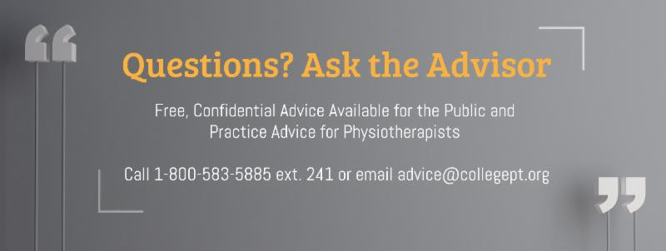

The College would like to welcome our newly registered physiotherapists.
View the List

Comments or questions related to Perspectives?
Get in touch at communications@collegept.org or 1-800-583-5885 ext. 234. www.collegept.org

