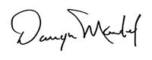

October 2019 | www.collegept.org | info@collegept.org

Welcome to the October issue of Perspectives. As always, a busy fall season is underway at the College and you will find lots of interesting information as you scroll through the newsletter.

As we consider potential blog topics for the coming year, we would like to know what you think we should write about. For example, the College blog is a great way to highlight topical issues or dig into common practice advice questions a little further.

We welcome any and all suggestions. Send them by email to communications@collegept.org and stay tuned for new blog posts in the near future.

Rod Hamilton Registrar
College of Physiotherapists of Ontario

By-law Consultations– Fee Reduction

The College is committed to ensuring that the resources it collects from registrants is consistent with its regulatory activities. The College recently reviewed its fees and current financial reserves, and determined that its fees can be reduced without impacting the College’s ability to regulate in the public interest.

As a result, the College is proposing to lower its annual registration fees from $595 to $575 starting in the 2020-2021 registration year.

Please take a moment to let us know if you support this fee reduction by answering one brief question using the link below.

Darryn Mandel
President, College Council

Share Feedback

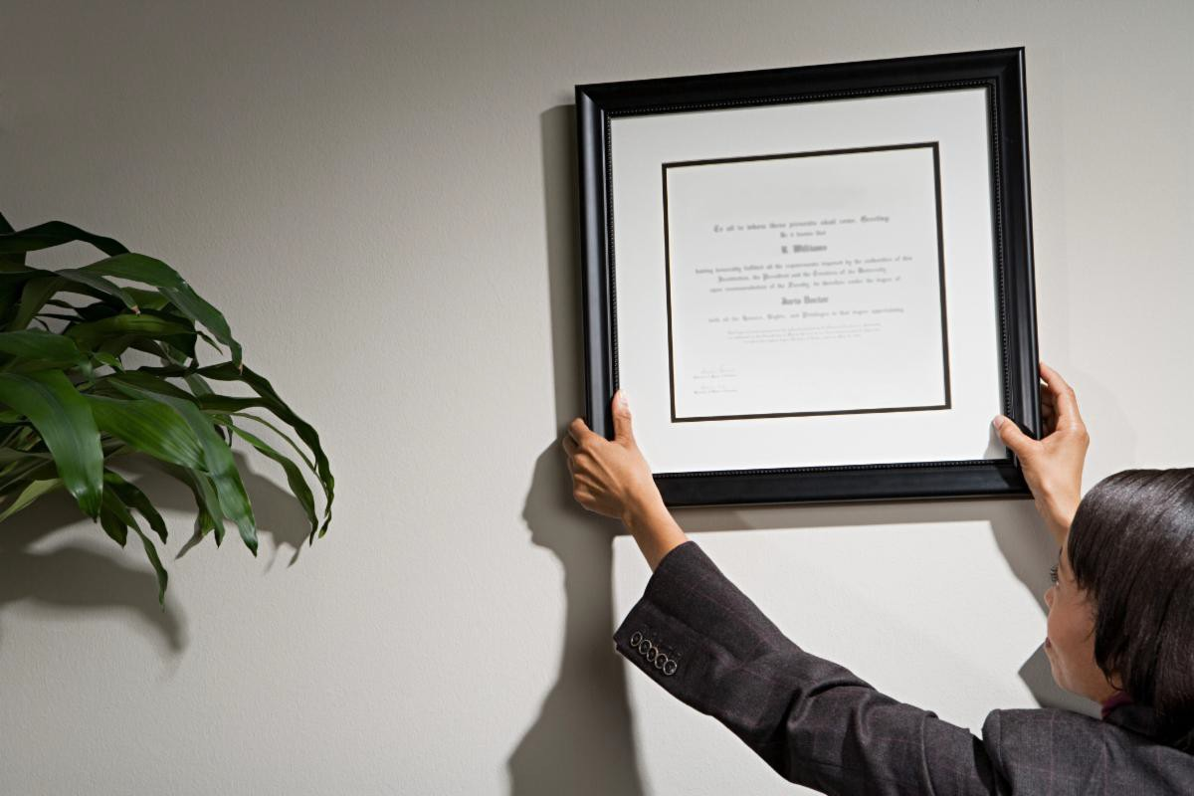Missing Persons Act and What it Means for You

The Missing Persons Act, 2018 came into effect on July 1, 2019, changing what information police can request or access when investigating missing persons in Ontario. The new power is designed to assist in cases where no criminal activity is suspected.

Health care providers, including PTs, need to be aware of this new law as police officers may now make an urgent request for records (including health records) if they believe:

- You have relevant records
- The records would help locate a missing person
- Time is sensitive and the missing person would be harmed or the records destroyed if not produced immediately

The police request will specify the type of information sought and which information is needed to assist the police in locating the individual. In some circumstances, it may be appropriate to provide information orally.

Important: A note should be made in the patient's record that the request was received, what information was provided, in what manner (oral, paper copy, etc.) and when.
Privacy and Record Keeping

New Case of the Month: All Together Now

In a larger clinical setting like a hospital, collaboration is often a key component of quality care.

But what happens if people just aren't on the same page?

Read all about how lack of communication and collaboration led to a complaint for one PT in our latest Case of the Month, All Together Now.
Read the Case

How to Get a Wall Certificate

Did you know: registrants have the option to purchase a wall certificate from the College?

If the walls in your office are looking a little bare, consider getting a College of Physiotherapists of Ontario wall certificate! Show patients that you are a registered physiotherapist and take pride in your profession.

Wall certificates are available on the PT Portal for $25. Follow these easy steps:

- Log in to the PT Portal
- Once logged in, select 'Online Requests' in the top navigation
- Select 'Wall Certificate' from the drop down
- Fill in your mailing address and pay the fee
- Proudly display your new wall certificate

Questions? Contact the Registration team at 1-800-583-5885 ext. 222 or email at registration@collegept.org .

Register Now for a College Event Near You!

Everything You Need to Know about the Rules

The College is travelling across the province to meet with PTs and others for coffee, sandwiches and good conversation.

Senior Physiotherapist Advisor, Fiona Campbell, PT will cover a range of popular topics – from working with physiotherapist assistants, to consent, to privacy, to record keeping and more.

Our next stop is Windsor on October 30.

We'll also be visiting London, Toronto and North York . If you can't make it in person, don't worry – we'll be hosting a webinar later in the year.

This session promises to provide practical advice, answers to your questions on best practices. To help you avoid the same pitfalls, examples of where other people have gone wrong will be shared.

Watch your email inbox, read Perspectives e-newsletter and visit collegept.org for more details.

Please be sure to register if you plan on attending so we can ensure there is enough space and food for all.
Register Now

Practice Advice Question

I am going on maternity leave, what should I do with my liability insurance?
Get the Answer
Myth vs Fact

Physiotherapists are allowed to offer package deals or bundled services.

Is this a myth or a fact?
Find Out

Update: New Practice Assessment Program

Work on the revised practice assessment process, also known as the Quality Assurance program, is ongoing. As we continue to work through the pilot phase we are carefully considering feedback from people who have participated in a variety of ways, in order to

make improvements.

Physiotherapists will not be selected for a new practice assessment until after the program launches in April 2020. Once the program launches, eligible PTs will be selected in sequence. Once you have completed a practice assessment you will be removed from the selection pool for approximately 10 years.

Stay tuned for more information in the new year!

The College would like to welcome our newly registered physiotherapists.
View the List

Comments or questions related to Perspectives?
Get in touch at communications@collegept.org or 1-800-583-5885 ext. 234. www.collegept.org

