March 2018 | info@collegept.org

Welcome to the March Issue of Perspectives

Happy Spring! We know it's officially here but now we just need some proof from Mother Nature.

At the time I am writing, about 5,200 PTs have completed renewal on our brand new system. The majority of you have had a good experience, but some people are encountering problems. I wish the transition to our new system had been flawless, but since it hasn't been, we've added lots of people to our phone lines to help you.

There is an Annual Renewal video as well - give it a try, follow the directions to set up your new portal account carefully (everyone has to do this, no matter how long you have been with the College), and get in touch if you have problems so we can help.

To make sure we are here for you, we are extending the renewal period to Friday, April 13, 2018. But please don't wait! You don't want to be the person who tries to renew at 11:00 pm on April 13, only to run into problems.

We know that we have A LOT of data clean-up to do: when we opened your data closet, we found lots of skeletons (especially errors in historical records of your past employment sites). We'll be getting your current work site information and roster information updated soon. We will work our way through cleaning up the rest over the coming months.

When we are done, we will have a state-of-the-art Public Register and be able to serve Ontario's public, you and all our other stakeholders better than we ever have before. We are excited about this, even while we burn the midnight oil to achieve that goal.

Spring at the College also means Council Elections. If you're in the GTA, elections opened March 19. An email was sent inviting you to vote. Please be a voter this

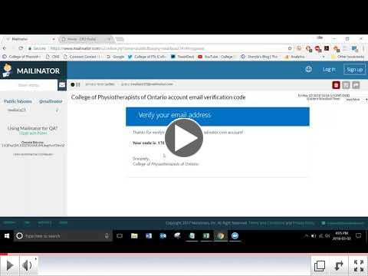time around!

If you're wondering what Council really does, learn a little more by reading my Blog. Click below.

Thanks for reading, for continuing to respond to our consultation requests, and for coming out to our outreach events. Happy spring!

Shenda, Registrar

Read Shenda's Blog

Se t Up Yo u r Ne w Pro f i le & Re n e w - Ap ri l 1 3
De a d l in e

We've launched a NEW Online Member Portal. This means that your existing online College profile no longer works. Everyone must set up a NEW profile the first time they use the Online Member Portal.

All physiotherapists with an Independent Practice Certificate are required to complete renewal by April 13, 2018.

Please go to your inbox and look for an email sent from the College. It will include directions about how to set up your online account for the first time and then how to renew.

Please Read: Important Renewal Information

We b in a r Av a i la b le fo r L is te n in g

Don't miss the recent webinar on popular practice questions. At just under an hour, find out what questions your peers are asking and hear the College's answers.

Many thanks to everyone who participated and sent in questions prior and during the live event.

Listen to the Webinar

Sto rie s Wo rth Re a d in g !

If you don't normally read the Case of the Month, why not have a quick read now?

Last month, just over 2,000 of you read The Snowball Effect. If you missed it, it's worth a read. It's a cautionary tale about what could happen if you date a patient.

Case of the Month features real physiotherapy cases that come before the College. It's a great way to see what is going on within the profession and educate yourself about situations to avoid.

Check out Cases such as:

Blurred Lines
When "I Didn't Know" Isn't Enough Pilates Problem
No Laughing Matter
No Such a Thing as Innocent Curiosity

My th v s . F a c t

Read Great Cases

Physiotherapists are not allowed to video record treatment sessions.

What do you think?

Su rv e y Re q u e s t - Co n s e n t & Ca p a c i ty Kn o wle d g e As s e s s me n t

Regulators are looking at ways to assess the knowledge of all regulated health professionals when it comes to consent and capacity. That's a big undertaking!

Can you give them a hand by completing a short survey?

Results will determine the need to create collaborative educational materials to help health professionals understanding their legal and professional obligations when getting consent and assessing capacity.

Complete the Short Survey

Qu e s t io n : Ho w c a n I ma k e s u re wa lk e rs a n d c a n e s

a re s a fe ?

It's a question the College Practice Advisors get asked fairly often. The answer comes from the revised Infection Control and Equipment Maintenance Standard.

Click below to get the answer and never hesitate to get in touch if you have a question we can help to answer.

Your Answer Here

Wh e re ' s th e Ev id e n c e ?

It's right here and it's free thanks to the Allied Health Professional Development Fund!

Sign up to receive free access to the most recent health care literature to help you determine the best approach to evidence-based practice. Databases such as MEDLINE®, CINAHL®, DynaMed Plus® and more.

Why Not Sign Up Now?

Are y o u g o in g to In te r ACT ION?

We are! And we hope you'll drop by and say hello.

The College is running a Saturday morning breakfast session, with 3 PT Practice Advisors taking your questions.

We also have a booth and encourage everyone to visit. Enter our contest, ask a question and get a prize, and chat with staff.

See you at OPA InterACTION

How Much Can You Charge to Provide a Photocopy of a Patient Record

Watch the Video

Boundaries & Sexual Abuse Standard

Read the Standard

PLEASE DO NOT UNSUBSCRIBE IF YOU ARE A MEMBER OF THE COLLEGE.
If members unsubscribe, they will be contacted to re-subscribe. The College communicates
to members by email, sending information such as tax receipts, Standards updates and mandatory registration requirements such as PISA, Jurisprudence and registration renewal.
We strive to keep communications relevant and to a minimum.

Questions, comments or suggestions related to e-Perspectives?
Get in touch at communications@collegept.org 416-591-3828 ext. 234 or 1-800-583-5885 ext. 234
www.collegept.org

