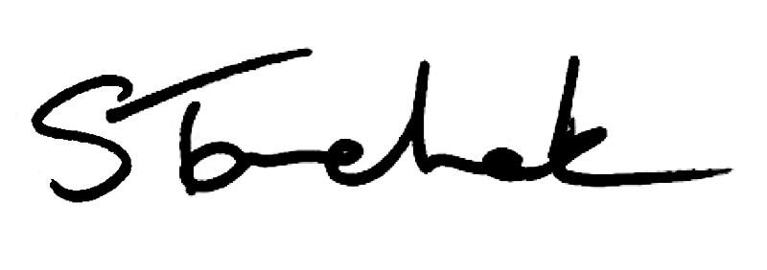

February 2018 | info@collegept.org

Welcome to the February Issue of Perspectives

February might be the shortest month in the calendar year but we have been cramming a lot into those 28 days. After a bit of a false start, we've launched a new database to get annual renewal up and running: we are conducting 2 consultations (quality assurance and by-laws), and we are hosting a Practice Advice webinar on February 26.

Have you signed up for the webinar yet? Be sure to submit a question. Whatever question you have on your mind is surely shared by your colleagues.

I'd love for all of you to join us, but I'm especially hoping to hear from people who have never used our free and confidential advisory service. Once you try it, you are sure to keep coming back - we are finding that more and more PTs are calling every month.

Thank you to all of you who have already participated in the Quality Assurance consultation - either online or in person. Your contributions are shaping our ideas about what the process should look like. Council will consider your input at its March meeting, so if you haven't already, have your say now.
Enjoy Perspectives and I'll see you next month. Shenda,
Registrar

PISA An n o u n c e me n t

We'll be distributing PISA later this year. Don't worry, we'll let you know when it's

released. Until then, all you need to worry about is completing your annual renewal.

We b in a r: As k th e Pra c t ic e Ad v is o r

Have you registered yet? Don't miss out on this opportunity to have your questions answered live by the Practice Advisor on February 26, 2018 during our Ask the Practice Advisor! webinar.

No topic or question is off limits. Click on the registration link below to make sure you don't miss out on the fun.

Register Here

Qu a l i ty As s u ra n c e Co n s u l ta t io n - F e b ru a ry 2 8 De a d l in e

Have you provided your feedback on the proposal for the Quality Assurance program yet? The February 28, 2018 deadline is quickly approaching.

Please spend a few minutes completing the survey to let us know if there are any issues, concerns, or considerations that we're missing. Your voice matters. Thank you.

Give Your Feedback

Ca s e o f th e Mo n th

Find out how what started as an investigation into a privacy breach morphed into a sexual abuse case that resulted in a PT losing her license. A must read!

Read the Case

Pra c t ic e Ad v ic e

Question: I have a Provisional Practice Certificate with the College. Can I use the title physiotherapist on a CV or business cards?

Get the Answer

Co u n c i l Ele c t io n s - No min a t io n s Clo s e F e b ru a ry 2 1 , 2 0 1 8

Do you live in Central Eastern, Toronto West or Toronto East? Your window for nominating a peer to run for Council elections is drawing to a close. Don't delay!

Council Elections

My th v s F a c t

Myth vs Fact: Physiotherapists must be registered with an Independent Practice Certificate for a minimum of 3 years before they can supervise a PT Resident.

Myth vs Fact

Re c o rd Ke e p in g Ch e c k l is t

Does your record keeping meet College requirements? Use this record keeping checklist to find out.

Record Keeping Checklist

Ca n I Us e th e T i t le Ac u p u n c tu ris t , in Ad d i t io n to Ph y s io th e ra p is t?

Q: I'm rostered to perform acupuncture. Can I use the title acupuncturist, in addition to physiotherapist?

Answer Here

Ne w Es s e n t ia l Co mp e te n c y Pro f i le Av a i la b le

The new Essential Competency Profile for Physiotherapists in Canada 2017 is now available.
The development of the Profile was made possible by: The Canadian Alliance of Physiotherapy Regulators
The Canadian Council of Physiotherapy University Programs Physiotherapy Education Accreditation Canada
Canadian Physiotherapy Association

Available Here

F in a n c ia l In v o ic e s in Pa t ie n t Re c o rd s

Did you know that the financial invoice and the sign-in sheet are considered to be a part of a patient's record? Why does this matter?

If you were required to provide the entire patient record in the future (say eight years from now), could you access the full patient's clinical records, the associated financial records and even copies of the sign-in sheet?

Being able to pull the entire patient record is something you might want to consider when you are storing files offsite or converting your files into a different format for example. Be sure to check out the Record Keeping Standard for more information.

Recording Keeping Standard

Rig h t Do e s No t Alwa y s Eq u a l Ea s y

Making ethical decisions can be difficult. Use the REACH acronym, found in the Code of Ethics, to help you analyze and work through any tough situation you are facing.

Code of Ethics

Pro p o s e d Co l le g e By - la ws Ch a n g e s

March 19 might be weeks away, but why wait until the deadline to comment on the proposed changes to our by-laws? Learn more about the proposed changes by clicking the on the survey link below.

By-law Survey

On ta rio Dis a b i l i ty Su p p o rt Pro g ra m Me d ic a l Re v ie w T ra in in g Co u rs e

As a physiotherapist, you might be asked to provide medical information for a patient who is undergoing a medical review for the Ontario Disability Support Program.

The Ministry of Community and Social Services has updated its Ontario Disability Support Program Medical Review Training Course for ease of use and accessibility. Click on the link below to learn more details.

Module Links

An Overview of the New Quality Assurance Program

Watch the Video
Conflict of Interest

Read the Standard

Questions, comments or suggestions related to e-Perspectives?

Get in touch at communications@collegept.org 416-591-3828 ext. 234 or 1-800-583-5885 ext. 234
www.collegept.org

PLEASE DO NOT UNSUBSCRIBE IF YOU ARE A MEMBER OF THE COLLEGE.

If members unsubscribe, they will be contacted to re-subscribe. The College communicates
to members by email, sending information such as tax receipts, Standards updates and mandatory registration requirements such as PISA, Jurisprudence and registration renewal.
We strive to keep communications relevant and to a minimum.

