What to Expect on Exam Day
Click on the section headers below to jump to specific sections.
Exam location 2
Dress code 2
Exam timing 2
What is a virtual waiting room? 3
Why am I required to login to the virtual waiting room 30 minutes before the exam starts? 3
How to login 4
Connecting to the virtual waiting room 6
Who is involved in the exam? 7
What is the examiners’ role? 8
What is a proctor? 8
What is the proctor’s role? 8
Meeting your examiners 10
Washroom breaks 11
Starting the Exam 11
Exam Set Up 12
Case 1: Assessment 13
Case 2: Treatment 15
What if I have a tech issue? 16
When your exam is over 17
Problem solving common issues 18

Exam location
The Ontario Clinical Exam (OCE) is a virtual remote exam. You will complete the exam using your own device that meets the technology requirements, and from a location of your choice that meets the room set up requirements.
Please carefully review the technology requirements and room set up requirements before your exam to make sure your technology will function properly, and that your room is set up appropriately. Both documents are available on the Preparing for the Ontario Clinical Exam page.
It is strongly recommended that you complete the exam in Ontario. All exam times are in eastern time (ET). If you are in a different time zone, it is your responsibility to know the local time of your exam. Candidates outside of the ET time zone will not be given alternative exam times.

Dress code
There is no dress code for the OCE, but you should wear something comfortable. Past candidates have worn clothes that they would wear when working with a patient in their workplace.
Depending on the temperature in your room, you may want to dress in layers and have a sweater in case you need it. You are not allowed to have blankets, jackets, or other bulky items, but you can have a sweater that you wear or place on the back of your chair. Your sweater cannot be on your desk, workspace, or in your lap. More information on how to organize your space for the exam is available in the room set up requirements, available on the Preparing for the OCE page.

Exam timing
Each exam day has two sessions, a morning (a.m.) session and an afternoon (p.m.) session. You will receive confirmation of your exam session and start time no later than 30 days before your scheduled exam date.
An email with the link to the exam platform, your login credentials (Unique ID and Password), and exam time confirmation will be sent to the primary email listed in your PT Portal account. This email will arrive no later than 45 minutes before your exam opens – 7:15 a.m. for morning candidates and 12:15 p.m. for afternoon candidates. Make sure your contact information in the PT Portal is accurate. If your contact information changes (email or phone number), please update your account at least one week before your scheduled exam.
- If you do not receive this information by the designated time, contact the exam team directly at 416-591-3828 ext. 215 or 1-800-583-5885 ext. 215.
Login precisely at your specified time.
- Morning candidates can begin logging in at exactly 7:30 a.m. and must be logged in no later than 8:00 a.m. to enter the virtual waiting room. You will be connected to the exam platform at 8:00 a.m. The exam will begin at 8:30 a.m., however, you will be marked as a late arrival if you login later than 8:00 a.m. Please ensure you review the Exam Failure to Attend and Late Arrival Policy.
- Afternoon candidates can begin logging in at exactly 12:30 p.m. and must be logged in no later than 1:00 p.m. to enter the virtual waiting room. You will be connected to the exam platform at 1:00 p.m. The exam will begin at 1:30 p.m., however, you will be marked as a late arrival if you login later than 1:00 p.m. Please ensure you review the Exam Failure to Attend and Late Arrival Policy.
The exam is a synchronous start, meaning all candidates who arrive on time and all examiners must be ready to start before the exam can start. We will never start the exam early. It will always start on time, or a few minutes late. Your examiners will keep you informed regarding the exam start time.

What is a virtual waiting room?
The virtual waiting room allows the exam team to see that you are connected to the exam delivery platform. It is also where you will connect with your proctors to complete the required security checks before the exam starts. You will then be connected to your examiners who will introduce themselves and provide you with a brief orientation.

Why am I required to login to the virtual waiting room 30 minutes before the exam starts?
The 30-minute period in the virtual waiting room allows for ID verification, security checks, and orientation. None of these processes can be skipped due to a candidate’s late arrival.
Morning candidates who login later than 8:00 a.m. and afternoon candidates who login later than 1:00 p.m. will be flagged as late arrivals and be subject to the parameters of the Exam Failure to Attend and Late Arrival Policy. Candidates who login after the required connection time will not be granted additional time to complete the mandatory security and ID verification processes and may start the exam at a time deficit or not be allowed to start the exam at all, depending on the situation.

How to login
1. Click on the link (URL) provided in your login information email. This is a different URL than the demo site.
2. Enter your login credentials. Login no earlier than the specified time using the credentials provided. Your email will have all the necessary information to login.
- If you login earlier than instructed, your credentials will not work. You will get an error message.
- Morning candidates can start to login at exactly 7:30 a.m.
- Afternoon candidates can start to login at exactly 12:30 p.m.
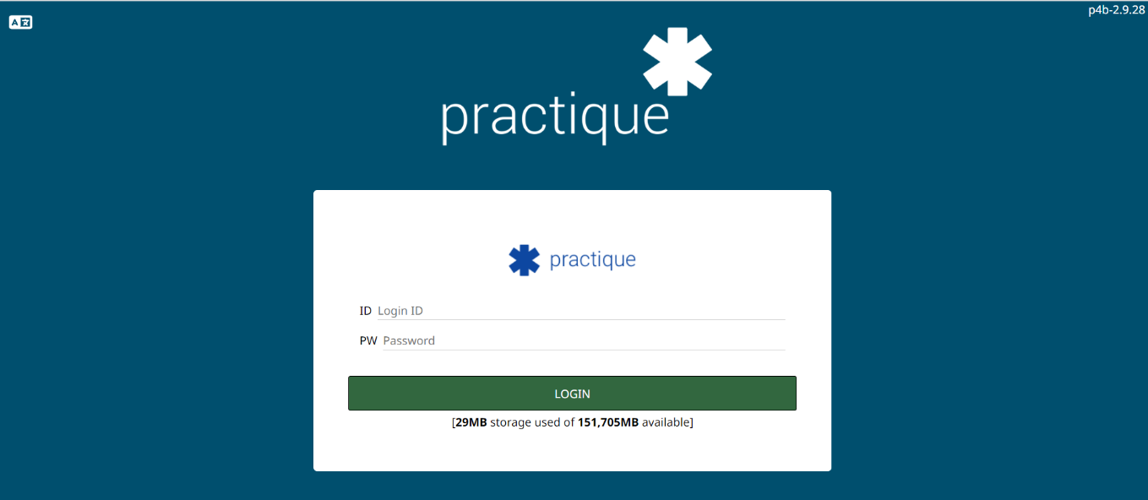
Here is an image of what the login page will look like. There will be space for you to enter the ID and password provided in the login credentials email.

3. One you have entered your ID and password, press the “Login” button. The exam will begin to download. This may take a few minutes. It is strongly recommended that morning candidates login at exactly 7:30 a.m. and afternoon candidates login at exactly 12:30 p.m. to avoid any delays with download speeds.
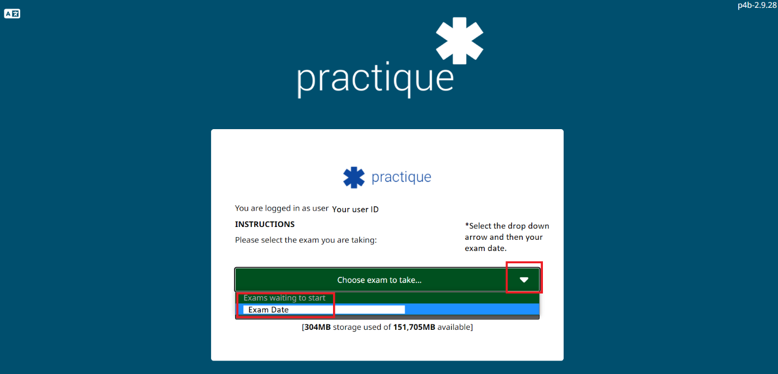
4. You will then be prompted to select your exam from the green dropdown bar (“Choose an exam to take”). There should only be one option. Select the correct date.
5. Once submitted, all buttons will display as gray. This means you have successfully logged in and arrived at the holding page. There is no PIN. No action is required on your part.
- While you are waiting for the exam to start, make sure you have closed all other windows on your computer, and exited your email.
- Remember, there are no scheduled breaks during the OCE. If you need to use the washroom, please do so before you are connected to the waiting room.

Once the exam has downloaded your screen should look like the image below with all buttons in gray. This means you have successfully logged in and are on the holding page. The exam will automatically connect you to the waiting room at the specified time.
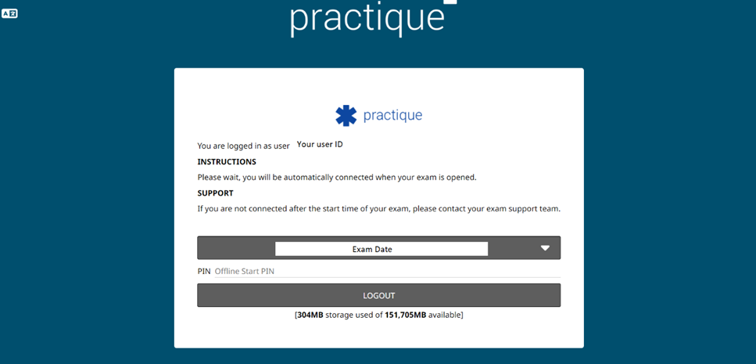

6. You will be connected to a waiting room within the platform at the exam start time. The exam is a synchronous start, meaning all candidates need to start the exam at the same time. The exam start will not be delayed if you do not log in on time. You are recorded as soon as you are connected to the exam waiting room.

Connecting to the virtual waiting room
When the exam starts, you will automatically be connected to a virtual waiting room within the exam platform. This may take a few moments. Once connected, your video, audio and your shared screen will be recorded.
1. Once connected to the waiting room, you will be immediately prompted to share your screen. All candidates are required to share their screen. Press the “OK” button when prompted. If you accidentally deny screen sharing access, simply press the “Disconnect” button and then the “Connect” button, located in your upper left screen.
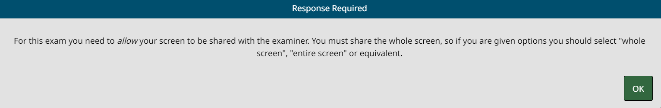
2. You will be prompted to select your screen and press “Submit.” There should only be one screen to select, because multiple screens are not allowed during the exam. Your screen is now visible to the proctor and examiners.
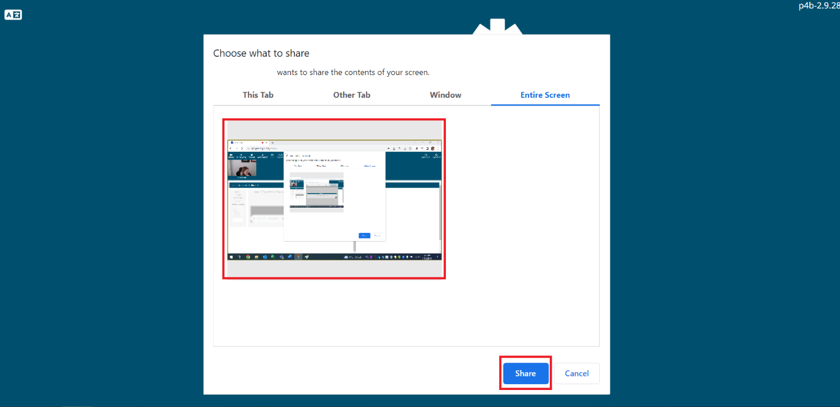
Once you are fully connected, you should be able to see yourself with your own camera. You are not able to hide your camera and there are no automatic backgrounds available in the platform.
Do not navigate to any sections of the exam. If you do, this will be noted as an incident and may lead to termination of your exam. Please note, you will be recorded for the entire duration of the exam starting the moment you are connected.

Who is involved in the exam?
There are many people involved in each exam session. During your exam you will primarily interact with the proctor and your two examiners. Behind the scenes, the exam team and IT team are managing the exam delivery. If an examiner or proctor flags anything of note, the exam team can log into your exam session without detection. Examiners not assigned to a candidate may also be watching your exam as an observer to review the session for quality assurance purposes. You will not know if an observer is watching your exam. They are not seen or heard and do not play an active role in the exam. All exams are recorded for quality assurance purposes. Recordings are not used for scoring or re-scoring purposes.

What is the examiners’ role?
Security
Although it is the proctor’s primary role to watch for violations or flag suspicious behaviour during the exam to the exams team, your examiners are also observing your behaviour and will flag any suspicious behavior to the exam team.
Scripting
Much of the examiners’ content is scripted, including introductions and questions. This ensures that all candidates receive the same information at the correct time during the exam.
Neutrality
Your examiners are instructed to maintain a neutral demeanor to support a standardized experience. Your examiners will be polite and respectful but may not be especially emotive. Although it may feel comforting for someone to make jokes, small talk, or smile a lot in a casual setting, examiners are discouraged from these types of behaviours as they could be easily misinterpreted. Examiners will not provide you with any feedback regarding your performance. Your examiners have undergone and continue to complete extensive training to ensure a standardized, fair, and valid exam experience for each candidate.

What is a proctor?
The proctor is a real person who has received training for their role in the exam. They complete security checks, ensure that the room and technology requirements are met and followed, and monitor the entire exam experience to flag any concerning activities or behaviours to the exam team. If you are connected to the exam platform, be mindful that the proctor is watching and listening.

What is the proctor’s role?
The proctor’s instructions and steps to complete the security checks may seem excessive but be assured that all guidelines are set to ensure a fair, standardized testing experience for all candidates, regardless of the testing location. Carefully reviewing the room set up requirements available on the Preparing for the OCE page and taking time to prepare will reduce delays on exam day. The proctor will verify your identification, instruct you to complete a 360-degree room scan, and ensure that technology is functioning properly before the exam begins.
The proctor and your two examiners will be observing you for the entire exam.
The proctor is present on the exam platform and can see and hear you. You are not able to see the proctor and will only hear them when they unmute themselves to interact with you. When you connect to the system, please wait for the proctor to speak to you. This may take a few minutes. Each proctor will validate more than one candidate, so please be patient. Do not navigate to any other areas within the exam site, away from the exam site, or open any additional applications or windows on your computer.
Your proctor will complete three tasks: ID verification, room scan, and technology confirmation.
1. ID verification: You will be asked to present your valid government issued photo ID. The name on the ID should match the name that you used to register for the exam exactly. Candidates must provide supporting documents if their name on file does not match their government issued photo ID. You will be asked to hold the ID up to your camera so the proctor can inspect it.

Acceptable forms of identification include:
- Passport
- Driver’s License
- Provincial Photo ID card

Unacceptable forms of identification include:
- Health Cards
- SIN (Social Insurance Number)
- Birth Certificates
- Student Cards

2. Room scan: The proctor will direct you to perform a 360-degree room scan. To avoid delays in this process, carefully review the Room Setup Requirements document on the Preparing for the OCE page to make sure you have followed the instructions for setting up the exam room. Certain violations of the Room Setup Requirements may result in the termination and invalidation of your exam session. These violations are explicitly outlined in the Room Setup Requirements document.
Follow the proctor’s directions. You will be asked to slowly complete the following actions:
- Pan across your desk area (Note: if you are using a white board, it must be blank)
- Show the area under your desk
- Slowly complete a 360-degree turn to show the entire room

Once completed, you will be asked to place your webcam or device back in its original place. The proctor will instruct you to make any changes to your set up if necessary.

- I have an external/detachable webcam
The proctor will ask you to pick up your webcam and follow their instructions to complete the room scan.

- I have a built-in webcam but can easily lift or move my device (i.e., laptop)
The proctor will ask you to pick up your device and follow their instructions to complete the room scan. You may need to unplug your charger to move the device.

- My webcam is built-in, and I cannot move/lift it (i.e., built in desktop webcam)
You need to have a mirror available. You must contact the exam team before your scheduled exam to let us know that you will be using a mirror. The mirror should be large enough to reasonably capture your surroundings during the room scan. A pocket mirror or compact is not acceptable. The proctor will ask you to position your mirror in front of the webcam. Please follow their instructions. You will be asked to place the mirror out of reach and face down after the room scan is complete.

The College is committed to supporting candidates of all abilities in accordance with the Ontario Human Rights Code and the Accessibility for Ontarians with Disabilities Act (AODA). If you are unable to complete the room scan as outlined above, please complete the Accommodations Request form after registering for the exam. Staff will contact you to discuss your individual needs and determine an alternative method to support you.
Any violations of the Room Setup Requirements will be noted in your candidate record and communicated to the exam team. If it is a minor violation, the proctor will direct you to change the room set up accordingly. If it is a major violation, your exam may be terminated and invalidated. Depending on the severity of the violation, the Exam Committee may consider your eligibility for future exams.
3. Technology confirmation: The proctor will confirm that they can see and hear you. The proctor can help with minor tech issues and triage issues to the exam team as required.
Proctors will be completing checks for multiple candidates, so they may not be able to work with you immediately after you are connected. Please be patient. Your two examiners will also arrive shortly after you are connected.
The exam team can see all logins (examiners, candidates, and proctors). Your exam will not start without your examiners present.

Meeting your examiners
Your examiners have a script to introduce themselves and verify that the technology is functioning properly. They will confirm that they can see and hear you, that you can see and hear them, and that they can see your screen. They will introduce themselves and confirm your name and how you would like to be addressed during the exam.
Your examiners will then mute themselves until the official start of the exam. Please do not engage your examiners in conversation, they cannot discuss anything other than the exam. If you have a question about the exam logistics, such as timing, you can ask your examiners. Examiners are in contact with the exam team and can forward your question if they are unsure of the answer. Examiners will not answer any questions about exam content.
Once you have been verified by the proctor and your examiners are logged in, please continue to wait. Your examiners will confirm when the exam has officially started and let you know when you can access material. Accessing material before the start of the exam may result in termination of your exam and invalidation of your results.

Washroom breaks
There are no untimed washroom breaks during the exam. It is recommended that you use the washroom before connecting to the exam waiting room. If you need to use the washroom after you are connected, please let the proctor or examiners know. We will not hold the start of the exam for candidates in the washroom.
Leave your phone in the exam room when you go to the washroom. If you need to use the washroom during the exam, let your examiners know and be mindful that you will not be given additional time. The recording will continue regardless of if you are in the room or not.
Note: Candidates that step off screen should continue to abide by the Room Set Up Requirements and Exam Candidate Conduct and Ethical Behaviour Policy, and be mindful of violations under the Exam Cheating Policy.

Starting the Exam
Your examiners will prompt you a few minutes before the exam officially starts and then again once the exam begins. Candidates can see the time remaining in their exam on the yellow timing bar in the middle of their screen between the resource dashboard and camera views. It is clearly labelled “Administration Time.” It will count down from three hours to zero.

Example: Waiting Room
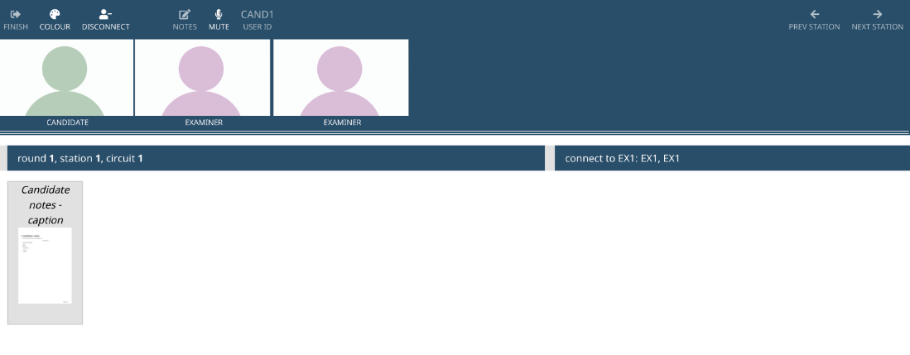
Example: Exam Started (note the yellow timing bar)
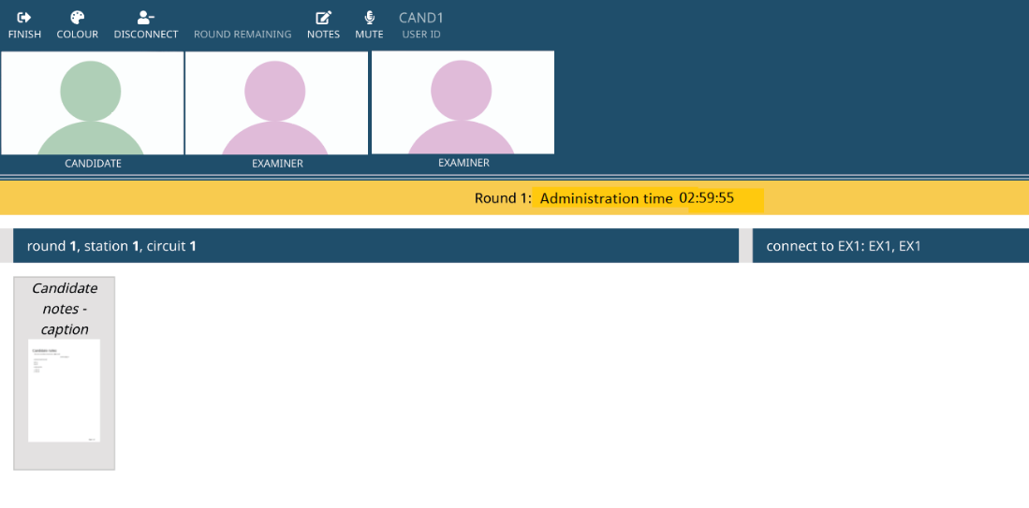

Exam Set Up
The OCE is in two parts, and you have a maximum of three hours to complete the entire exam. Part 1 is composed of two long cases and should take approximately 90 minutes (one and a half hours) to complete. Part 2 is composed of eleven shorter vignettes and should take approximately 90 minutes (one and a half hours) to complete. One examiner will lead the cases, meaning they will be the primary examiner asking questions, and the other examiner will lead the vignettes. Examiners are trained to lead both parts; but, this system allows examiners to share the responsibility of leading the exam. Both examiners are marking you throughout the exam.
All performance areas assessed during the OCE are outlined in the OCE Blueprint. You can use the How to Prepare for the OCE Checklist to confirm that you have accessed all required material to prepare for the exam. This exam progresses in a linear format meaning you will start with the first case and move sequentially through the material until you get to the end of the exam.
You will have a maximum of three hours to complete all cases and vignettes. You cannot skip a question or a case/vignette and come back to it later. The exam must be completed in the order presented. Refusing to answer a question or complete a section will result in a loss of marks for that question or selection. Examiners cannot mark information that you do not provide. Once you have completed a case or vignette, you cannot go back to it. It is considered complete. All cases and vignettes are presented in written and audio format. The audio file and the written document contain the same information.
When the exam begins, your examiners will direct you to press “Next Case” in the upper right corner of your screen. You will see the Case 1 material in the resource dashboard. You will see the written version of the Case 1 information and an audio file which contains the exact same information as the written content.

Case 1: Assessment
You will have five minutes to review the Case 1 material and take notes. Let your examiner know if you would like to start your response earlier. The first core question will be included at the end of Case 1 content. Notes can be taken on your small whiteboard, or electronically in the exam delivery platform. Any notes that you take in the exam delivery platform are for your reference only. We do not use these to assess you and your examiners do not have access to them. Any notes you take are not saved or marked.
Core questions
Once the five-minute reading time is complete, your examiners will prompt you by stating the core question. As a reminder, core questions are broad questions that are prefaced by an orientation statement to help focus your answer. Each core question should take you about five to eight minutes to complete. Make sure your answer is specifically related to the case presented and addresses the question you have been asked.
Example orientation statement with core question:
“Physiotherapists are expected to conduct a comprehensive assessment to determine a clinical impression and to guide their decisions. For this case, describe the steps you would take to conduct the assessment.” **
**To protect the confidentiality of exam content the examples presented are for illustrative purposes only. They are not reflective of actual exam content.

Probing questions
Examiners are provided with scripted probing questions which are only delivered verbally and are linked to specific performance indicators on the blueprint. Depending on the fulsomeness of your answer, you may be asked a probing question. Probing questions provide a standardized way for examiners to assess your knowledge. You do not lose marks for being asked probing questions. You can take a moment to review the case, consult your notes, or think before providing an answer if you need to, just remain mindful of the time.
Example of probing questions: **
- What is the most important objective information that you should collect?
  - Why is this information important?
- How would you determine the patient’s level of pain or discomfort?
- What effect does the patient’s pain level or discomfort have on your assessment?
**To protect the confidentiality of exam content the example presented are for illustrative purposes only. They are not reflective of actual exam content.
Interrupting
This exam assesses entry to practice competencies, not excellence. Your examiners will let you know if you have provided enough information for them to assess you and move you along to ensure that you have sufficient time to complete the exam. If you go off topic or are not addressing the question that was asked, your examiners may politely interrupt you in the interest of time.
What if I don’t understand a question?
If you do not understand a question, let your examiner know and they may be able to help by determining which part is not understood. Usually, your examiner will start by repeating the question and asking what part of the question you do not understand, or they may ask what your understanding of the question is. Some questions may not be able to be rephrased, especially if the question is asking for a core competency or information determined to be essential to the practice of physiotherapy. Examiners cannot provide definitions of essential competencies. Ensure that you have reviewed the exam blueprint and are familiar with all key words used throughout the document.
In total, Case 1 has four core questions associated with it. Each core question will be presented to you in a written format and asked verbally by your examiner. When you get to question 4 in Case 1, your examiner will share additional information about the case. You will have five minutes of reading time to review the additional information and take notes. Let your examiners know if you would like to start your response earlier. After five minutes, your examiner will prompt you by stating the core question. All written content shared with you by your examiner will appear in your resource dashboard. Review the exam demo webinar to learn how to access shared information and use other features in the platform.
Once you have completed Case 1, your examiner will instruct you to press the “Next Case” button in the upper right corner of your screen to navigate to Case 2.

Case 2: Treatment
You will have five minutes to review the Case 2 material and take notes. Let your examiner know if you would like to start your response earlier. The first core question will be included at the end of the Case 2 content. You will be asked two additional core questions for this case. Each core question will be presented to you in a written format and asked verbally by your examiner. Each core question should take you about five to eight minutes to complete. Examiners will use scripted probing questions as necessary. These probing questions are only delivered verbally.
When you have completed Case 2, you will be directed to press the “Next Case” button in the upper right corner of your screen so that you can start Part 2 of the exam – the vignettes.
Vignettes
All information related to the content of the vignettes can be found in the Exam Blueprint. Vignettes are short scenarios, normally three to five sentences long. You will have three minutes to read, take notes, and think about the presented vignette. There is only one core question associated with each vignette, presented at the end. Let your examiner know if you would like to start your response earlier, otherwise, they will prompt you at the three-minute mark by asking you the core question. Each vignette should take three to five minutes to complete. Depending on the fulsomeness of your answer, you may be asked a probing question. There are a total of 11 vignettes that you will be asked to complete.
Timing
You will have a maximum of three hours to complete the exam. Your examiners are responsible for ensuring that you are provided with the prescribed time to read cases (five minutes) and vignettes (three minutes).
Your examiners will work to keep you on time which may require polite interruption. They will make you aware of the time where appropriate throughout the exam. Your answers should be organized, concise, and grounded in the specifics/context of the presented case or vignette material. Candidates can see the time remaining in their exam on the timing bar in the middle of their screen between the resource dashboard and camera views. It is clearly labelled “Assessment Time.” It will count down from three hours to zero.

What if I have a tech issue?
If possible, your examiners or proctor will assist. If you are unable to communicate via the exam delivery platform because of a tech issue, call the exam team directly at 416-591-3828 ext. 215 or 1-800-583-5885 ext. 215.
If you are experiencing a tech issue, your examiner may suggest that you press the “Disconnect” and “Connect” button to refresh your connection with the exam platform.
What about non-technical issues?
Non-technical issues refer to events that are outside your foreseeable control that may impact your exam day experience. If you encounter a non-technical issue, the exam team will work with you directly to resolve the issue and/or create a plan to mitigate the impact of the issue on your exam performance. The issue will also be documented by staff. Depending on the issue, the exam team may ask you to email exam@collegept.org with a written statement of the issue to keep on record.
Medical (includes mental and physical medical issues)
- Your safety is our priority. Let your examiners know if you feel ill or unwell. Staff will discuss next steps with you.
- You will be asked to provide a statement to the exam team by email (exam@collegept.org) within 24 hours of your exam.
Fire Alarm
- If there is a fire alarm, let your examiners know and follow the emergency procedures of your building. Leave the computer as is and do not log out.
- Once in a safe area, call the exam team at 416-591-3828 ext. 215 or 1-800-583-5885 ext. 215 to let them know.
Administrative issues
- During the exam: Let your examiners know if you feel that something is happening that qualifies as an administrative irregularity. They will work with staff to correct the issue.
- After the exam: If you feel that an administrative irregularity has occurred, contact the exam team immediately after your exam by email (exam@collegept.org) to provide an official statement. A written record is required.
Technical issues that are mitigated by extra time or other processes do not constitute administrative issues. All technology related incidents and the corrective action taken are documented by the exam team during the exam.
More details regarding medical and administrative issues and exceptional circumstances can be found in the Exam Review Policy and the Exam Appeal Policy.
Ending your exam
This exam progresses in a linear format meaning you will start with the first case and move sequentially through the material until you get to the end of the exam. You have a maximum of three hours to complete the exam. Once you have completed the last vignette of the exam, your examiners will prompt you to submit the exam by pressing the “Finish” button and then “Submit” when prompted by the popup.

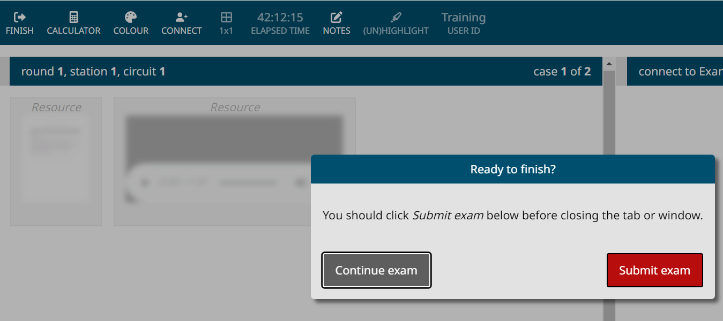

When your exam is over
Once you have submitted your exam, you can log off and close the browser. You cannot restart the exam. If you attempt to login again after submitting the exam, you will receive an error and it will be flagged for the exam team and documented in your candidate file.
Results
More information about results and exam validity can be found in the Exam Results section of the website. Results will be provided to candidates no later than eight weeks from the last exam date in the session. The College will email all candidates once results are released.

Problem solving common issues

Internet connection and stability
- It is your responsibility to ensure that your internet connection meets the minimum standards and is reliable enough to complete the exam.
- Hardwiring your device (plugging an ethernet cable directly from your router into your device) is strongly recommended.
- During the exam, you can refresh your connection by pressing the “Disconnect” and then “Connect” button.

Drop in Connection/Network error when logging into platform
1. Refresh browser/reload the page using the “Refresh” button in your browser
2. Disconnect and reconnect your computer from your internet
3. Reboot your router, and if possible, hardwire directly into your router
4. If the issue persists, contact the exam team at 416-591-3828 ext. 215 or 1-800-583-5885 ext. 215
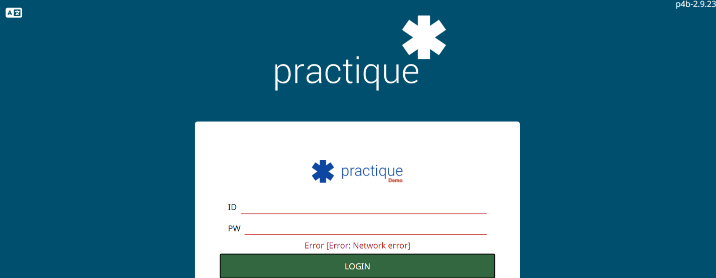

Login credentials are not working
- Ensure that you used the correct link (URL) for the exam. This link (URL) is referenced in your login email. The URL for the demo site is different than the live exam site.
- To avoid errors in transcription, copy your ID and password from your login email and paste it into the exam platform. Ensure you are not accidentally selecting a space before or after either piece of login information.
- If copying and pasting the credentials is not working, manually type the credentials in.
  - Your ID will be a series of numbers.
  - Passwords are eight alphanumeric characters and are case sensitive. The password pattern is as follows: upper case, lower case, four numbers, upper case, lower case.
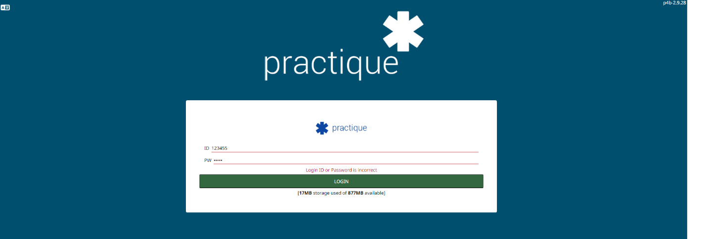
Example: Error if login credentials are incorrect

Exam is taking a long time to download

1. Clear your browser cache
- How to clear your cache Chrome
- How to clear your cache Safari
2. Once your browser cache is cleared, close all windows.
3. Launch a new window and login.

Upgrade Prompts
- If you are prompted to upgrade your browser when logging in, select “OK” and the upgrade will be applied immediately.
Enable pop ups
- Ensure pop ups are enabled in your browser settings.
  - Allow pop ups on Chrome
  - Allow pop ups on Safari
- If pop ups are disabled when you login, you will be prompted to allow popups. Select “OK.”

Connectivity errors during exam
- You will be prompted with a pop up that states “low internet connection.” This means there is an internet connection issue on your end.
- Press the “Disconnect” button and then the “Reconnect” button to reconnect with your examiners. This will refresh the site.
- If disconnecting and reconnecting does not work, try refreshing the browser. Use the refresh button on your browser. In Chrome and Safari the Refresh button is located in the URL bar and looks like this:

- If issues persist, let your examiners know and they will contact the exam team. Hardwiring your device directly into your router using an ethernet cable is a good way to avoid connectivity issues.
Audio and video issues
- If you are using a headset, make sure you have selected your headset as your speakers and microphone in the platform.
- Audio and video issues are usually the result of connectivity issues or low internet speed.
  - Attempt to refresh using the refresh button or the “Disconnect” and then “Reconnect” button.
  - It is your responsibility to ensure that your internet speed is sufficient, and your connection is reliable.
  - If issues persist, let your examiners know and they will communicate with the exam team. If your examiners cannot hear you or you cannot hear them, contact the exam team at 416-591-3828 ext. 215 or 1-800-583-5885 ext. 215.
Selecting the correct microphone

If you have more than one microphone (i.e., an external microphone from your head set and a built-in microphone from your laptop/computer), ensure you have the correct device selected.

1. Select “microphone.” This button will not appear if only one microphone is detected.

2. Ensure the correct microphone is selected. The selected microphone will be BOLDED as shown below.

In the example below, there are three microphones that the user could select. The first microphone selected is associated with the user's headset. The next microphone is associated with the user's laptop and the last microphone option is associated with the user’s external webcam. Wired headsets are recommended for candidates to reduce echo and improve clarity of the exam audio for all participants.

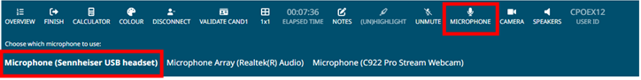

Selecting the Correct Speaker

If you have more than one speaker (i.e., an external speaker from your headset and a built-in speaker from your laptop/computer), ensure you have the correct device selected.

1. Select “speaker.” This button will not appear if only one speaker (sound source) is detected.

2. Ensure the correct speaker is selected. The selected speaker will be BOLDED as shown below.

In the example below, there are two speakers that the user could select. The first speaker is associated with the users’ built in laptop speakers. The second option is associated with the users’ external headset. Wired headsets are recommended for candidates to reduce echo and improve clarity of the exam audio for all participants.
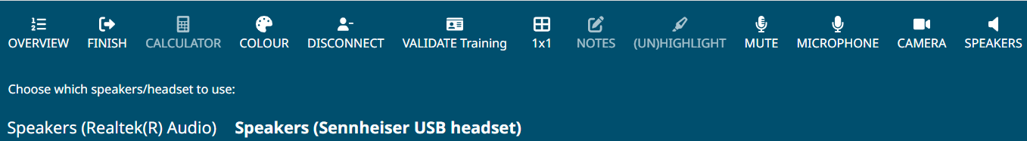

During the exam, any candidate or examiner interactions with staff regarding IT issues are documented as incident reports.
Power or internet outage
- Contact the exam team directly at 416-591-3828 ext. 215 or 1-800-583-5885 ext. 215.

