How to Create an Account in the PT Portal
In order to complete the exam registration form for the Ontario Clinical Exam (OCE), candidates need to have a PT Portal account with the College of Physiotherapists of Ontario. Candidates who have never been registered for Provisional Practice with the College will need to create a new PT Portal account.
Please follow the step-by-step instructions below to set up your account.
If you previously held or currently hold a Provisional Practice Certificate of Registration with the College, there is no need to create a new account. Please use your existing PT Portal account to register for the OCE. Your account will be connected to the email address that the College has on file for you.
Questions?
If you are unable to access your account, please contact Ann-Marie Humber at ahumber@collegept.org or 1-800-583-5885 ext. 258 or 416-591-3828 ext. 258.

Steps to Create a New PT Portal Account
Step 1:
Select the PT Portal button which appears on the College’s website www.collegept.org in the top right-hand corner or visit: https://portal.collegept.org.
Select Sign In.
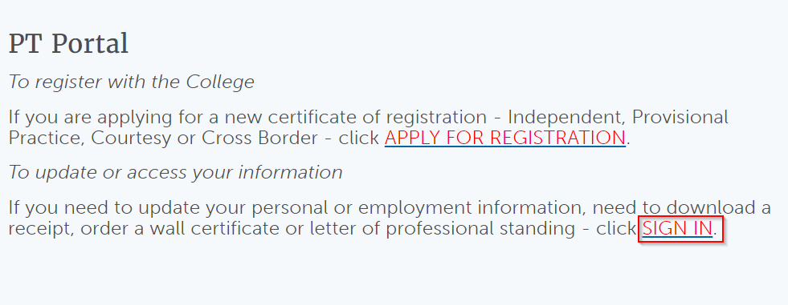
Step 2:
Click Sign up Now to begin the account creation process.
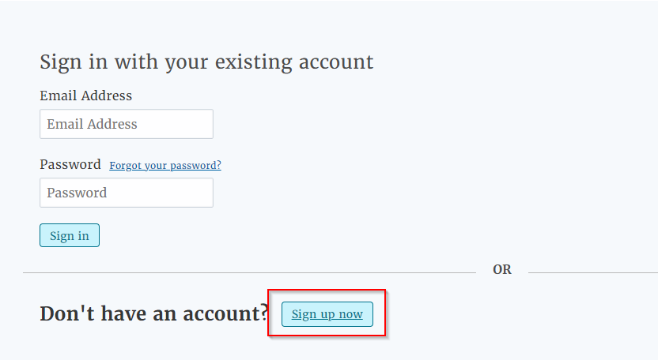
In order to create an account, you will have to send your email a verification code, and input it in the screen.
Step 3:
Type in in the verification code (do not paste) and clicking on the Sign up page "verify" button.
Step 4:
You can then create a PT Portal account with that email address and a password of your choice.
Step 5:
Provide contact information and submit information to complete the account creation process.
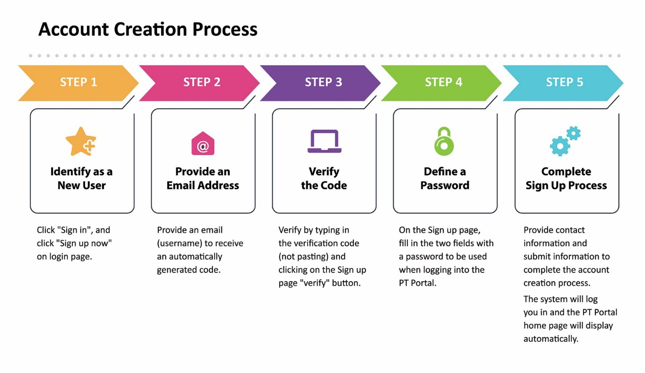
The following chart also illustrates the process:

