MEETING OF THE COUNCIL OF THE COLLEGE OF PHYSIOTHERAPISTS OF ONTARIO

MINUTES

November 27, 2020
College of Physiotherapist Boardroom & Virtually via Zoom

In-person Attendees: | Zoom Attendees: | Staff on Zoom:
Darryn Mandel, President | Theresa Stevens, PT  Martin Bilodeau, PT Janet Law, PT  Tyrone Skanes, Public Sharee Mandel, PT  Sharon Switzer-McIntyre, PT Hervé Cavanagh, PT  Nitin Madhvani, Public Ronald Bourret, Public Katie Schulz, PT  Jesse Finn, Public Karen St. Jacques, PT | Rod Hamilton, Registrar  Anita Ashton, Deputy Registrar Zoe Robinson  Melissa Collimore Shelley Martin Fiona Campbell Allan Mak  Justin Rafton Lisa Pretty Olivia Kisil Barbara Hou
Regrets:
Tom McAfee, Public Jennifer Clifford, PT
 |  | Recorder: Barbara Hou

 |  | Friday, November 27, 2020
9:00 am. | 1.0  Motion | Approval of the Agenda  It was moved by S. Mandel and seconded by R. Bourret that:  the agenda be accepted as presented with the possibility for changes to the order of items to address time constraints.
 |  |  | CARRIED.
 | 2.0  Motion | Approval of the Council Meeting Minutes of October 22-23, 2020 2.0  It was moved by M. Bilodeau and seconded by H. Cavanagh that:  the Council meeting minutes of October 22-23, 2020 including the in- camera minutes be approved.
 |  |  | CARRIED.
 | 3.0  Motion | Amendment of Committee Slate 2020-2021  It was moved by T. Stevens and seconded by S. Switzer McIntyre that:  the amendments to the Committee slate appointing J. Law as Chair to the Finance Committee and N. Madhvani to the Quality Assurance Committee be approved.
 |  |  | CARRIED.

4.0 | Investment Strategy Report  Bill Quinn, RBC advisor provided Council with an overview of the economic market amidst the COVID-19 global pandemic. Council was reassured with the College’s conservative investments in the preservation of capital and that the earnings suggest good returns keeping in line with inflation. B. Quinn, in consultation with the Registrar, reviews the markets and maturity dates periodically.
5.0 | Canadian Alliance of Physiotherapy Regulators (CAPR) Board Representative Update  D. Mandel declared a Conflict of Interest (COI) with the agenda item.  Gary Rehan, CAPR board representative informed Council that due to COVID-19 restrictions and physical limitations, CAPR had cancelled the June & November 2020 clinical exam. In 2021, in order to accommodate approximately 3000 candidates, CAPR is proposing to host the clinical component of the exam in a OSCE format on a virtual platform, while allowing for special accommodations.
6.0 | Program Area Operations Report (Q1 & Q2)  Council was presented the College’s Program area reports for 2019- 2020 highlighting:
 | - Registration | - Professional Conduct
 | - Quality Assurance | - Compliance Monitoring
 | - Practice Advice | - Hearings highlight
 | - Communications | - Executive Office
 | - Corporate Services | - Strategic Projects & Policy
 | - Patient Relations
7.0 | Annual Committee Reports 2019-2020  All Committee Chairs provided an update on the Committee’s activities for 2019-2020:
 | - Executive Committee  - Finance Committee  - Registration Committee  - Quality Assurance Committee | - Patient Relations Committee  - Inquiries, Complaints and Reports Committee  - Discipline and Fitness to Practise Committee
8.0 | 2020/21 Q2 Financial Management Report  Zoe Robinson, Director of Corporate Services, presented Council with the College's financial performance for Quarter 2 (Q2), ending September 30, 2020 and forecasting for upcoming quarters.

9.0  Motion | Appointment of Auditor  It was moved by T. Skanes and seconded J. Law that:  Council appoints Hilborn LLP as the Auditor for the fiscal year ending March 31, 2021.
 |  | CARRIED.
10.0  Motion | Honorary Physiotherapist Designation  At their December 2019 meeting, Council approved in principle the creation of an honorary membership designation.  After considering alternative policy options that had been identified in response to issues noted by Council at its last consideration of this matter in December 2019, and in response to the Executive Committee recommendation that Council approve a governance policy describing an Honorary Recognition Award rather than create an honorary membership by-law, Council proposed the acceptance of an Award.  It was moved H. Cavanagh and seconded K. Schulz that:  Council approves the Governance Policy-Honorary Recognition Award.
 |  | CARRIED.
11.0  Motion | College Policies Framework  As part of the Colleges By-law and Governance review, a framework for policy development, decision making, and approval was developed. Staff will support the policy development for Council and Committees. Policies will be reviewed on a defined schedule and as needed to respond to emerging issues and changes.  This framework was considered by the Executive Committee and recommended for approval by Council.  It was moved T. Skanes and seconded R. Bourret that: Council approves the College Policies framework.
 |  | CARRIED.
12.0 | President’s Report  D. Mandel, President, provided an update on the following:  - Responsibilities handling affairs with legal opinions, COI, office lease, and copyright infringement  - Pursuing legal council appropriate for College matters  - Executive and Finance Committee  - QA Working group  - Registrar review process
13.0 | Registrar’s Report  R. Hamilton, Registrar provided an update on the following:

- Budget operational planning
- Strategic planning for 2021-2022
- COVID-19 lockdown communication
- CAPR clinical exam townhall information
- Staffing update: New Policy Analyst Evguenia Ermakova
14.0 | Members’ Motion/s  J. Law added a member’s motion on the inclusion of Land Acknowledgments as part of the Truth and Reconciliation process.
 | Adjournment
It was moved by S. Switzer-McIntyre that the Council meeting be adjourned.  The meeting was adjourned at 1:00 p.m. |  | CARRIED.
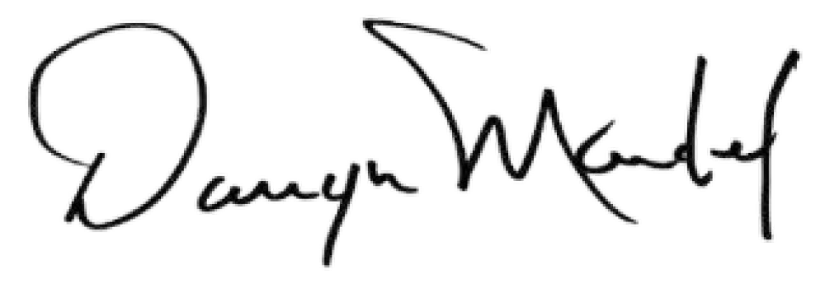
Mr. Darryn Mandel, President

