MEETING OF THE COUNCIL OF THE COLLEGE OF PHYSIOTHERAPISTS OF ONTARIO

MINUTES

September 23, 2020

Chelsea Hotel, Toronto & Virtually via Zoom

In-person Attendees: | Zoom Attendees: | Staff on Zoom:
Darryn Mandel, President | Martin Bilodeau, PT | Rod Hamilton, Registrar
Theresa Stevens, PT Vice President | Hervé Cavanagh, PT | Anita Ashton, Deputy Registrar
Janet Law, PT | Karim Kanji, Public | Lisa Pretty
Tyrone Skanes, Public | Ronald Bourret, Public | Zoe Robinson
Sharee Mandel, PT | Katie Schulz, PT | Justin Rafton
Jennifer Clifford, PT | Jesse Finn, Public | Olivia Kisil
Sharon Switzer-McIntyre, PT | Karen St. Jacques, PT | Barbara Hou
Regrets: Tom McAfee, Public | Nitin Madhvani, Public | Recorder: Barbara Hou

 | Wednesday September 23, 2020
9:00 am. | Additional item CAPR examination was added before the Elections.  Approval of the Agenda 1.0  It was moved by T. Skanes and seconded by R. Bourret that:  the agenda be accepted as presented with the possibility for changes to the order of items to address time constraints.
1.0
Motion
 |  | CARRIED.
2.0  Motion | Appointment of New Academic Member 2.0  It was moved by J. Law and seconded by J. Clifford that:  Council ratify the appointment of Ms. Sharon Switzer-McIntyre to Council as the academic councillor from the University of Toronto effective September 23, 2020 to June 2023.
 |  | CARRIED.

3.0  Motion | Approval of the Council Meeting Minutes of December 16-17,  2019  3.0  It was moved by T. Skanes and seconded by S. Mandel that:  the Council meeting minutes of December 16-17, 2019 be approved.
 |  | CARRIED.
4.0 | Executive Committee Minutes  Council was provided with an overview of the Executive Committee’s activities since the December 2019 Council meeting and during the Covid-19 emergency response.  Due to the urgent need associated with the Covid pandemic, Executive Committee met on an emergent basis to provide advice on the College registrants on 18 ocassions between March and June.  Members of Council inquired about the following:  - The frequency of the updates provided to Council  - The reasons why Council as a whole did not meet  - The status of the relationship between the President and the Registrar  - The role of the Executive Committee in operational matters  There was a suggestion for the creation of a centralized repository to allow members of Council to access background documents and in this case decisions made by the Executive Committee in a timely manner
5.0 | President, Vice President and Executive Committee Election  R. Hamilton, Registrar provided an overview of the elections process which would be supported by the electronic online voting system.  Election of the President:  The following nomination was received:  President:  - D. Mandel, PT  Rod Hamilton called for additional nominations from the floor; none were received  D. Mandel was acclaimed President.  Election of the Vice President:

The following nomination was received

Vice President:
- T. Stevens, PT

Rod Hamilton called for additional nominations from the floor; none were received

T. Stevens was acclaimed Vice President

Election of the Executive Committee: members-at-large
The following nominations were received for the remaining three positions:
- J. Law, PT
- R. Bourret, public representative
- T. Skanes, public representative
- S. Mandel, PT

Rod Hamilton called for additional nominations from the floor; none was received.

The following individuals were elected to the Executive Committee as members-at-large for the 2020-2021 year.
- R. Bourret
- T. Skanes
- S. Mandel

The following councillors will make up the Executive Committee for the 2020-2021 year:
- D. Mandel (President)
- T. Stevens (Vice President)
- R. Bourret
- T. Skanes
- S. Mandel
6.0  Motion | Approval of the 2020-2021 Committee Slate  It was moved by T. Skanes and seconded by S. Mandel that: Council appoint Monica Clarke to the Inquiries, Complaints and  Reports Committee (ICRC) replacing Katie Schulz and Karim Kanji be appointed to the Quality Assurance Committee replacing Jesse Finn as presented on the draft Committee slate.  The following suggestions were made for future improvements to the process:  - That Council members be advised of their potential appointments in advance

- That Council members be advised of how long individuals have been on various committees  With the changes noted above, Council approves the proposed committee slate for 2020-2021. |  | CARRIED.
Executive Committee:  Inquires, Complaints and Reports Committee:  Discipline and Fitness to Practise Committee:  Quality Assurance Committee: | Darryn Mandel, PT (Chair) Theresa Stevens, PT Sharee Mandel, PT  Ron Bourret, Public Tyrone Skanes, Public  Gary Rehan, PT non council (Chair)  Monica Clarke, PT Theresa Stevens, PT Jennifer Clifford, PT Tyrone Skanes, Public Tom McAfee, Public  Sharee Mandel, PT (Chair) Janet Law, PT  Martin Bilodeau, PT Jennifer Clifford, PT Karen St. Jacques, PT  Sharon Switzer-McIntyre, PT Theresa Stevens, PT  Katie Schulz, PT  Herve Cavanagh, Public Ron Bourret, Public Nitin Madhvani, Public Jesse Finn, Public  Tom McAfee, Public Karim Kanji, Public  James Wernham, PT non council Daniel Negro, PT non council Sue Grebe, PT non council Angelo Karalekas, PT non council  Nicole Graham, PT non council Richa Rehan, PT non council  Theresa Stevens, PT (Chair) Herve Cavanagh, PT  Tom McAfee, Public Karim Kanji, Public  Antoinette Megens, PT non council  Elizabeth Bergmann, PT non council

Registration Committee:

Patient Relations Committee:

Finance Committee:
Tyrone Skanes, public (Chair) Katie Schulz, PT
Martin Bilodeau, PT Jesse Finn, Public
Anastasia Newman, PT non council

Sharee Mandel, PT (Chair) Karen St. Jacques, PT
Ron Bourret, Public Antoinette Megens, PT non council

Darryn Mandel, PT Theresa Stevens, PT Janet Law, PT Jennifer Clifford, PT
Nitin Madhvani, Public

7.0 Canadian Alliance of Physiotherapy Regulators (CAPR) executing examination during Covid-19

H. Cavanagh and M. Bilodeau declared a Conflict of Interest (COI)

Gary Rehan, CAPR board representative advised Council that due to COVID-19 CAPR was considering its options as it related to the clinical component of the exam. The June 2020 clinical exam was cancelled, and the November 2020 exam was pending.

The exam (OSCE) is held in person across the country and due to provincial requirements regarding travel and physical distancing, all registered candidates will not be able to attempt the PCE in November.

Gary Rehan commended CAPR for its thoughtful and careful consideration of all of the challenges related to hosting the exam.

Council advised that if at all possible CAPR should host the November 2020 exam, and that registration priority would be assigned on a first come first served basis based on the date that the candidate submitted their application.

8.0 President’s Report

D. Mandel, President, provided an update on the following:
- Council turnover and transition planning
- Committee Orientation

- The relationship between the College and CAPR
- Retaining legal counsel for Council
- A meeting with Allison Henry of the Ministry (MOHLTC) where the Performance Measurement Framework was discussed
9.0 | 2019-2020 Q3 Financial Report  Council reviewed and accepted the Q3 Financial Report. Questions were raised regarding the use of the College’s reserves and the concept of a deficit budget, the status of the College’s lease given the fact that the College is operating virtually and the pending decrease in income due to the potential cancellation of the clinical exam.
10.0  Motion | Approval of 2020-2021 Budget 10.0  It was moved by T. Skanes and seconded by J. Law that:  That Council approve the Operating and Capital Budgets for the 2020-2021 Fiscal year that were revised by the Finance Committee in August and considered by the Executive Committee in September.
 |  | CARRIED.
11.0 | 2020-2021 Q1 Financial Report  Council reviewed and accepted the Q1 Financial Report
12.0 | The College’s Relationship with the Canadian Alliance of Physiotherapy Regulators (CAPR)  H. Cavanagh and M. Bilodeau declared COI  D. Mandel provided Council with an overview of the College’s current relationship with CAPR and his perception of the current issues in the relationship as outlined in the supporting briefing note. These include but are not limited to the governance and reporting structure.  Council approves the following:  The Executive Committee seek a legal opinion to assess the College’s current relationship with CAPR. Key areas of focus would be the opportunity to become an affiliate member and the disclosure of exam results. Council would be provided with the information being shared with counsel in advance of the request  being made.

That staff seek a legal opinion regarding if, when and how current
council members could have a conflict of interest as it relates to the ongoing discussion regarding the College’s relationship with CAPR.
13.0 | Registrar’s Report  R. Hamilton Registrar, provided an update on the following:  - Activities undertaken by the College program areas since December 2019  - The Operations Report since December 2019  - Service delivery in the virtual office  - The ongoing work of the Finance and Executive Committee  - Financial projections and budget planning as a result of COVID-19
14.0 | Bylaw and Governance Review – Recommended Changes  Council agreed to defer this to the October Council meeting due to time constraints.
15.0  Motion | 2020-2021 Audited Financial Report  Mr. Blair Mackenzie Hilborn provided an overview of the audited financial statements for 2019 / 2020. The auditor noted that it was a “clean audit” and no concerns were identified. It was also noted that this audit was completed virtually.  It was moved by T. Skanes and S. Mandel that:  Council approve the 2019-2020 Audited Financial Statements ending March 31, 2020.
 |  | CARRIED.
 | Adjournment
 | It was moved by T. Skanes and S. Mandel that the meeting be adjourned.  The meeting was adjourned at 4:00 p.m. | CARRIED.

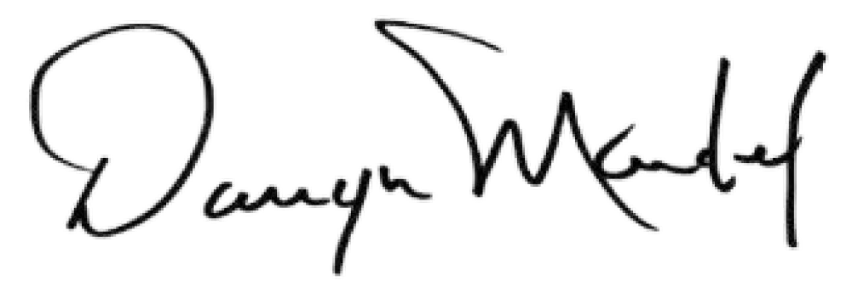Mr. Darryn Mandel, President

