Annual Report 2017–2018

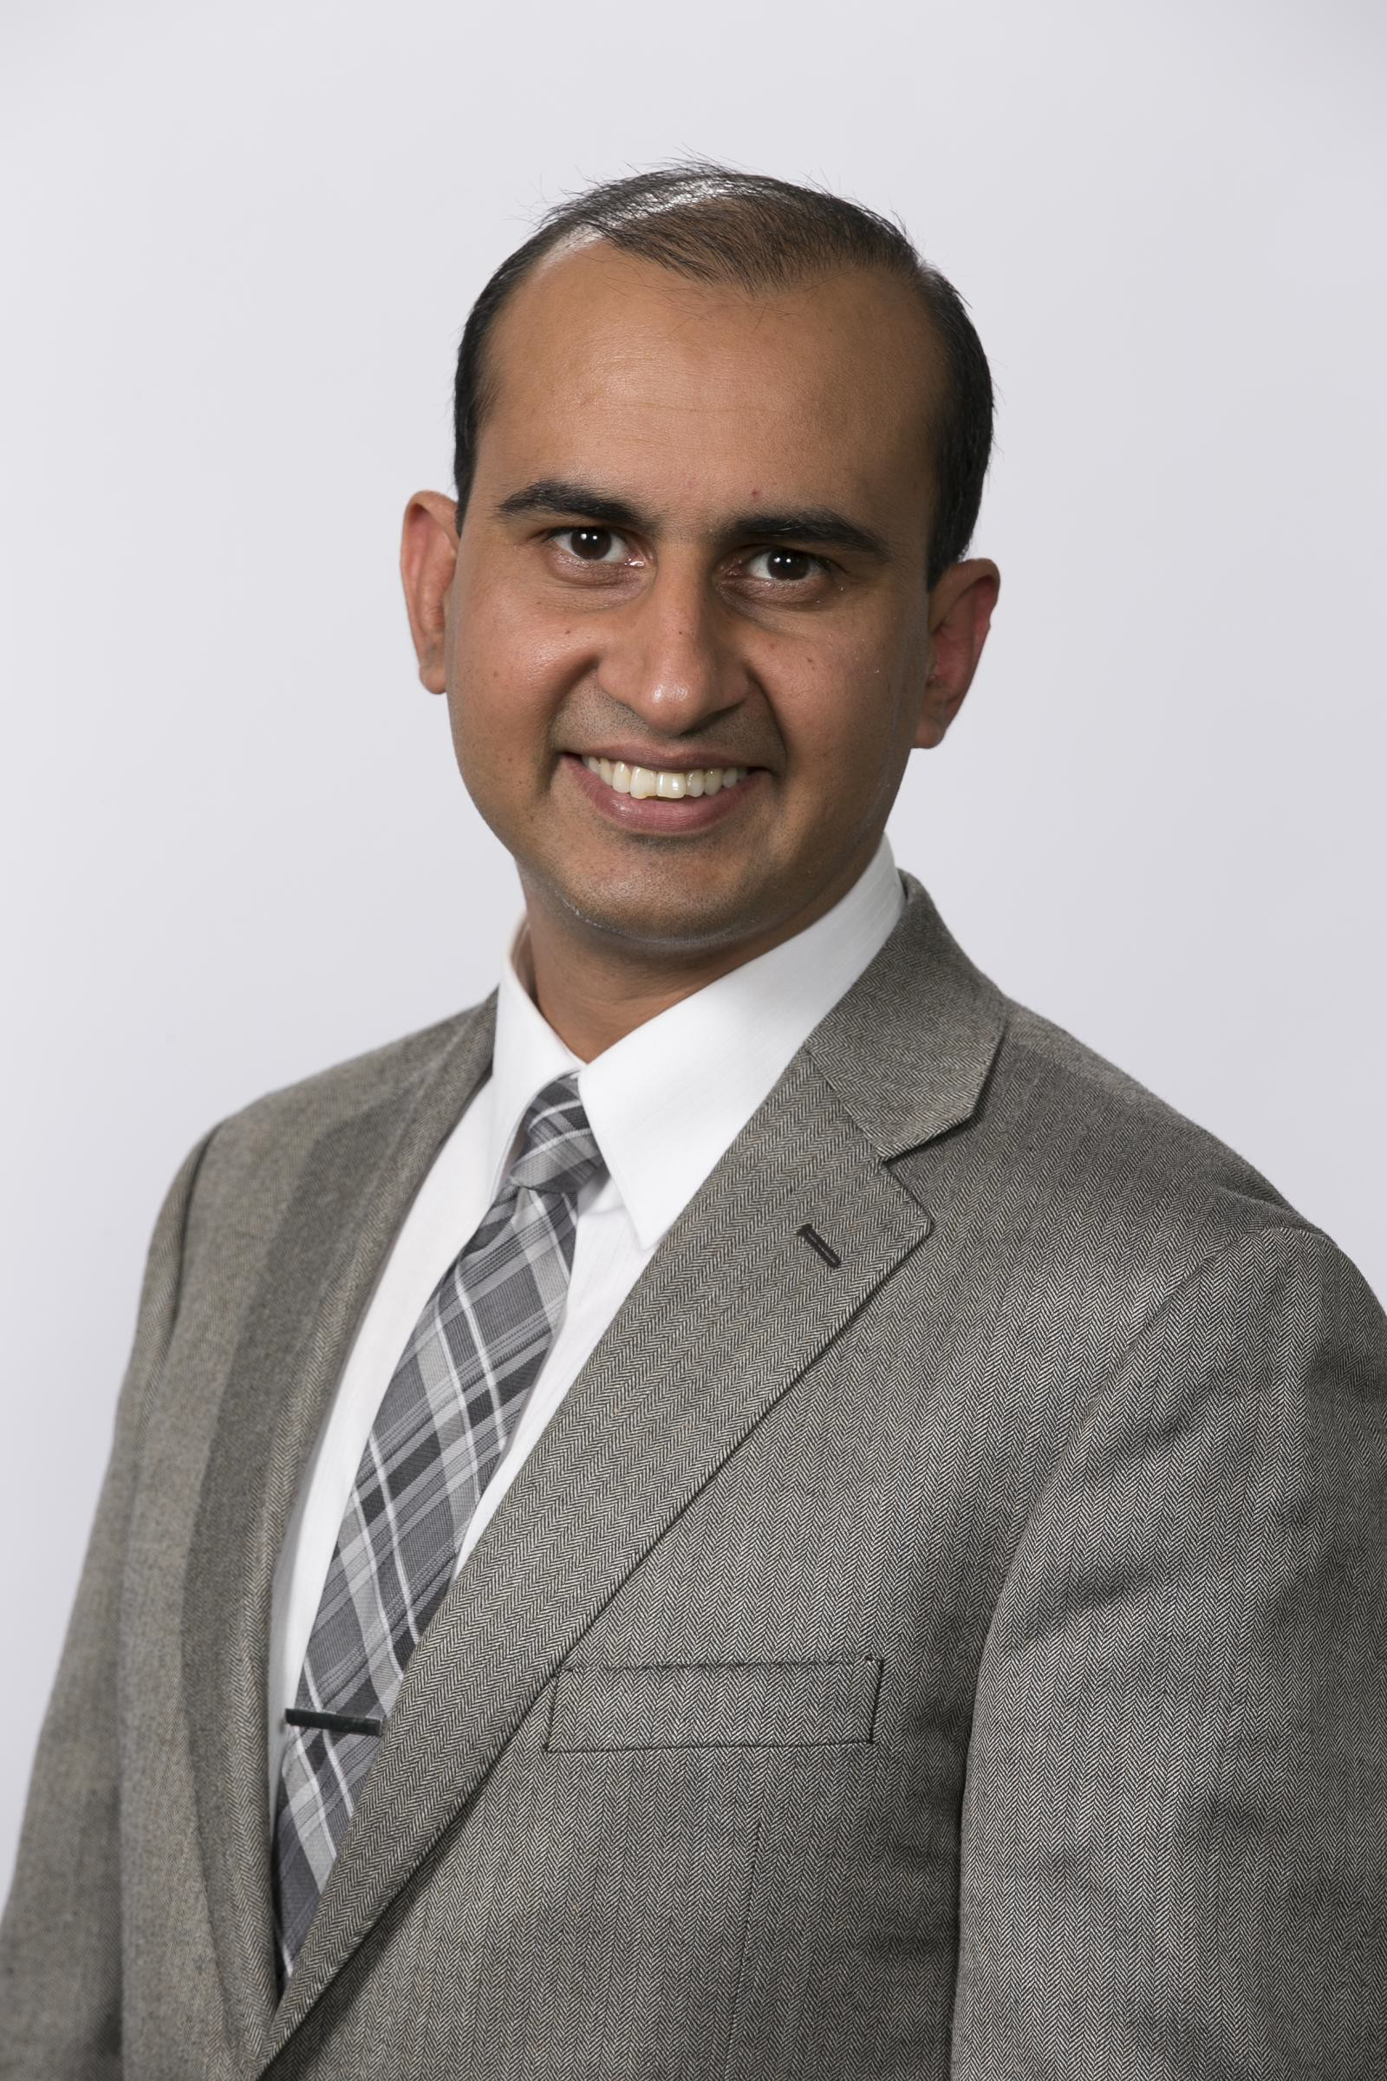
Letter from the President
Over the past year I have taken great pride in my role as Council President and I am delighted to recap another successful year for the College of Physiotherapists of Ontario. As you continue through the annual report you will ﬁnd highlights from a number of key initiatives and I would like to take this opportunity to speak to one speciﬁcally—the development of the new Quality Assurance program.
A project of this scale requires signiﬁcant preparation and multi-faceted research in order to generate informed solutions and maximize efﬁciency. The research consisted of extensive consultations with all stakeholders including physiotherapists, the public, the academic community and those who have been involved with the current Quality Assurance program, along with a meticulous study of programs from other regulators and best practices from around the world.
Armed with a library of research, a dedicated Quality Assurance Working Group— made up of Council and Committee members, members of the public and College staff—scrutinized the data and established the framework for a more streamlined and responsive program.

With collaboration at the forefront of the project, a second consultation phase was launched with physiotherapist members and other stakeholders to validate the recommended changes and ensure that the College was on the right path. The results were positive and the feedback received via surveys and in-person consultations was invaluable in making adjustments and developing a detailed work plan.
The new program has been approved by Council and will launch next spring. For updates please continue to watch the College website, Perspectives e-newsletter and our social media channels.

As I enter my second term as President, I am looking forward to seeing the Quality Assurance project, along with many other important initiatives, come to fruition as the College works to fulﬁll its strategic goals. I would like to thank my fellow Council members and College staff for their hard work and dedication over the past year.
Sincerely,
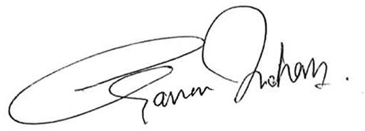

Gary Rehan, PT
President, College of Physiotherapists of Ontario president@collegept.org

Letter from the Registrar

I’m happy to report anotherbusy and productive yearat the College.

First and foremost, we implemented a newstrategic plan. Forthe next three years, we’ll focus on the following three goals:

- Ensure physiotherapists’ business practices meet professional standards and do not damage the reputation of the profession.
- Promote quality physiotherapy services by ensuring registered physiotherapists are aware of and adhere to professional standards and expectations .
- Increase the value and awareness of the services the College provides for Ontarians.

The cornerstone of accomplishing ourstrategic goals is communication. Our approach to regulation is to make every effort to advance education and foster cooperation.

In the past year, we made 11 visits to Ontario University programs and the Bridging Program at the University of Toronto, attended the Physio North conference, and made more than 10 presentations (in person and via
videoconference) to hospitals, PT employers and PTA programs. Plus, we hosted breakfast and had a booth at OPA’s InterACTION conference where we met approximately 250 PTs and PT students.
We also attended the Zoomer Show in Toronto for the first time this year, where we connected with 500 patients and caregivers. This was part of our effort to ensure that we have an opportunity for frank exchange with the public we were created to serve. We also partnered with Ontario’s other health regulatory colleges to create a single website for members of the public to access information about all health care providers in Ontario – ontariohealthregulators.ca.
Finally, we built on our
earlier success in convening a Citizen Advisory Group to meet regularly and provide unfiltered advice as to how we can best meet patient and caregiver needs.

From an operational perspective, modernization of our information system has been a demanding project this year as physiotherapists

tested our new online annual renewal system and member portal. Members of the public will see the difference in our brand new website and Public Register. We’re not done with these changes yet, but we’re proud to say that the new public register contains more information and is more user friendly than ever before.
We’re looking forward to a
year ahead that’s just as busy and fruitful as the last. Please be sure to flip through the annual report to see more details from each of our program areas, along with some fun facts.
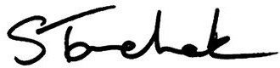
Shenda Tanchak Registrar and CEO
College of Physiotherapists of Ontario

About the College

The College of Physiotherapists of Ontario is the regulatorforphysiotherapists in Ontario. We believe patients have the right to safe, competent and ethical physiotherapy care.
We work to protect and serve the public interest, and to continually improve the practice of more than 9,500 physiotherapists, also known as physical therapists.

By law, we are required to:
make certain that only qualifled people can practice as physiotherapists
ensure that physiotherapists continue learning throughout theircareer
make sure that all physiotherapists meet our standards forentry into the profession
and forongoing conduct and practice considerall complaints and concerns brought to the College’s attention by the public

Ourwork is guided by the College Council, which is

made up of:
members of the public—appointed by the Lieutenant Governorof Ontario
physiotherapists—elected by theirpeers
academic representatives who are physiotherapists
—appointed by theireducational institutions
Deborah Lucy
The College would like to acknowledge the passing of Deborah Lucy, a long-term, well respected and committed Academic Council and Committee member.
Our sympathies go out to her family and friends.

COUNCIL MEMBERS 2017-2018

Elected Representatives

Gary Rehan President

Nicole Graham Janet Law

Sharee Mandel Stephen Mangoff (until June 20, 2017)

Catherine Hecimovich
Vice President
Gary Rehan
Theresa Stevens
Lisa Tichband

(from June 21, 2017 to
February 27, 2018)

Academic Representatives

Darryn Mandel Vice President
(from March 19, 2018)
Nadine Graham McMaster University

Public Appointees
Deborah Lucy
Western University (until June 20, 2017)
Kathleen Norman Queen's University

THE COUNCIL
is the governing body for more than 9,500 PTs practicing in Ontario.
Council is made up of 8 elected physiotherapists, 2 academic representatives and
- government-appointed public members.
Councillors are

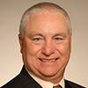
Ronald Bourret Jane Darville Zita Devan Jennifer Dolling

responsible for ensuring the protection of the public interest.
James Lee Shadi Katirai
(until April 15, 2017)
Ken Moreau
(from November 29, 2017)
Tyrone Skanes

COMMITTEE MEMBERS 2017-2018

Executive Committee
Gary Rehan—Chair (from June 21, 2017) Darryn Mandel
Tyrone Skanes
Theresa Stevens (from June 21, 2017)
Catherine Hecimovich (until February 27, 2018)
Stephen Mangoff (until June 20, 2017)
Professional Committee Members
Michelle Addison Jatinder Bains
Kelly Brewer (until June 20, 2017) Sheila Cameron
Marcia Dunn Vinh Lu
Deborah Lucy (from June 21, 2017 to April 15, 2018) Daniel Negro
Lori Neill
Jim Wernham

Discipline and Fitness to Practise Committee Darryn Mandel—Chair (from March 19, 2018) Sheila Cameron
Nadine Graham (until June 20, 2017) Ronald Bourret
James Lee Zita Devan Daniel Negro Jim Wernham Lori Neill
Lisa Tichband (from June 21, 2017)
Catherine Hecimovich (until February 27, 2018)
Janet Law (until June 20, 2017)
Inquiries, Complaints and Reports Committee (ICRC)
Michelle Addison—Chair Sharee Mandel
Gary Rehan Tyrone Skanes Jane Darville Vinh Lu
Kenneth Moreau (from March 20, 2018)
Sheila Cameron (until June 20, 2017)
Jennifer Dolling (until June 20, 2017)
Zita Devan (until June 20, 2017)
Registration Committee
Jennifer Dolling—Chair (from June 21, 2017) Marcia Dunn
Janet Law (from June 21, 2017)
Jane Darville (from June 21, 2017)
Kathleen Norman (from September 28, 2017)
Shadi Katirai (until April 15, 2017)
Gary Rehan (until June 20, 2017)
Nadine Graham (until September 27, 2018)

Quality Assurance Committee Theresa Stevens—Chair Ronald Bourret
Lisa Tichband (from June 21, 2017) James Lee
Jatinder Bains Deborah Lucy
Kelly Brewer (until June 20, 2017)

Finance Committee James Lee—Chair Gary Rehan
Janet Law
Nicole Graham (from June 21, 2017)
Darryn Mandel (from March 19, 2018)
Catherine Hecimovich (until February 27, 2018)
Stephen Mangoff (until June 20, 2017)
Lisa Tichband (until June 20, 2017)
Patient Relations Committee
Sharee Mandel—Chair
Jatinder Bains (from June 21, 2017)
Nicole Graham (from June 21, 2017)
Zita Devan (from June 21, 2017)
Lisa Tichband (until June 20, 2017)
Vinh Lu (until June 20, 2017) Shadi Katirai (until April 15, 2017)
The Canadian Alliance of Physiotherapy Regulators Representative
Darryn Mandel

Practice Advice/Physiotherapy Information Advisor
Patients, family members, physiotherapists, employers and others can contact the College for confidential advice about the practice of physiotherapy. This service is offered to support the quality of practice
for physiotherapists, and to help the public better understand their rights as physiotherapy patients.

Practice Advice
1-800-583-5885 ext. 241
647-484-8800
practiceadvice@collegept.org

MAIN USERS OF PRACTICE ADVICE 2017-2018

PTs
70
7
7
10
20
30
40
50
60
70
7
9

Employers

Patients

PT Residents and Students

Other

0

2016-2017
Calls by Employers: Increased by 2% from 2016–2017 Calls by Patients: Increased by 3% from 2016–2017

TOP 5 Questions from Patients

Looking to Find a PT Asking How to Make a Complaint Clarifying Information on Fees, Billing and Accounts
General Questions about Physiotherapy Care Other

TOP 5 PT Issues from PTs

Patient Records (Privacy, Security, and Access)

Patient Care: (PT Assessments, Diagnosis, and Treatments, Controlled Acts & Other Restricted Activities) Practice Management (Fees, Billing, and Accounts, Advertising, Starting or Leaving a Practice)
Professional Obligations (Duty to Warn, Mandatory Reporting, Liability Insurance) Supervision—Delegation and Responsibility for Treatment Assigned to PTAs

Strategic Goals 2017–2020
On April 1, 2017 the College launched a new three-year strategic plan with three overarching goals:

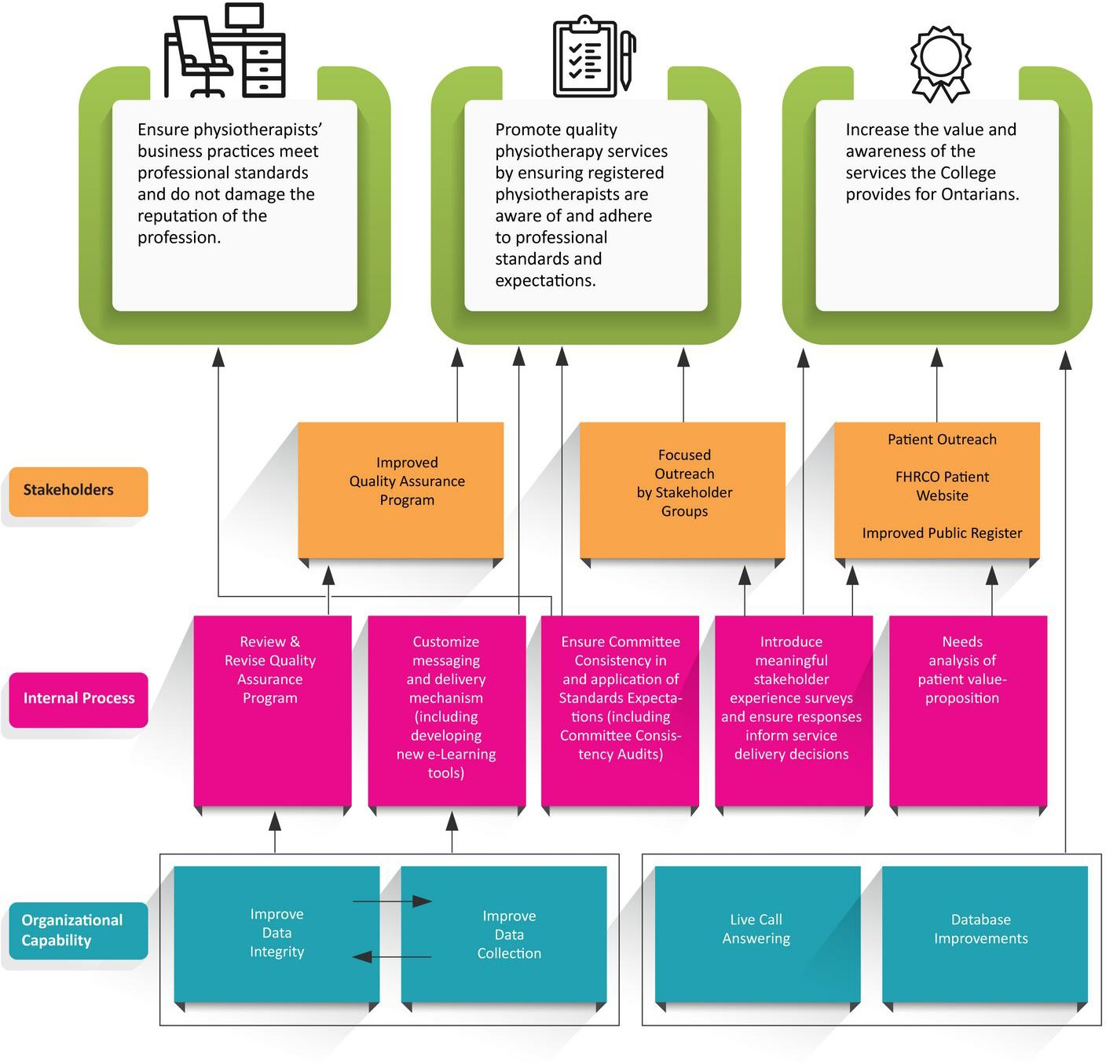

2017-2018 Highlights

In pursuit of these goals we successfully launched a number of initiatives.

Bill 87: Better Support and Protection for Patients
Conducted sexual abuse awareness training for all Council members
Launched new Boundaries and Sexual Abuse Standard
Improved access to funding for therapy or counselling for victims of sexual abuse
Reviewed all cases in progress with allegations related to sexual abuse and offered funding for therapy or counselling to patients involved in the intake or investigations phase
Expanded the definition of ‘patient’ to include any individual under the member’s care in the past year
Considered suspension or restrictions of a member’s license at any time following an allegation of sexual abuse
Updated website information on mandatory reporting
Confirmed our commitment to not use gender-based restrictions
Committed to building our video library for training purposes
  - Understanding and Managing Our Own Values, Beliefs, Feelings, and Response to Sexual Abuse

Quality Assurance Consultations
Engaged more than 1,000 physiotherapists in person and via webinars
Conducted two rounds of Council discussions resulting in the development of a Quality Assurance Working Group with Council members, Committee members, College staff and patient representatives
365 online member consultations
Targeted online consultations: 247 responses from recently assessed PTs, 41 responses from peer assessors, current and past Quality Assurance Committee members and other regulators
Conducted patient consultations via the Citizen Advisory Group
Completed environmental scan of best practices in Canada and abroad

Broad and segmented consultations with different stakeholders aiding in the development and redevelopment of eight standards
Introduced a streamlined approach to writing Standards, and improved readability using plain language.

- New Standards Passed

Boundaries and Sexual Abuse Standard – June 2017 Supervision Standard – June 2017
Conflict of Interest Standard – June 2017

Restricted Titles, Credentials and Speciality Designations Standard – June 2017 Infection Control and Equipment Maintenance Standard – September 2017 Record Keeping Standard – September 2017
Collaborative Care Standard – September 2017 Providing and Refusing Care Standard – March 2018

By-law and Standard Consultations

Updated CPO By-laws and circulated for public consultation

Advertising Audit
 4,364 facility websites covering the practice of 8,463 physiotherapists were reviewed to ensure compliance with the Advertising Standard

Efforts to Connect with Physiotherapists and Students in Ontario
 Ten visits to Ontario Universities and Bridging Programs to speak with first and second year students
 More than 10 presentations covering curated topics to hospitals, physiotherapy employers and PTA programs, both in person and via webinar
 Participated in the Physio North conference
 Breakfast presentation to more than 200 physios at the OPA annual InterACTION conference, plus a booth where we connected with more than 250 PTs and students

Scope of Practice Submission to Government
 Submitted in partnership with the Ontario Physiotherapy Association
 Provided additional information regarding a physiotherapist’s ability to order diagnostic tests, at the request of the Ministry of Health

Physiotherapy Information Advisor Interactions
 Answered 4,850 total calls this year
 Added a fourth Advisor to help with increased volume of calls and emails

In-Person Patient Outreach
 Connected with more than 500 patients and caregivers face-to-face at the Zoomer Show

Patient and Caregiver Research (in partnership with Goldfarb Market Intelligence)
 Patient focus groups explored a variety of topics and inspired the updated website and Public Register
 Conducted fraud-related surveys

Ongoing Commitment to Communication
 Strong focus on patients, caregivers and academics
 Revamped social media strategy focused on Facebook, Twitter and YouTube
 Initiation of a quarterly update to Ontario Universities with physiotherapy programs

Training for Council Members
 Governance training completed
 Sexual abuse awareness training completed

Commitment to External Relationships and Collaboration
 Federation of Health Regulatory College of Ontario (FHRCO), College Registrar Shenda Tanchak is President
 Advisory Group of Regulatory Excellence (AGRE)
 Canadian Alliance of Physiotherapy Regulators (CAPR)
 Physiotherapy Education Accreditation Canada (PEAC)

Cross Border Care
 Create a new Certificate of Registration to allow for the provision of cross-border care Canada-wide.

Citizen Advisory Group Contribution of Feedback
 Changes to the Quality Assurance program
 Specialty designations
 What is viewed as a conflict of interest
 Patient/caregiver focused website content and messaging
 How we define the term ‘patient’
 Updates to the Public Register

Launched Citizen Advisory Group Partnership
Now includes 13 regulatory health colleges and continues to grow.

College of Dental Hygienists of Ontario
College of Denturists of Ontario
College of Massage Therapists of Ontario
College of Medical Laboratory Technologists of Ontario
College of Medical Radiation Technologists of Ontario
College of Naturopaths of Ontario
College of Nurses of Ontario
College of Occupational Therapists of Ontario
College of Opticians of Ontario
College of Optometrists of Ontario
College of Physicians and Surgeons of Ontario
College of Physiotherapists of Ontario
Ontario College of Pharmacists

Summary
Financial Statements

Report of the Independent Auditor on the Summary Financial Statements To the Council of the College of Physiotherapists of Ontario

The accompanying summary ﬁnancial statements, which comprise the summary statement of ﬁnancial position as at March 31, 2018, and the summary statement of operations for the year then ended, and related note, are derived from the audited ﬁnancial statements of the College of Physiotherapists of Ontario for the year ended March 31, 2018. We expressed an unmodiﬁed audit opinion on those ﬁnancial statements in our report dated June 26, 2018.
The summary ﬁnancial statements do not contain all the disclosures required by Canadian accounting standards for not-for-proﬁt organizations. Reading the summary ﬁnancial statements, therefore, is not a substitute for reading the audited ﬁnancial statements of the College of Physiotherapists of Ontario.

Management’s Responsibility for the Summary Financial Statements
Management is responsible for the preparation of a summary of the audited ﬁnancial statements on the basis described in the note to the summary ﬁnancial statements.

Auditor’s Responsibility
Our responsibility is to express an opinion on the summary ﬁnancial statements based on our procedures, which were conducted in accordance with Canadian Auditing Standard (CAS) 810, “Engagements to Report on Summary Financial Statements”.

Opinion
ln our opinion, the summary ﬁnancial statements derived from the audited ﬁnancial statements of the College of Physiotherapists of Ontario for the year ended March 31, 2018 are a fair summary of those ﬁnancial statements, on the basis described in the note to the summary ﬁnancial statements.

Hilborn LLP
Chartered Professional Accountants Licensed Public Accountants
Toronto, Ontario June 26, 2018

Note to Summary Financial Statements
March 31, 2018 Basis of presentation
These summary ﬁnancial statements have been prepared from the audited ﬁnancial statements of the College of Physiotherapists of Ontario (the “College”) for the year ended March 31, 2018, on a basis that is consistent, in all material respects, with the audited ﬁnancial statements of the College except that the information presented in respect of changes in net assets and cash ﬂows has not been presented and information disclosed in the notes to the ﬁnancial statements has been reduced.
Complete audited ﬁnancial statements are available to members upon request from the College.

Please contact the College of Physiotherapists of Ontario at info@collegept.org or 1-800-583-5885 ext. 256 to request a copy of the complete set of audited ﬁnancial statements.

 | 5,489,678 |  | 5,656,159
Deferred lease incentives | 246,225 |  | -
 | 5,735,903 |  | 5,656.159
Net assets
Invested in capital assets | 719,349 |  | 180,073
Internally restricted for contingency | - |  | 6,078,725
Internally restricted for fee stabilization | - |  | 327,865
Internally restricted for complaints and discipline | 1,000,000 |  | -
lnternally restricted for sexual abuse therapy | 100,000 |  | -
Internally restricted for strategic initiatives | 500,000 |  | -
Internally restricted for lT improvements | 250,000 |  | -
Unrestricted | 3,862,813 |  | 303,936
 | 6,432,162 |  | 6,890,599
 | 12,168,065 |  | 12,546,758

Summary Statement of Financial Position |  |  |  |  | Summary Statement of Operations
MARCH 31 | 2018 | 2017 |  |  | YEAR ENDED MARCH 31 | 2018 | 2017
Assets | $ | $ |  |  | Revenues | $ | $
Current assets |  |  | Registration fees 5,575,488 5,330,262
Cash | 6,119,060 | 7,434,338 | Investment income |  |  | 158,158 |  | 141,503
Investments | 1,185,153 | 1,159,494 | Sundry |  |  | 42,134 |  | 35,445
Prepaid expenses | 260,779 | 225,785 |  |  |  | 5,775,780 |  | 5,507,210

Expenses
 | 7,564, 992 |  | 8,819,617
Investments | 3,637,499 |  | 3,547,068
Capital assets | 965,574 |  | 180,073
 | 4,603,073 |  | 3,727,141
 | 12,168,065 |  | 12,546,758
Liabilities
Current liabilities
Accounts payable and accrued liabilities | 626,927 |  | 477,854
Deferred
registration fees | 4,862,751 |  | 5,178,305

Salaries and beneﬁts | 3,091,727 |  | 2,950,420
Administration and oﬃce | 918,532 |  | 739,698
Programs | 260,017 |  | 300,435
Communications | 176,671 |  | 224,089
Professional fees | 384,808 |  | 319,634
Organizational eﬀectiveness | 123,220 |  | 140,348
Committee fees
and expenses | 239,796 |  | 263,709
Information technology | 860,323 |  | 145,175
Networking, representation
and travel | 33,502 |  | 31,955
Amortization | 145,621 |  | 60,071
 | 6,234,217 |  | 5,175,534
Excess of revenues over
expenses (expenses over revenues)
for year | (458,437) |  | 331,676

QUALITY ASSURANCE
The College creates programs to

promote and assure the public of practicing physiotherapists’ competency. All registered physiotherapists must participate in the Quality Assurance program and demonstrate a commitment to continuous improvement and ongoing learning.

Practice assessments measure the knowledge and consistent application of the College’s professional standards and rules. If an assessment identifies areas for learning and growth, a practice enhancement may be required. Enhancements provide resources and support to help physiotherapists meet their professional obligations and expectations.

Practice Assessments

2017–201
8
362
7
0 50 100 150 200 250 300 350 400
310

2016–201

Practice Enhancements
12
7
1 2 3 4 5 6 7 8 9 10 11 12

2017–2018

2016–2017

0

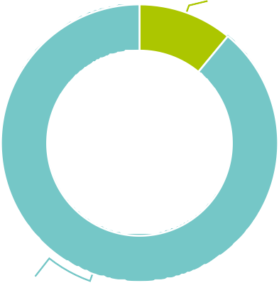
Practice Assessment Reports
Committee Reviewed 11.00%
Compared to 12% for 2016–2017

Staff Reviewed 89.00%
Compared to 88% for 2016–2017

QUALITY ASSURANCE

Areas for Improvement Identified through the Practice Assessment

26 Percentage
Practice Issues
Business Practices
Record Keeping
CSR
Portfolio
0 2 4 6 8 10 12 14 16 18 20 22 24

2016-2017 2017-2018

22%
Improvement Required
Compared to 30% for 2016–2017
Perform Authorized Activities
PTs Assessed
206

ROSTERED ACTIVITIES

 | Number of Authorized Activities Assessed |  | Number of PTs who have registered to perform each activity
 | 2016-2017 | 2017-2018 | 2016-2017 | 2017-2018
Acupuncture | 112 | 150 | 3047 | 3356
Spinal Manipulation | 45 | 60 | 1099 | 1205
Tracheal Suctioning | 16 | 31 | 733 | 692
Oxygen Administration | 37 | 58 | 1029 | 1218
Pelvic Floor/Incontinence Care | 14 | 13 | 361 | 495
Wound Care | 1 | 2 | 34 | 37
Total | 225 | 314 | 6303 | 7003

REGISTRATION
The College ensures qualifications of individuals applying to become registered physiotherapists in Ontario. Anyone using the title physiotherapist, physical therapist or PT in Ontario must be a member of the College, and renew annually.

Canadian Labour Mobility (AIT)
41
Individuals became registered in Ontario through the use of the Canadian Free Trade Agreement (CFTA) provisions between April 1, 2017 to March 31, 2018.

Registration Committee Decisions

 | 2016–2017 | 2017-2018
Total Number of Decisions | 14 | 8
Outcome: Certiﬁcates Granted | 0 | 0
Outcome: Certiﬁcates with Additional Terms, Conditions and Limitations Granted | 11 | 3
Outcome: Certiﬁcates Denied | 3 | 5

Appeals 2017-2018
There were no appeals of Registration Committee decisions to the Health Professions Appeal and Review Board (HPARB)

2,515
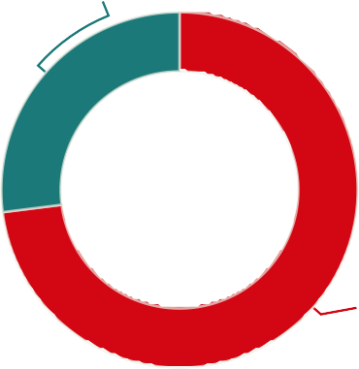Internationally Educated 27.00%
PTs

6,960
Canadian Educated 73.00%

TOP 5 COUNTRIES
Male 27
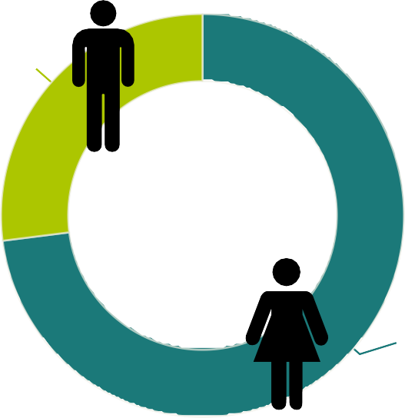
2,543

GENDER

6,935
Female 73

India
UK USA
Philippines Australia
0
MEMBERS
998

1100

314
275
169
114
100 200 300 400 500 600 700 800 900 1000

78
8880
578
94
613
0
2000
4000
6000
8000
10000
2017-2018
2016-2017

Total Members New Members

PROFESSIONAL CONDUCT
CASES RECEIVED
 | 2017
Total Cases | 203 | 389
Complaints | 65 | 118
Complaints Conﬁrmed | 38 | 33
Registrar’s Inquiries | 138 | 271

2016-
2017-2018

REGISTRAR'S INQUIRIES
The College receives complaints and reports about the practice or conduct of physiotherapists. All complaints made by the public are investigated. The College Registrar may also initiate investigations where reported information suggests reasonable and probable grounds to believe a physiotherapist may have engaged in professional misconduct or is incompetent. The results of investigations are considered by the Inquiries, Complaints and Reports Committee, which may take no action, order a range of educational or remedial activities, or refer a physiotherapist to the Discipline Committee or Fitness to Practise Committee for a hearing.

The College is also interested in receiving information about individuals who are not registered to practice but refer to themselves as physiotherapists or physical therapists.

 | 2016-  2017 | 2017-  2018
Mandatory Report – Termination | 5 | 7
Mandatory Report – Incapacity | 0 | 1
Mandatory Report – Sexual Abuse | 2 | 4
Mandatory Report – Self-reports Made by PTs about Offences, Malpractice and Negligence | 13 | 7
Self-reports Made during the Renewal Process | 0 | 27
Failure to Complete the Jurisprudence Module | 17 | 4
Failure to Complete PISA | 0 | 3
Other Member Speciﬁc Matters | 94 | 160
Referrals from the Inquiries, Complaints and Reports Committee to the Registrar | 0 | 0
PTs Reporting their Name and Registration Number has been Misused | 5 | 5
Non-PTs Misusing Title/Holding Out | 2 | 16

DIVISIONAL COURT REVIEWS

 | 2016-2017 | 2017-2018
Divisional Court Reviews | 0 | 3

Dispositions of the ICRC

 | 2016-2017 | 2017-2018
Total Decisions | 70 | 64
No Action | 34 | 24
Advice and Recommendations | 15 | 19
Caution | 3 | 6
Speciﬁed Continuing Education and Remediation Program (SCERP) | 12 | 3
Referral to Discipline | 4 | 9
Referral to Fitness to Practise | 0 | 0
SCERP and Caution | 2 | 0
Undertakings | 0 | 1

Health Professions Appeal and Review Board (HPARB) Review Process (Complaints)

 | 2016-2017 | 2017-2018
Number of Cases Appealed to the Board | 10 | 10
Number of Decisions Received from HPARB | 7 | 6
Number of Decisions Conﬁrmed by HPARB | 5 | 4
Number of Decisions Returned for Reconsideration | 2 | 2
Hearings

 | 2016-2017 | 2017-2018
Number of Hearings | 9 | 8
Number of Hearing Days | 12 | 8
Hearings Adjourned Sine Die | 4 | 3
Discipline Hearings Completed | 8 | 8
Findings of Professional Misconduct | 4 | 5
Fitness to Practise Hearings | 0 | 0
Findings of Incapacity | 0 | 0
Reinstatement Hearings | 0 | 0

Annual Report April 1, 2017–March 31, 2018 | 24

PATIENT RELATIONS
The Committee met on two different occasions.

The College started to offer funding for therapy and counselling during the intake process. We also looked at all files in process to see if funding could or should be offered to patients who were involved in investigations where there were allegations of sexual abuse and boundary violations.

Discipline Summaries

In 2017-2018 there have been eight Discipline hearings
that have taken place at the College of Physiotherapists of Ontario. Visit www.collegept.org to viewthe complete list of Discipline Hearings and the Decisions.

Read about the College's Discipline hearings at www.canlii.org.

Always visit the online Public Register, Find a Physiotherapist tool https:/ portal.collegept.org/public-register to access important information about the health care provideryou are choosing to see.

If you want to learn more about otherregulated health care providers, you can visit their Public Registers.

See a complete list of Public Registers
https:/ ontariohealthregulators.ca/fnd-health-care-professional

Joselyne Bellamy
Cases: 2015 0204 and 2016 0018 Case: 2015 0204
Hearing Date: June 5, 2017

On March 8, 2017 the Inquiries, Complaints and Reports Committee referred a matter involving Joselyne Bellamy to the Discipline Committee for a hearing.
Overview of the allegations: That between January 2014 and January 2017 Ms. Bellamy:

 Failed to return patient charts to her employers after her contracts were terminated
 Submitted accounts for physiotherapy services when no services were provided or failed to keep records in accordance with the standards of practice of the profession
This matter was adjourned sine die.

Case: 20160018

On March 8, 2017 the Inquiries, Complaints and Reports Committee referred a matter involving Joselyne Bellamy to the Discipline Committee for a hearing.

Overviewof the allegations: That Ms. Bellamy * Failed to attend before the ICRCto receive a caution

* Failed to complete the requirements of a Specified Continuing Education and Remediation Program (SCERP)

The hearing was held on June 5, 2017.

At the conclusion of the hearing the panel found that Ms. Bellamy engaged in professional misconduct under paragraphs 12, 13 and 18 of section 1 of the professional misconduct regulation O Reg 388/08.

- Failing to comply with an order of a statutory committee of the College when the order is issued in accordance with the committee’s authority under the Regulated Health Professions Act, 1991.

- Failing to reply appropriately or within a reasonable time to a written inquiry from the College.

18. Engaging in conduct or performing an act relevant to the practice of the profession that, having regard to all the circumstances, would reasonably be regarded by members as disgraceful, dishonourable or unprofessional.

Having made the above findings the panel directed the Registrar to revoke the certificate of registration of the member effective June 5, 2017.

Neil Boon
Cases: 2015 0094
Hearing Date: Various dates in 2016 and 2017

On October 20, 2015 the Inquiries, Complaints and Reports Committee referred a matter involving Neil Boon to the Discipline Committee for a hearing. The dates for the hearing were:

June 7, 8, 2016
 October 6, 7, 17, 18, 2016
April 20, 2017

Current Status: Decision on Finding, Penalty and Costs: Appealed by the Member
Matter was heard on: May 29, 2018 Decision of the Discipline Committee was upheld: http://canlii.ca/t/h5rst

Overview of the Allegations: In April 2015, Mr. Boon touched a patient in a sexual manner. More specifically, Mr. Boon:

 placed, rubbed or otherwise touched his hand on the patient's thigh and inner thigh
 inappropriately leaned his body or otherwise touched his body against the patient
 grabbed, squeezed or otherwise touched the patient's breast
 placed the patient's foot against or on his crotch and/or thigh, and
 rubbed the patient's back

Findings

At the conclusion of the hearing, the Panel found that Mr. Boon engaged in acts of professional misconduct within the meaning of:

 paragraph 1 (Failing to maintain the standards of practice of the profession),
 paragraph 7 (Performing a professional service for which consent is required by law without such consent),
 paragraph 18 (Engaging in conduct or performing an act relevant to the practice of the profession that, having regard to all the circumstances, would reasonably be regarded by members as disgraceful, dishonourable or unprofessional) and
 paragraph 19 (Conduct unbecoming a physiotherapist) as defined by section 1 of the College’s Professional Misconduct Regulation, being Ontario Regulation 388/08 made under the Physiotherapy Act, 1991.

The Panel was not satisfied that the touching was of a sexual nature as that term is defined by subsections 1(3) and (4) of the Health Professions Procedural Code of the Regulated Health Professions Act, 1991.

At the conclusion of the hearing, the Committee ordered:
- A 3-month suspension.
- A reprimand.
- A term, condition and limitation requiring practice monitoring for two years.
- A term, condition and limitation requiring the completion of a boundaries education course.
- A term, condition and limitation regarding working with a physiotherapist assistant while suspended.
- Restrictions on the supervision of physiotherapy students and physiotherapist assistant students while involved in practice monitoring.
- Costs in the amount of $30,000.

Discipline Committee and Divisional Court decisions are available at canlii.org.

Colleen Bourgeois

REVOKED - Case 2015 0305
Hearing date: August 24, 2017

On April 18, 2017 the Inquiries, Complaints and Reports Committee of the College of Physiotherapists of Ontario referred specified allegations against Colleen Bourgeois to the Discipline Committee of the College.

Overview of the allegations: Breach of Privacy
Between the period March 1, 2015 and November 30, 2015, Ms. Bourgeois accessed patient records, including sensitive mental health records, of patients T, D, J and K. Patients T, J and K were not patients of Ms. Bourgeois. In respect of patient D, Ms. Bourgeois accessed health records during a period when D was not Ms. Bourgeois’ patient. Ms. Bourgeois did not access the records of patients T, D, J and K, for a purpose related to the provision of physiotherapy care.

Sexual Abuse

In or about March 2015, Ms. Bourgeois commenced a sexual relationship with patient D. The sexual relationship included sexual intercourse. Ms.
Bourgeois continued to provide physiotherapy care to patient D during and following the termination of the sexual relationship.
Findings

At the conclusion of the hearing the panel found that Ms. Bourgeois had committed the following acts of professional misconduct:
paragraph 1: Failed to maintain the standards of practice of the profession;
paragraph 10: Sexually abused a patient;
paragraph 15: Contravened a federal provincial or territorial law relevant to themember’s suitability to practice;
paragraph 18: Engaged in conduct or performing an act relevant to the practice of the profession that, having regard to all the circumstances, would reasonably be regarded by members as disgraceful, dishonourable or unprofessional; and
paragraph 19: Engaged in conduct unbecoming a physiotherapist.

The Discipline Committee further found that the Member engaged in sexual abuse of a patient as defined by ss.1(3), 1(4) and 51(1)(b.1) of Health Professions Procedural Code, being Schedule 2 to the Regulated Health Professions Act, 1991, S.O. 1991, c.18.

Penalty

The panel ordered the following penalty:

That the Member appear before the panel of the Discipline Committee to be reprimanded at the conclusion of the hearing on August 24, 2017.
That the Registrar revoke the Member’s certificate of registration effective August 24, 2017.
That the Member pay costs to the College in the amount of $1,000 payable by August 30, 2017.

David Evans

Cases: 2015 0113
Hearing Date: November 28, 2017

Discipline Summary On August 10, 2017 the Inquiries, Complaints and Reports Committee referred a matter involving David Evans to the Discipline Committee for a hearing.

Overview of the Allegations

During the period of July 1, 2013 and August 5, 2016, Mr. Evans:

delegated to an athletic therapist the assessment and re-assessment of, and the development of treatment plans for, Clinic physiotherapy patients;
failed to perform assessments and to develop treatment plans for some physiotherapy patients ostensibly under his care;
failed to obtain informed consent from some patients for the involvement of physiotherapist assistants in the delivery of physiotherapy;
directly and/or indirectly held out an athletic therapist, as a Member of the College to patients of his Clinic and members of the public;
 issued invoices to some patients for a “Physiotherapy Assessment” under his name and registration number, when a different employee of Mr. Evans’ clinic, who is not a registered physiotherapist, performed the assessment;
directly or indirectly misrepresented to the College that he, and not an athletic therapist, had assessed and/or developed the treatment plans for the patients
Findings

At the conclusion of the hearing the panel found that Mr. Evans had committed several act(s) of professional misconduct and a penalty was ordered.

Penalty

The panel ordered the following penalty:

a reprimand at the conclusion of the hearing on November 28, 2017
a suspension of 15 months with 7 months remitted if the following remedial activities are completed within the required timelines
successful completion of the PROBE ethics program
a review of various College standards, tools and resources
When Mr. Evans returns to practice he will be required to work with a practice coach for no more than three years during which time he will not be able to supervise physiotherapy students or PTA students, or members of the College who hold a provisional practice certificate of registration. In addition Mr. Evans will not be able to teach or assist with the teaching of physiotherapy students or PTA students.
 Costs payable to the College in the amount of $2,000
 Costs payable to the Ministry of Finance in the amount of $3,000

Jeklina (Gina) Konjarski

Cases: 2016 0177
Hearing Date: Various dates in 2017

Hearing dates:
Preliminary Motions - Monday May 15, 2017 starting at 9:30am Additional Dates: May 16, 2017 and June 6, 2017

On December 8, 2016 the Inquiries, Complaints and Reports Committee referred a matter involving Jeklina Konjarski to the Discipline Committee for a hearing.

Overview of the allegations:
On October 13, 2016 Jeklina Konjarski failed to attend before a panel of the Inquiries, Complaints and Reports Committee (ICRC) to receive a caution as required by decision of the ICRCdated May 14, 2015.

The Discipline Committee convened to hear the allegations on June 6, 2017. Ms. Konjarski did not attend.
Having reviewed the Notice of Hearing, considered the evidence presented, including the evidence of a witness for the College, and having heard submissions from College counsel, the Panel found the Member to have engaged in professional misconduct under paragraphs 12 and 18 of section 1 of the Professional Misconduct Regulation O Reg 388/08.

12. Failing to comply with an order of a statutory committee of the College when the order is issued in accordance with the committee’s authority under the Regulated Health Professions Act, 1991.

- Engaging in conduct or performing an act relevant to the practice of the profession that, having regard to all the circumstances, would reasonably be regarded by members as disgraceful, dishonourable or unprofessional.

Penalty and Costs

Having made findings of professional misconduct the Panel directed that:

  - The Registrar suspend the certificate of registration of the Member, effective June 6, 2017, until such time that the Member successfully completes (unconditional pass) the PROBE ethics program offered through CPEP and provides proof of her successful completion that is satisfactory to the Registrar.
  - Jeklina Konjarski appear before the panel to receive a reprimand on a date to be set by the Registrar.
  - Jeklina Konjarski pay costs to the College in the amount of $4500, no later than 90 days of the date the Order is signed.

Cases: 2015 0144
Hearing Date: June 5, 2017

On October 13, 2016 the Inquiries, Complaints and Reports Committee referred a matter involving France Laberge to the Discipline Committee for a hearing.

Overview of the allegations:

Between January 2010 and December 2015, Ms. Laberge:

Submitted invoices for physiotherapy assessments under her name and registration number when the assessments were completed by non physiotherapists
Assigned physiotherapy assessments, reassessments and the development of treatment plans to athletic therapists
Failed to obtain informed consent for the use of support personnel in the provision of care
Held out five staff members at her clinic as physiotherapists when these individuals were not registered physiotherapists

The hearing was held on June 5, 2017.

Having reviewed the Notice of Hearing dated October 19, 2017, the Acknowledgement and Undertaking to the College signed by Ms. Laberge on May 30, 2017 and on consent of the parties, the Panel orders that the hearing in this matter shall be adjourned sine die.
ACKNOWLEDGEMENT AND UNDERTAKING signed
on May 30, 2017

I, FRANCE LABERGE, HEREBY ACKNOWLEDGE AND UNDERTAKE AS FOLLOWS:

- Iam currently a member of the College of Physiotherapists of Ontario (the “College”).

- Iacknowledge that as a result of an investigation there were allegations made that I:

* Submitted invoices for physiotherapy assessments under my name and registration number when the assessments were completed by non- physiotherapists
* Assigned physiotherapy assessments, reassessments and the development of treatment plans to athletic therapists.
* Failed to obtain informed consent for the use of support personnel in the provision of care, and
* Directly or indirectly held out staff members at my clinic as physiotherapists when these individuals were not registered physiotherapists.

Iacknowledge that those allegations have been referred by the Inquiries, Complaints and Reports Committee to the Discipline Committee of the College.

- In light of these allegations Ihave decided to retire and in the circumstances, Iagree that it would be in my interest not to have a contested hearing.

- Iundertake to cease practising physiotherapy and to resign my certificate of registration effective at 5:00
p.m. on the date on which Isign this Undertaking; no later than June 4, 2017.

(continued on next page)

- Iundertake to neverapply formembership, registration, orlicensure with the College as a physiotherapist.

- Iacknowledge that the College will seek to indefinitely adjourn the discipline hearing as soon as possible aftermy resignation has become effective (at 5:00 p.m. on the date I sign this Undertaking) and will only seek to bring the discipline hearing back on if the Registrarbelieves Ihave breached this Undertaking, and Ihereby consent to this indefinite adjournment.

- Iacknowledge that immediately upon my resignation becoming effective Iwill not be able to practise physiotherapy, hold myself out as qualified to practice as a physiotherapist, use the title “physiotherapist”, “PT”, “Reg PT” orany variation orabbreviation thereof orequivalent in anotherlanguage.

- Iacknowledge that the text of this Undertaking will appearon the public register(which is found on the College’s website).

- Iacknowledge that any breach of this Undertaking may result in allegations of professional misconduct against me being referred to discipline.

- Iacknowledge that Ihave consulted with legal counsel priorto signing this Undertaking.

Lo-Ming Lum

Cases: 2016 0176
Hearing Date: Various dates in 2017

Hearing dates: Preliminary Motions—Monday May 15, 2017 starting at 9:30am Additional Dates: May 16, 2017 and June 6, 2017

On December 8, 2016 the Inquiries, Complaints and Reports Committee referred a matter involving Lo- Ming Lum to the Discipline Committee for a hearing. Overview of the allegations:

On October 13, 2016 Lo-Ming Lum failed to attend before a panel of the Inquiries, Complaints and Reports Committee (ICRC) to receive a caution as required by a decision of the ICRCdated May 14, 2015.

The Discipline Committee convened to hear the allegations on June 6, 2017. Ms. Lum did not attend.
Having reviewed the Notice of Hearing, considered the evidence presented, including the evidence of a witness for the College, and having heard submissions from College counsel, the Panel found the Member to have engaged in professional misconduct under paragraphs 12 and 18 of section 1 of the Professional Misconduct Regulation O Reg 388/08.

12. Failing to comply with an order of a statutory committee of the College when the order is issued in accordance with the committee’s authority under the Regulated Health Professions Act, 1991.

18. Engaging in conduct or performing an act relevant to the practice of the profession that, having regard to all the circumstances, would reasonably be regarded by members as disgraceful, dishonourable or unprofessional.

Penalty and Costs

Having made findings of professional misconduct the Panel directed that:
- The Registrar suspend the certificate of registration of the Member, effective June 6, 2017, until such time that the Member successfully completes (unconditional pass) the ProBe ethics program offered through CPEP and provides proof of her successful completion that is satisfactory to the Registrar.
- Lo-Ming Lum appear before the panel to receive a
reprimand on a date to be set by the Registrar.
- Lo-Ming Lum pay costs to the College in the amount of $4500, no later than 90 days of the date the Order is signed.

Contact the College
College of Physiotherapists of Ontario
375 University Avenue, Suite 800 Toronto, Ontario M5G 2J5

General Inquiries info@collegept.org 1-800-583-5885
416-591-3828
Contact the Practice Advisor
1-800-583-5885 ext. 241
647-484-8800
practiceadvice@collegept.org
Concerns or Complaints
1-800-583-5885 ext. 227
investigations@collegept.org

@CollegeofPTs College Blog Facebook.com/CollegeofPTs Watch Us on YouTube

