May 201 9 | www.collegept.org | info@collegept.org

We live in an increasingly technology-driven world, and the possibilities that come with new technology are innovative and exciting. Questions about how to best utilize technology in health care are abundant, and physiotherapy is no exception.

We would like to know more about how physiotherapists are using
tele-rehabilitation in their practice. Please consider completing the brief survey at the link below. The data will be used to inform further discussions about
tele-rehabilitation in physiotherapy.
Thanks for your cooperation, Rod Hamilton
Registrar
College of Physiotherapists of Ontario

Tele-rehabilitation Survey

This short survey is to gather data on the number of physiotherapists in Canada using telecommunications or digital technologies to deliver physiotherapy services and the type of services used.

Tele-rehabilitation includes the delivery of physiotherapy services at a distance using telecommunications or digital technologies. The most common platform is videoconferencing.

The survey only takes two minutes to complete and will be open until May 12.
Complete the Survey

Rostering: Some Important Reminders

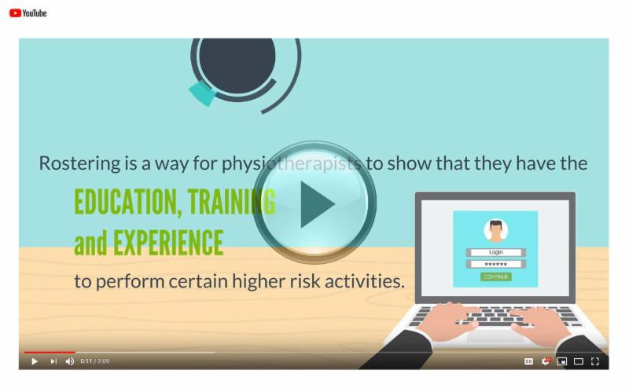Have you checked the controlled acts that you're rostered for lately?

As we move closer to the official launch of our new practice assessment process (the pilot test is in full swing!), we'd like to remind PTs to review the controlled acts that they're rostered for. Here are some things to keep in mind:

You can only perform controlled acts that you're rostered for

You should only roster for controlled acts that you have performed on patients OR done training for in the last two years

If you're rostered for a controlled act you will be asked about it in a practice assessment

Have a quick look at your profile. Be sure to add any acts you are doing now and delete any high-risk activities you are no longer doing.
More About Controlled Acts

Video: Learn How to Roster for Controlled Acts

Succession Planning to Help Prevent Abandoned Records

Abandonment of health records continues to be a problem in Ontario, resulting in serious implications for the privacy of individuals and the security of their health information.

As part of a strategy to help prevent abandoned records, the Information and Privacy Commissioner of Ontario (IPC) has developed a new fact sheet – Succession Planning to Help Prevent Abandoned Records.

The fact sheet is a must read and outlines the importance of succession planning in the event that a Health Information Custodian (HIC) retires, relocates or otherwise becomes incapacitated.
Learn More

Patient Declaration of Values for Ontario

The Minister of Health and Long-Term Care's Patient and Family Advisory Council has released a set of principles that champion the role of patients, families and caregivers across the health care system.

Read the Declaration as it outlines expectations about values, resources and supports that everyone should consider as they deliver care.

You might even want to print copies to share with your patients, staff or to post in your workplace.

Read the Declaration

New Blog! Patients and Mental Health: Let's Keep the Conversation Going
We'd like to thank everyone who joined us for our recent webinar, In Harm's Way – Strategies to Support Patients with Mental Health Issues.

This is an important subject and it's imperative that we keep the conversation going to help end the stigma around mental health and best support patients.

Check out our newest blog post for a quick recap of the webinar, key take-aways for PTs, helpful phrases to engage patients and make them feel supported, and useful resources that can assist you should a patient disclose abuse, suicidal thoughts or mental health challenges.
Read the Post

Practice Advice Question

I see patients for years and sometimes get invited to attend birthday parties

Myth vs Fact

Physiotherapists can only claim practice hours for hours spent treating

and other events.

If professional boundaries are maintained, are there any other ethical issues I should consider?
patients.

Is this a myth or a fact?
Get the Answer

Get the Answer

New Case of the Month: Supervising a Forgetful Student

So you've agreed to supervise a physiotherapy student – that's fantastic! They seem pretty competent so you ease up on your supervision a bit. Everything should be fine... right?

Find out what happens when lack of student supervision leads to a complaint in a new Case of the Month.
Read the Case

The College would like to welcome our newly registered physiotherapists.
View the List

Comments or questions related to Perspectives?
Get in touch at communications@collegept.org or 1-800-583-5885 ext. 234

www.collegept.org

